UNITED STATES
SECURITIES AND EXCHANGE COMMISSION
Washington, D.C. 20549
SCHEDULE 14A
Proxy Statement Pursuant to Section 14(a) of the Securities Exchange Act of 1934
(Amendment No. ___)
x |  | Filed by the Registrant
o |  | Filed by a Party other than the Registrant
Check the appropriate box:
o |  | Preliminary Proxy Statement
o |  | Confidential, for Use of the Commission Only (as permitted by Rule 14a-6(e)(2))
x |  | Definitive Proxy Statement
o |  | Definitive Additional Materials
o |  | Soliciting Material under §240.14a-12
TRIPADVISOR, INC.
(Name of Registrant as Specified in its Charter)
(Name of Person(s) Filing Proxy Statement, if other than the Registrant)
Payment of Filing Fee (Check all boxes that apply):
x No fee required
☐ Fee paid previously with preliminary materials
☐ Fee computed on table in exhibit required by Item 25(b) per Exchange Act Rules 14a-6(i)(1) and 0-11



April 30, 2026
Dear Fellow Stockholders:

A year ago, we set out to build on our leadership in experiences. In 2025, we delivered — becoming an experiences-first company, a shift we believe is clearly reflected in our performance. Year over year, experiences booked grew 16% to 22.9 million, while gross booking value (GBV) grew 13% to $4.7 billion. Adjusted EBITDA in our Experiences segment, meanwhile, reached $91 million, up from $79 million in 2024. Our Experiences segment accounted for nearly half of total Group revenue, and we expect its share of total Group revenue to grow even further in 2026. This reflects meaningful scale, with growth and efficiency that have enabled us to become the world’s largest experiences platform, and operating profitably.

Beyond experiences, we made progress across the portfolio:

•
In dining, we saw significant growth at TheFork, with revenue up 22%, while adjusted EBITDA more than tripled, which we believe demonstrates an attractive long-term growth profile.

•
In Hotels & Other, we streamlined and simplified the business through a restructuring that we anticipate will better align costs with its revenue profile, protect profitability, and enable a greater focus on experiences.

•
And across all our brands, our data and AI capabilities are improving how travelers discover and book. We accelerated AI-driven product matching and personalized recommendations across our platforms to drive conversion. We expanded partnerships with leading AI and search platforms, ensuring we are present wherever travelers plan and book. At the trusted intersection between travelers and operators, we believe we’ve built a differentiated data asset with unmatched utility.

This progress is representative of our deliberate shift to more durable, higher growth marketplace offerings, which in 2025 represented over 60% of revenue and 35% of adjusted EBITDA. We achieved record revenue of $1.9 billion, driven by 12% growth in our marketplace offerings, our Experiences and TheFork segments, which more than offset weaker performance in our legacy offerings within our Hotels & Other segment. On a consolidated basis, year over year revenue grew 3%, while net income was $40 million, adjusted EBITDA1 was $319 million, and free cash flow1 was $163 million.

Finally, we simplified our capital structure through the April 2025 merger transaction with our former controlling stockholder. Combined with $90 million in share repurchases, these actions reduced our share count by approximately 21% since the end of 2024. We also began to refresh our Board, adding leadership and operational experience aligned with our focus on long-term value creation.

In 2026 we plan to build on this momentum — continuing to grow our leadership in experiences, leverage the power of our assets for an AI-driven future, and simplify the portfolio with discipline.

To our employees — thank you for your ongoing commitment and engagement. 2025 brought significant change, and your focus, resilience and dedication made our progress possible. Across our teams and geographies, your collective contributions strengthen our business every day.

To our shareholders — thank you for your continued support. We’re confident that our shift to becoming an experiences-first company, combined with disciplined execution, positions Tripadvisor to create meaningful long-term value.

1 Free cash flow for fiscal year ended December 31, 2024 included the impact of a net cash outflow of approximately $96 million related to a previously disclosed IRS settlement. Free cash flow and adjusted EBITDA are non-GAAP measures. Please refer to “Non-GAAP Reconciliations” on the Company’s investor relations website for definitions of our non-GAAP financial measures, as well as reconciliations to the most directly comparable GAAP measure.

1

You are cordially invited to attend the Annual Meeting of Stockholders of Tripadvisor, Inc. to be held on Monday, June 29, 2026, at 10:00 a.m. Eastern Time. The Annual Meeting will be held virtually. You may attend the meeting, submit questions and vote your shares electronically during the meeting by visiting www.virtualshareholdermeeting.com/TRIP2026. To enter the Annual Meeting, you will need the control number that is printed in the box marked by the arrow on your proxy card. We recommend logging in at least fifteen minutes before the meeting starts. Online check-in will start at approximately 9:45 a.m. Eastern Time on Monday, June 29, 2026.

At the Annual Meeting, stockholders will be asked to vote on the matters described in the accompanying Notice of Annual Meeting and Proxy Statement, as well as such other business that may properly come before the meeting and any adjournments or postponements thereof. Your vote is very important to us. Please review the instructions for each voting option described in the Notice and in this Proxy Statement. Your prompt cooperation will be greatly appreciated.

Sincerely,
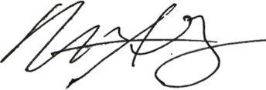

MATT GOLDBERG
President and Chief Executive Officer

2

PROXY STATEMENT FOR THE ANNUAL MEETING OF STOCKHOLDERS
400 1st Avenue
Needham, Massachusetts 02494
NOTICE OF ANNUAL MEETING OF STOCKHOLDERS
To Be Held on June 29, 2026

The 2026 Annual Meeting of Stockholders of Tripadvisor, Inc., a Nevada corporation, will be held on Monday, June 29, 2026, at 10:00 a.m. Eastern Time. The Annual Meeting will be held via the Internet and will be a virtual meeting. You may attend the Annual Meeting, submit questions, and vote your shares electronically during the meeting via the Internet by visiting www.virtualshareholdermeeting.com/TRIP2026. To enter the Annual Meeting, you will need the 16-digit control number that is printed in the box marked by the arrow on your proxy card. We recommend logging in at least fifteen minutes before the meeting to ensure that you are logged in when the Annual Meeting begins. The online check-in will start shortly before the Annual Meeting on June 29, 2026. At the Annual Meeting, stockholders will be asked to consider and vote on the following proposals:
1.
To elect the ten directors named in this Proxy Statement, each to serve for a one-year term from the date of his or her election and until such director’s successor is elected or until such director’s earlier resignation or removal;
2.
To ratify the appointment of KPMG LLP as our independent registered public accounting firm for the fiscal year ending December 31, 2026; and
3.
To consider and act upon any other business that may properly come before the Annual Meeting and any adjournments or postponements thereof.
Only holders of record of outstanding shares of Tripadvisor, Inc. capital stock at the close of business on April 30, 2026 are entitled to notice of and to vote at the Annual Meeting and at any adjournments or postponements thereof. We will furnish over the Internet the Notice of Annual Meeting of Stockholders, Proxy Statement and Annual Report for the fiscal year ended December 31, 2025. Whether or not you plan to attend the Annual Meeting, we encourage you to access and read the Proxy Statement and Annual Report. We will send to our stockholders a Notice of Internet Availability of Proxy Materials on or about May 11, 2026, and provide access to our proxy materials over the Internet. You may request paper copies by following the instructions on the Notice of Internet Availability of Proxy Materials.
By Order of the Board of Directors,
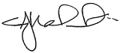
SETH J. KALVERT
Chief Legal Officer and Secretary
April 30, 2026
Important Notice Regarding the Availability of Proxy Materials
for the Annual Meeting of Stockholders to Be Held on June 29, 2026
This Proxy Statement and the 2025 Annual Report are available at:
https://ir.tripadvisor.com/financial-information/annual-reports

3



TABLE OF CONTENTS

 | Page
Annual Meeting Matters | 5
Proposal 1: Election of Directors | 9
Corporate Governance | 16
Proposal 2: Ratification of Appointment of Independent Registered Public Accounting Firm | 25
Audit Committee Report | 27
Executive Officers | 28
Compensation Discussion and Analysis | 29
CEO Pay Ratio | 40
Pay Versus Performance | 41
Executive Compensation | 45
Director Compensation | 58
Security Ownership of Certain Beneficial Owners and Management | 60
Certain Relationships and Related Person Transactions | 62
Where You Can Find More Information | 63
Annual Reports | 63
Proposals by Stockholders for Presentation at the 2026 Annual Meeting | 63
Delivery of Documents to Stockholders Sharing an Address | 64

4

ANNUAL MEETING MATTERS
This Proxy Statement is being furnished to holders of common stock of Tripadvisor, Inc., a Nevada corporation, in connection with the solicitation of proxies by Tripadvisor’s Board of Directors (the “Board”) for use at its 2026 Annual Meeting of Stockholders or any adjournment or postponement thereof (the “Annual Meeting”). All references to “Tripadvisor,” the “Company,” “we,” “our” or “us” in this Proxy Statement are to Tripadvisor, Inc. and its subsidiaries. An Annual Report to Stockholders, containing financial statements for the year ended December 31, 2025, and this Proxy Statement are being made available to all stockholders entitled to vote at the Annual Meeting.
Tripadvisor’s principal executive offices are located at 400 1st Avenue, Needham, Massachusetts 02494. We will send our stockholders a Notice of Internet Availability of Proxy Materials on or about May 11, 2026, and provide access to our proxy materials over the Internet.
Date, Time and Place of Meeting
The Annual Meeting will be held on Monday, June 29, 2026, at 10:00 a.m. Eastern Time. The Annual Meeting will be held via the Internet and will be a completely virtual meeting. You may attend the meeting, submit questions and vote your shares electronically during the meeting via the Internet by visiting www.virtualshareholdermeeting.com/TRIP2026. To enter the Annual Meeting, you will need the 16-digit control number that is printed in the box marked by the arrow on your proxy card. We recommend logging in at least fifteen minutes before the meeting to ensure that you are logged in when the meeting starts.
If you encounter any difficulties accessing the virtual meeting during the check-in or meeting time, please call the technical support number that will be posted on the virtual meeting web portal. Technical support will be available during this time and will remain available until the Annual Meeting has ended. No recording of the Annual Meeting is allowed, including audio or video recording.
Record Date and Voting Rights
The Board established the close of business on April 30, 2026, as the record date for determining the holders of Tripadvisor common stock entitled to notice of and to vote at the Annual Meeting. On the record date, 116,359,654 shares of common stock were outstanding and entitled to vote at the Annual Meeting. Tripadvisor stockholders are entitled to one vote for each share of common stock held as of the record date, voting together as a single voting group, on (i) the election of ten director nominees; and (ii) the ratification of the appointment of KPMG LLP as Tripadvisor’s independent registered public accounting firm for the year ending December 31, 2026. Stockholders have no right to cumulative voting as to any matter, including the election of directors.
Recent Changes
On December 18, 2024, Tripadvisor, Liberty TripAdvisor Holdings, Inc. ("LTRIP") and Telluride Merger Sub Corp., a Delaware corporation (“Merger Sub”) and an indirect wholly-owned subsidiary of Tripadvisor, entered into an Agreement and Plan of Merger (the “Merger Agreement”), pursuant to which, and subject to certain terms and conditions (i) Merger Sub would be merged with and into LTRIP (the “First Merger”), with LTRIP surviving the First Merger as an indirect, wholly-owned subsidiary of the Company, and (ii) immediately following the First Merger, LTRIP (as the surviving corporation in the First Merger) would be merged with and into TellurideSub LLC, a Delaware limited liability company and a direct wholly-owned subsidiary of the Company (“ParentSub LLC”) (such merger, the “ParentSub LLC Merger” and together with the First Merger, the "Merger"), with ParentSub LLC surviving the ParentSub LLC Merger as the surviving company and a wholly-owned subsidiary of the Company.
Following the consummation of the Merger on April 29, 2025, our Board of Directors retired and canceled the shares of Tripadvisor common stock and Class B common stock held by LTRIP. As a result of the Merger, we simplified our capital structure to a single class of common stock and no longer have a controlling stockholder or qualify as a "controlled company" under the Nasdaq Stock Market Listing Rules. The Governance Agreement among Tripadvisor and certain LTRIP entities has accordingly terminated. For additional information regarding the Merger and related transactions, please see our Annual Report on Form 10-K for the year ended December 31, 2025 and our Current Report on Form 8-K filed on April 29, 2025.
In addition, effective April 29, 2025, Tripadvisor effected the redomestication of the Company to the State of Nevada by conversion, which redomestication by conversion was approved by the Tripadvisor stockholders in June 2023. With respect to such redomestication, a Certificate of Conversion was filed with the Delaware Secretary of State and Articles of Conversion and Articles of Incorporation were filed with the Nevada Secretary of State. This summary of the redomestication by conversion and any reference
5

to the Company's charter documents are qualified in their entirety by reference to Tripadvisor's Form 10-K filed with the SEC on February 13, 2026 and the Company's Articles of Incorporation and bylaws filed therewith.
On March 18, 2026, each of Gregory B. Maffei, Chair of the Board, and Albert E. Rosenthaler, a member of the Board, notified the Company of his respective decision not to stand for re-election at the 2026 Annual Meeting of Stockholders. Their decisions to retire from the Board were not the result of any disagreement with the Company on any matter relating to the Company's operations, policies, or practices.
On March 22, 2026, we entered into a cooperation agreement (the "Cooperation Agreement") with Starboard Value LP and certain of its affiliates (collectively, "Starboard"), pursuant to which four additional independent directors join our Board of Directors (two appointed effective March 22, 2026 and two nominated for election at the 2026 Annual Meeting), and Starboard has agreed to customary standstill, voting and other provisions for the term of the agreement. In connection with the Cooperation Agreement and as part of our ongoing corporate governance enhancements, effective March 22, 2026, our Board approved amended and restated Bylaws (the "Bylaws") that, among other things, supersede and replace our prior bylaws in their entirety and implement additional stockholder rights, including stockholder action by written consent and the ability of stockholders to call special meetings, subject to certain ownership thresholds set forth in our Bylaws. For additional information regarding the Cooperation Agreement and our amended and restated Bylaws, please see our Current Report on Form 8-K filed on March 23, 2026 and the exhibits filed therewith.
Quorum; Abstentions; Broker Non-Votes
Transaction of business at the Annual Meeting may occur if a quorum is present. If a quorum is not present, the Annual Meeting will be adjourned or postponed in order to permit additional time for soliciting and obtaining additional proxies or votes. At any subsequent reconvening of the Annual Meeting, all proxies will be voted in the same manner as such proxies would have been voted at the original convening of the Annual Meeting, except for any proxies that have been effectively revoked or withdrawn.
The holders of a majority of the voting power of the outstanding shares of capital stock of Tripadvisor entitled to vote thereat, present in person or represented by proxy, constitutes a quorum for the transaction of business, including (i) the election of ten director nominees; and (ii) the ratification of the appointment of KPMG LLP as Tripadvisor’s independent registered public accounting firm for the fiscal year ending December 31, 2026. Virtual attendance at the Annual Meeting also constitutes presence in person for purposes of determining a quorum at the Annual Meeting.
Shares of Tripadvisor common stock represented by a properly executed proxy will be treated as present at the Annual Meeting for purposes of determining a quorum, without regard to whether the proxy is marked as casting a vote or abstaining.
Abstentions and broker non-votes are counted as present and entitled to vote for purposes of determining a quorum. A broker non-vote occurs when a nominee holding shares for a beneficial owner does not vote the shares on a proposal because the nominee does not have discretionary voting power for a particular item and has not received instructions from the beneficial owner regarding voting. Brokers who hold shares for the accounts of their clients have discretionary authority to vote shares if specific instructions are not given with respect to the proposal to ratify the appointment of our independent registered public accounting firm. Brokers do not have discretionary authority to vote on the proposal regarding the election of our directors, so we encourage you to provide instructions to your broker regarding the voting of your shares.
Required Vote for Each Proposal
For Proposal 1 regarding the election of directors, the vote required to approve is a plurality of the votes cast. You may vote "FOR" or "WITHHOLD" for the director nominees. If nominees are unopposed, election of a director requires only a single "FOR" vote or more. Withholding authority to vote your shares with respect to one or more director nominees and broker non-votes will have no effect on the election of those nominees.
The vote required to approve Proposal 2 relating to the ratification of the selection of our independent auditors is the affirmative vote of a majority of the voting power of the shares present in person or represented by proxy at the meeting and entitled to vote on the matter. Abstentions and broker non-votes, if any, will have the same effect as votes “AGAINST” the ratification of the appointment of KPMG LLP as our independent registered public accounting firm.
Solicitation of Proxies
Tripadvisor will bear the cost of the solicitation of proxies from its stockholders. In addition to solicitation by mail, the directors, officers and employees of Tripadvisor, without additional compensation, may solicit proxies from stockholders by telephone, by
6

letter, by facsimile, in person or otherwise. We have engaged D.F. King & Co., Inc. to assist in the solicitation of proxies and provide related advice and informational support, for a services fee, which is not expected to exceed $16,000 in total, plus customary expenses and disbursements. In addition, D.F. King & Co., Inc. and certain related persons will be indemnified against certain liabilities arising out of or in connection with the engagement. D.F. King & Co., Inc. may solicit proxies by electronic mail, mail and telephone. Following the mailing of the proxy materials and other soliciting materials, Tripadvisor will ask brokers, trusts, banks or other nominees to forward copies of the proxy materials and other soliciting materials to persons for whom they hold shares of Tripadvisor capital stock and to request authority for the exercise of proxies. In such cases, Tripadvisor, upon the request of the brokers, trusts, banks and other stockholder nominees, will reimburse such holders for their reasonable expenses.
Voting of Proxies
The manner in which your shares may be voted depends on whether you are a:
•
Registered stockholder: Your shares are represented by certificates or book entries in your name on the records of Tripadvisor’s stock transfer agent and you have the right to vote those shares directly; or
•
Beneficial stockholder: You hold your shares in “street name” through a broker, trust, bank or other nominee and you have the right to direct your broker, trust, bank or other nominee on how to vote the shares in your account; however, you must request and receive a valid proxy from your broker, trust, bank or other nominee.
Whether you hold shares directly as a registered stockholder or beneficially as a beneficial stockholder, you may direct how your shares are voted without attending the Annual Meeting. For directions on how to vote, please refer to the instructions below and those on the website listed on the Notice of Internet Availability of Proxy Materials, proxy card or voting instruction form provided. To vote using the Internet or by telephone, you will be required to enter the control number included on your Notice of Internet Availability of Proxy Materials or other voting instruction form provided by your broker, trust, bank or other nominee.
•
Using the Internet. Registered stockholders may vote using the Internet by going to www.proxyvote.com and following the instructions. Beneficial stockholders may vote by accessing the website specified, if one was provided, on the voting instruction forms provided by their brokers, trusts, banks or other nominees.
•
By Telephone. Registered stockholders may vote, from within the United States, using any touch-tone telephone by calling 1-800-690-6903 and following the recorded instructions. Beneficial owners may vote, from within the United States, using any touch-tone telephone, if a number was provided, by calling the number specified on the voting instruction forms provided by their brokers, trusts, banks or other nominees.
•
By Mail. Registered stockholders may submit proxies by mail by requesting printed proxy cards and marking, signing and dating the printed proxy cards and mailing them in the accompanying pre-addressed envelopes. If your brokers, trusts, banks or other nominees permit you to vote by mail, beneficial owners may vote by marking, signing and dating the voting instruction forms provided and mailing them in the accompanying pre-addressed envelopes.
All proxies properly submitted and not revoked will be voted at the Annual Meeting in accordance with the instructions indicated thereon. If no instructions are provided, such proxies will be voted FOR proposals (1) and (2).
The electronic voting procedures provided for the Annual Meeting are designed to authenticate each stockholder by use of a control number, to allow stockholders to vote their shares and to confirm that their instructions have been properly recorded.
Beneficial stockholders should refer to the voting instruction form provided by their broker, trust, bank or other nominee for instructions on voting and the voting methods they offer.
Voting in Person at the Annual Meeting
Virtual attendance at the Annual Meeting constitutes presence in person for purposes of each required vote. Votes cast at the Annual Meeting will replace and supersede any previous votes you have made by mail or telephone or via the Internet. Attendance at the Annual Meeting without voting or revoking a previous proxy in accordance with the voting procedures will not, by itself, revoke a proxy.
Holders of record may vote their shares electronically during the meeting via the Internet by visiting www.virtualshareholdermeeting.com/TRIP2026. To enter the Annual Meeting, holders will need the 16-digit control number that is printed in the box marked by the arrow on their Notice of Internet Availability of Proxy Materials. We recommend logging in at least fifteen minutes before the meeting to ensure that you are logged in when the meeting starts. Online check-in will start shortly before the meeting.
7

Your vote is very important. Whether or not you plan to attend the Annual Meeting, please take the time to vote via the Internet, by telephone or by returning your marked, signed and dated proxy card so that your shares will be represented at the Annual Meeting.

Revocation of Proxies
Any proxy given pursuant to this solicitation may be revoked by the person giving it before the taking of the vote at the Annual Meeting.
If you are a beneficial stockholder, you may revoke your proxy or change your vote only by following the separate instructions provided by your broker, trust, bank or other nominee.
If you are a registered stockholder, you may revoke your proxy at any time before it is exercised at the Annual Meeting by (i) delivering written notice, bearing a date later than the revoked proxy, stating that the proxy is revoked and such notice is received before the start of the Annual Meeting, (ii) submitting a later-dated proxy relating to the same shares by mail or telephone or via the Internet prior to the vote at the Annual Meeting, or (iii) attending and casting a vote at the Annual Meeting. Registered stockholders may send any written notice or request for a new proxy card to Tripadvisor, Inc., c/o Broadridge, 51 Mercedes Way, Edgewood, New York 11717, or follow the instructions provided on the Notice of Internet Availability of Proxy Materials and proxy card to submit a new proxy by telephone or via the Internet. Registered holders may also request a new proxy card by calling 1-800-579-1639. Your attendance at the Annual Meeting will not, by itself, revoke a prior vote or proxy from you.
Other Business
The Board does not presently intend to bring any business before the Annual Meeting other than the proposals discussed in this Proxy Statement and specified in the Notice of Annual Meeting of Stockholders. The Board has no knowledge of any other matters to be presented at the Annual Meeting other than those described in this Proxy Statement. If any other matters should properly come before the Annual Meeting, the persons designated in the proxy will vote on them according to their best judgment.
8

PROPOSAL 1:
ELECTION OF DIRECTORS
Board of Directors Overview
Our Board currently consists of ten members. Pursuant to the terms of Tripadvisor’s bylaws, each director serves for a one-year term from the date of his or her election and until such director’s successor is elected or until such director’s earlier resignation or removal. The Board recommends that each of the ten nominees listed below be elected to serve a one-year term and until such director’s successor shall have been duly elected and qualified or until such director’s earlier resignation or removal:

Laura Bisesto
Andrew Cates
Alex Dichter
Dhiren Fonseca
Matt Goldberg
Betsy L. Morgan
Jeremy G. Philips
Trynka Shineman Blake
Carl D. Sparks
Robert S. Wiesenthal
Tripadvisor only has common stock outstanding and the holders of Tripadvisor common stock are entitled to elect the directors. Election of each director requires a plurality of votes cast. Proxies cannot be voted for a greater number of individuals than nominees named. In connection with the Merger, the Governance Agreement permitting LTRIP the right to nominate and vote on directors is no longer in place. Therefore, holders of Tripadvisor common stock are entitled to elect all ten directors.
The nominees for election to the Board have each consented to their nomination. Although management does not anticipate that any of the nominees named above will be unable or subsequently unwilling to stand for election, in the event of such an occurrence, proxies may be voted for a substitute nominee designated by the Board.
As previously disclosed, on March 22, 2026, we entered into the Cooperation Agreement with Starboard, pursuant to which, among other things, (i) four new independent directors joined our Board of Directors (Andrew Cates and Dhiren Fonseca were appointed to the Board in March 2026 and have been recommended for re-election at the 2026 Annual Meeting; Laura Bisesto and Carl Sparks have been nominated for election at the 2026 Annual Meeting), (ii) we increased the size of the Board from eight to ten, and (iii) Starboard agreed to, among other things, vote all shares of the Company’s common stock beneficially owned by Starboard in favor of the Company’s director nominees and in accordance with the Board’s recommendation on all other proposals, subject to certain limited exceptions. The Cooperation Agreement also includes provisions regarding committee membership of the directors to be appointed and elected, and procedures for determining any replacements for directors who join the Board pursuant to the Cooperation Agreement. For additional information regarding the Cooperation Agreement and our Bylaws, please see our Current Report on Form 8-K filed on March 23, 2026 and the exhibits filed therewith.
Information Regarding Director Nominees
The information provided below about each nominee is as of the date of this Proxy Statement. The information presented includes the name of each of the nominees, along with his or her age, any positions held with the Company, term of office as a director, principal occupations or employment for the past five years or more, involvement in certain legal proceedings, if applicable, and the names of all other publicly-held companies for which he or she currently serves as a director or has served as a director during the past five years. The information also includes a description of the specific experience, qualifications, attributes and skills of each nominee that led our Board to conclude that he or she should serve as a director of the Company for the ensuing term.
The ten nominees to the Board possess the experience and qualifications that we believe will allow them to make substantial contributions to the Board. In selecting nominees to the Board, we seek to ensure that the Board collectively has a balance of backgrounds, experience, and expertise, including chief executive officer experience, chief financial officer experience, international expertise, corporate governance experience and experience in other functional areas that are relevant to our business. The following contains a more detailed discussion of the business experience and qualifications of each of the nominees to the Board.
9

Laura Bisesto    Age: 41 | Ms. Bisesto has served as Chief of Staff to the Chief Financial Officer of OpenAI Group PBC (d/b/a “OpenAI”), an artificial intelligence research and deployment company, since August 2024. In this role, Ms. Bisesto leads finance strategy and operations and OpenAI’s AI-native finance transformation. Previously, Ms. Bisesto served as the Head of Policy and Privacy / Head of Corporate Counsel at Nextdoor Holdings, Inc., a hyperlocal social media platform, from September 2020 to August 2024. From January 2024 to August 2024, she also served as Chair of the Board of Directors of Internet Works, a middle-tech advocacy organization. Prior to that, Ms. Bisesto served as Director of Policy at Checkr, Inc., an AI-powered background check and screening company, from December 2019 to July 2020, and as Head of U.S. State Public Policy at Verizon Media Inc. (n/k/a Yahoo Inc.) from June 2018 to December 2019. Ms. Bisesto also previously held various public policy leadership roles at Lyft, Inc. from November 2015 to June 2018. Earlier in her career, she served as an Assistant District Attorney in the San Francisco District Attorney’s Office from July 2011 to October 2015. Ms. Bisesto earned a B.A. in Political Science from the University of California, Los Angeles and a J.D. from the University of California, College of the Law, San Francisco (f/k/a University of California, Hastings College of the Law).  Board Membership Qualifications: Ms. Bisesto brings to the Board expertise in AI and technology policy, and global privacy, which are critical to the Company’s strategic evolution. Her leadership in OpenAI’s AI-native finance transformation provides unique insights into the operational integration of emerging technologies. Additionally, her background in public policy and legal affairs at Nextdoor and Lyft, combined with her service as an Assistant District Attorney, offers a robust perspective on navigating complex regulatory environments and public corporate governance.

Andrew Cates    Age: 55  Director Since: 2026  Committee Memberships:   Nominating and Corporate Governance | Mr. Cates is the founder and Managing Member of Value Acquisition Fund LLC, an acquisition, development and asset management firm he has led since 2005. He is also the Chief Executive Officer and General Partner of RVC Outdoor Destinations, a leading developer and owner of high quality outdoor resorts across the United States. Mr. Cates previously served on the boards of Pioneer Natural Resources Company from 2009 to October 2020 and PICO Holdings Inc. from 2016 to 2017, where he was a member of the Audit and Compensation Committees of each company. Earlier in his career, he was a Partner of Viceroy Investments, LLC, a Dallas based commercial real estate investment firm, and worked at Crow Family Holdings (formerly Crow Investment Trust) on partnership and loan workouts, acquisitions and asset management. Mr. Cates is also active in civic and nonprofit initiatives, including leading the development of the Soulsville Revitalization Project in Memphis, and serving as Board Chairman of Memphis Fourth Estate, Inc. and as a member of the Board of Advisors of Myelin Repair Foundation. He holds a B.B.A. in Finance from The University of Texas at Austin.  Board Membership Qualifications: Mr. Cates brings to the Board real estate, hospitality, and asset management expertise, particularly through his leadership of RVC Outdoor Destinations, which provides him with insight into the outdoor travel and resort sector. His public company board experience offers the Board a perspective on capital allocation and strategic oversight.

10

Alex Dichter    Age: 58  Director Since: 2025  Committee Memberships:   None | Mr. Dichter has served as a senior advisor to KSL Capital Partners, a private equity firm specializing in hospitality and travel, since February 2025. He is also a senior advisor to 26 North, an investment firm focused on long-term value creation. From September 1999 through January 2025, Mr. Dichter held several positions at McKinsey & Company, most recently as Senior Partner leading the Global Airline, Aviation & Travel Practice and the Asia-Pacific Travel, Transport & Logistics Practice. Since February 2024, Mr. Dichter has served as Chair of the Board of Hurtigruten Expeditions, the world’s oldest expedition cruise line, and as a Board Advisor to Tortuga Resorts, a KSL Capital Partners portfolio company. He also serves as an independent director of Flight Radar 24. Mr. Dichter holds a bachelor’s degree from Embry-Riddle Aeronautical University and an M.B.A. from The Tuck School of Business.  Board Membership Qualifications: Mr. Dichter has strategic and operational experience across the global airline, hospitality and travel sectors, including more than 20 years leading a major consulting firm's airline and travel practices. His role as a senior advisor and board chair in travel and leisure businesses provide the Board with insight into industry dynamics, capital deployment and risk management that is relevant to Tripadvisor's strategy.

Dhiren Fonseca    Age: 61  Director Since: 2026  Committee Memberships:   Compensation | Mr. Fonseca has served as Executive Chairman of Rent the Runway, Inc., an e-commerce platform focused on subscription designer apparel and accessories, since October 2025. He also advises private equity and growth companies, including TPG Global, LLC since May 2025, GetPica Group S.p.A since January 2023 and Certares LP since 2018, where he was previously a Partner from 2014 to 2018. From December 2020 to April 2021, Mr. Fonseca was Chief Executive Officer and President of RentPath, Inc., an online residential rental marketplace, and served on its board of directors, and earlier spent nearly two decades at Expedia Group, Inc. in senior leadership roles including Chief Commercial Officer and Co-President, Partner Services Group. He began his career at Microsoft Corporation, where he was part of the management team that launched Expedia.com. Mr. Fonseca has served on numerous public and private company boards across travel, technology and services, including Alaska Air Group, Inc., Rackspace Technology, Inc., Cynosure Inc., Osiris Acquisition Corp, Wilbur Ellis, DRF Logistics, LLC and others. Mr. Fonseca attended the University of Manitoba.  Board Membership Qualifications: Mr. Fonseca brings over 30 years of online travel and technology leadership, having been part of the original Microsoft management team that founded Expedia.com. His operational background, including his tenure as Chief Commercial Officer of Expedia, provides the Board with expertise in scaling global marketplaces and managing complex supplier ecosystems.

11

Matt Goldberg    Age: 55  Director Since: 2022 | Mr. Goldberg has served as President and CEO of Tripadvisor, Inc. since July 2022. From February 2020 through June 2022, Mr. Goldberg held various senior positions at The Trade Desk, a global technology company, including Executive Vice President, North America and Executive Vice President, Global Operations, as well as serving as founding director of Dataphilanthropy, a private foundation. Mr. Goldberg served as Global Head of M&A and Strategic Alliances and Head of India for News Corp from December 2016 through December 2019. Mr. Goldberg served as Senior Vice President, Global Market Development and Head of Corporate Development for QVC Group from October 2013 through November 2016. Prior to that, Mr. Goldberg was CEO of Lonely Planet, a global travel guide publisher for nearly five years. Mr. Goldberg is active in edtech, philanthropy and nonprofit board leadership, including Lingoda GmbH, The Burning Man Project, Lumina Foundation, and Jim Joseph Foundation. Mr. Goldberg holds an M.B.A. from Stanford University, an M.A. in International Studies from The University of Melbourne, and a B.A. in English from Cornell University.  Board Membership Qualifications: Mr. Goldberg has more than 25 years of experience across global and multinational businesses with a particular focus on the global travel industry. Mr. Goldberg also brings strategic, operational and governance acumen from his executive and director roles with several companies across the travel, digital media, and data sectors.

Betsy L. Morgan    Age: 57  Director Since: 2019  Committee Memberships:   Compensation—Chair   Nominating and Corporate Governance | Ms. Morgan is currently the co-founder of Magnet Companies, a private equity-backed company focused on media and commerce. From February 2016 to July 2018, Ms. Morgan served as an Executive in Residence of LionTree, an advisory and merchant bank firm specializing in technology and media. From January 2011 to July 2015, Ms. Morgan was the CEO of TheBlaze, an early multi-platform and direct-to-consumer news and entertainment company. Prior to TheBlaze, Ms. Morgan was the CEO of The Huffington Post. Ms. Morgan currently serves on the board of directors of the following privately-held companies: Trusted Media Brands, Chartbeat and TheSkimm. Ms. Morgan has an M.B.A. from Harvard Business School and a B.A. in Political Science and Economics from Colby College, where she served as a member of the Board of Trustees for eight years. She is also a contributor to Riptide, an oral history of journalism and digital innovation created by Harvard’s Shorenstein Center on Media, Politics and Public Policy.  Board Membership Qualifications: Ms. Morgan has experience leading digital media, subscription and original content businesses, which are relevant to Tripadvisor's strategy. Her financial background, investment knowledge and board experience also offer a valuable perspective to the Company.

12

Jeremy G. Philips    Age: 53  Director Since: 2011  Committee Memberships:   Nominating and Corporate Governance - Chair   Audit   Lead Independent Director | Mr. Philips has been a general partner of Spark Capital since May 2014. From 2012 to 2014, Mr. Philips invested in private technology companies. From 2010 to 2012, Mr. Philips served as the Chief Executive Officer of Photon Group Limited, a holding company listed on the Australian Securities Exchange. From 2004 to 2010, Mr. Philips held various roles of increasing responsibility with News Corporation, most recently as an Executive Vice President in the Office of the Chairman. Before joining News Corporation, he served in several roles, including co-founder and Vice-Chairman of ecorp, a publicly-traded Internet holding company. Mr. Philips has served on the board of directors of Angi Inc. since November 2021, and served on the board of Affirm Holdings from 2015 to 2021. He holds a B.A. and LL.B. from the University of New South Wales and an MPA from the Harvard Kennedy School of Government.  Board Membership Qualifications: Mr. Philips has a broad understanding of technology products, including AI technologies. He also brings financial literacy and expertise regarding mergers, acquisitions, investments and other strategic transactions. He has strategic and operational experience acquired through his service as chief executive officer and other executive-level positions.

Trynka Shineman Blake    Age: 52  Director Since: 2019 | Ms. Shineman has served on the board of directors of SEMRush, an online visibility and content marketing SaaS business, since November 2020 until its acquisition by Adobe in April 2026, where she served as chair of its Nominations and Governance Committee and as a member of its Compensation Committee; Twist Bioscience, a leader in synthetic biology since 2025, where she serves on the Audit Committee; Captura since 2022 and Steer since 2024, two private vertically focused SaaS businesses. From March 2004 through February 2019, Ms. Shineman held positions of increasing responsibility with Cimpress N.V., most recently was the Chief Executive Officer of its Vistaprint business. Previously, she was a member of the board of Ally Financial, and UBM PLC. Ms. Shineman has an M.B.A. from Columbia Business School and a B.A. in Psychology from Cornell University.  Board Membership Qualifications: Ms. Shineman has many years of experience with customer-focused businesses and digital business models. She has experience helping companies develop an understanding of customer needs and shaping the organization around those needs.
13

Committee Memberships:
 Audit
 Compensation

Carl D. Sparks    Age: 58 | Mr. Sparks has served as Managing Partner at Interlock Partners, a venture capital firm, since 2020. Prior to joining Interlock Partners, Mr. Sparks served as Senior Advisor at Bain Capital from 2018 to 2019 and as Chief Executive Officer of Academic Partnerships from 2016 to 2017. Previously, he served as President and Chief Executive Officer of Travelocity Global from 2011 to 2014 and as President of Gilt Groupe from 2010 to 2011, after initially serving as its Chief Marketing Officer. Mr. Sparks also served in various roles of increasing responsibility at Expedia Group, Inc., including as General Manager at Hotels.com USA, Latin America & Canada from 2008 to 2009 and Chief Marketing Officer at Expedia.com from 2006 to 2007. Earlier in his career, he held senior roles at Capital One Financial Corp., Diageo PLC, PepsiCo Inc., and Boston Consulting Group. Mr. Sparks currently serves on the Boards of Directors of Waste Connections, Inc. since March 2024, Cint Group AB since January 2022, and Copart, Inc. since September 2021. He previously served as a director of Avis Budget Group, Inc. from 2018 to 2021, Dunkin’ Brands Group, Inc. from 2013 to 2020, and Vonage Holdings Corp. from 2011 to 2018. Mr. Sparks earned a B.S.E. in Mechanical and Aerospace Engineering from Princeton University and an M.B.A. from Harvard Business School.  Board Membership Qualifications: Mr. Sparks brings leadership and operational experience in the online travel and technology sectors, having served as the Chief Executive Officer of Travelocity Global and in senior executive roles at Expedia and Hotels.com. His background in digital marketing and brand strategy is complemented by venture capital experience and a track record of driving growth at scale. Furthermore, Mr. Sparks’ service on the boards of several other publicly traded companies provides expertise in corporate governance, capital allocation, and strategic oversight.

Robert S. Wiesenthal    Age: 59  Director Since: 2011  Committee Memberships:   Audit—Chair | Since July 2015, Mr. Wiesenthal has served as Chief Executive Office of Blade (now a wholly owned subsidiary of Joby Aviation) and, since August 2025, has served as Chairman of Strata Critical Medical ("Strata") (formerly Blade Air Mobility, Inc.). He has served as one of Strata's directors since June 2014. From January 2013 to July 2015, Mr. Wiesenthal served as Chief Operating Officer of Warner Music Group Corp., a global music conglomerate. From 2000 to 2012, Mr. Wiesenthal served in various senior executive capacities with Sony Corporation ("Sony"), most recently as Executive Vice President and Chief Financial Officer of Sony Corporation of America. Prior to joining Sony, from 1988 to 2000, Mr. Wiesenthal served in various capacities with Credit Suisse First Boston, most recently as Managing Director, Head of Digital Media and Entertainment. Mr. Wiesenthal previously served on the board of directors of Starz, a global media and entertainment company. Mr. Wiesenthal has a B.A. from the University of Rochester.  Board Membership Qualifications: Mr. Wiesenthal possesses strategic, operational and financial experience, gained through his service in executive-level positions with a strong focus on networked consumer electronics, entertainment, and digital media. He also brings financial literacy and expertise regarding mergers, acquisitions, investments and other strategic transactions.
14

 Nominating and Corporate Governance

In addition to the information presented regarding each nominee’s specific experience, qualifications, attributes, and skills that led the Board to the conclusion that he or she should be nominated as a director, each nominee has proven business acumen, extensive management experience in complex organizations, and an ability to exercise sound judgment, as well as a commitment to Tripadvisor and its Board as demonstrated by each nominee’s past service. The Board considered the Nasdaq requirement that Tripadvisor’s Audit Committee be composed of at least three independent directors, as well as specific Nasdaq and U.S. Securities and Exchange Commission (“SEC”) requirements regarding financial literacy and expertise.
Required Vote
Election of each director requires a plurality of the votes cast.
We ask our stockholders vote "FOR" each of the director nominees. Valid proxies received pursuant to this solicitation will be voted in the manner specified. With respect to the election of directors, you may vote “FOR” or “WITHHOLD”. Where no specification is made, it is intended that the proxies received from stockholders will be voted "FOR" the election of the director nominees identified. Votes withheld and broker non-votes will have no effect on the outcome.
THE BOARD RECOMMENDS THAT STOCKHOLDERS VOTE “FOR” THE ELECTION OF EACH OF THE NOMINEES FOR DIRECTOR NAMED ABOVE.
15

CORPORATE GOVERNANCE
Corporate Governance Highlights
The Company’s Board endeavors to conduct itself and to manage the Company in a way that best serves all of the Company’s stockholders. We strive to maintain high governance standards in our business and our commitment to effective corporate governance is illustrated by the following practices:
•
Chair of the Board separate from the CEO;
•
Existence of a Lead Independent Director;
•
Nine of the ten directors will be independent;
•
All three Audit Committee members are independent and all three qualify as a “financial expert”;
•
Existence of a Nominating and Corporate Governance Committee;
•
Self-evaluation by members of the Board regarding the workings of the Board and optimizing its performance;
•
All directors attended at least 75% of Board and applicable committee meetings during the period in which they served in 2025;
•
Board oversight over management’s development and execution of the Company’s strategy and plan, including the extent to which risks and opportunities are embedded in that strategy;
•
Board review of enterprise risk management and related policies, processes and controls, with Board committees exercising oversight for risk matters within their purview;
•
Board oversight over cybersecurity risk management;
•
Direct access and regular communication between the Board and members of senior management;
•
We do not have a shareholder rights plan (also known as a poison pill);
•
Stock ownership guidelines for directors and executive officers; and
•
Comprehensive insider trading policy that also prohibits hedging and pledging transactions of our stock by directors or employees.
In connection with our ongoing Board refreshment process, the following summary information reflects the composition of our director nominees standing for election at the Annual Meeting, who we believe contribute valuable leadership and operational experience aligned to support our focus on long-term value creation.

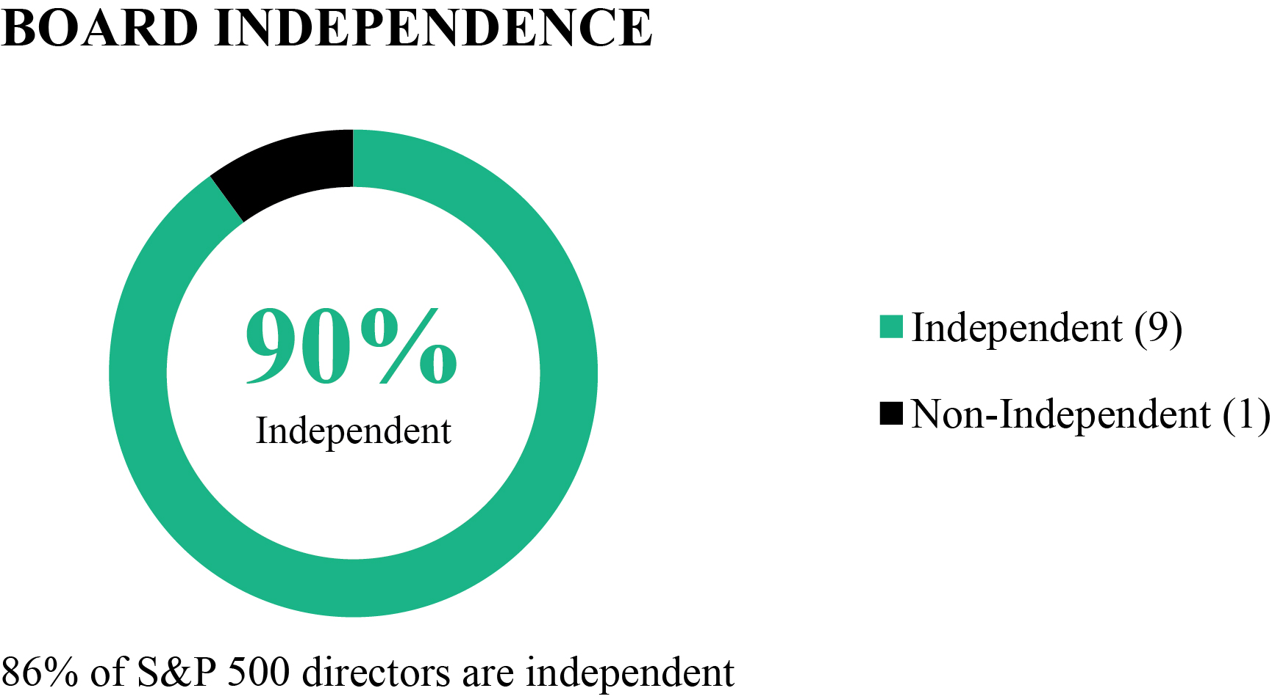 | 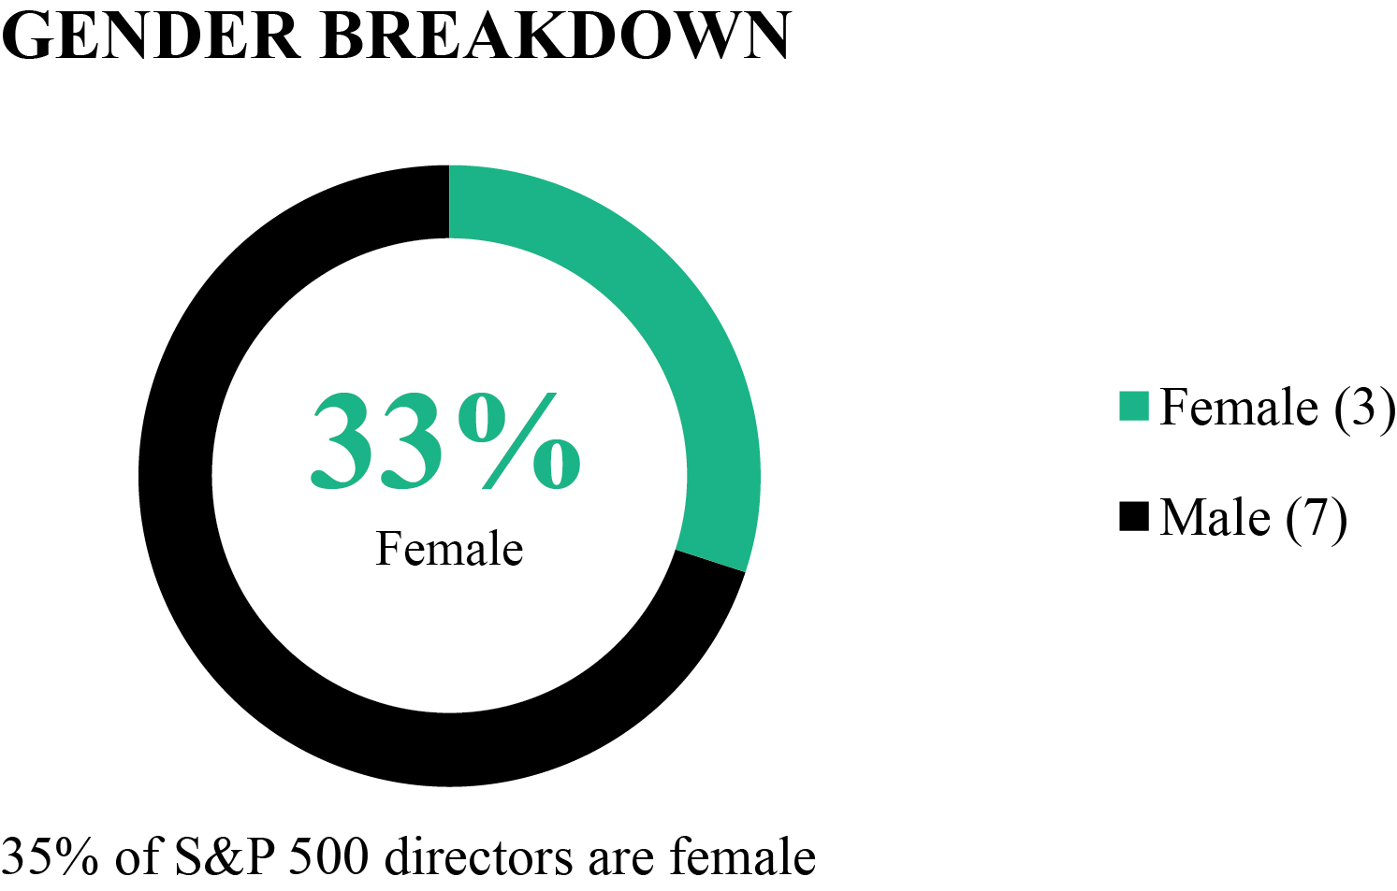
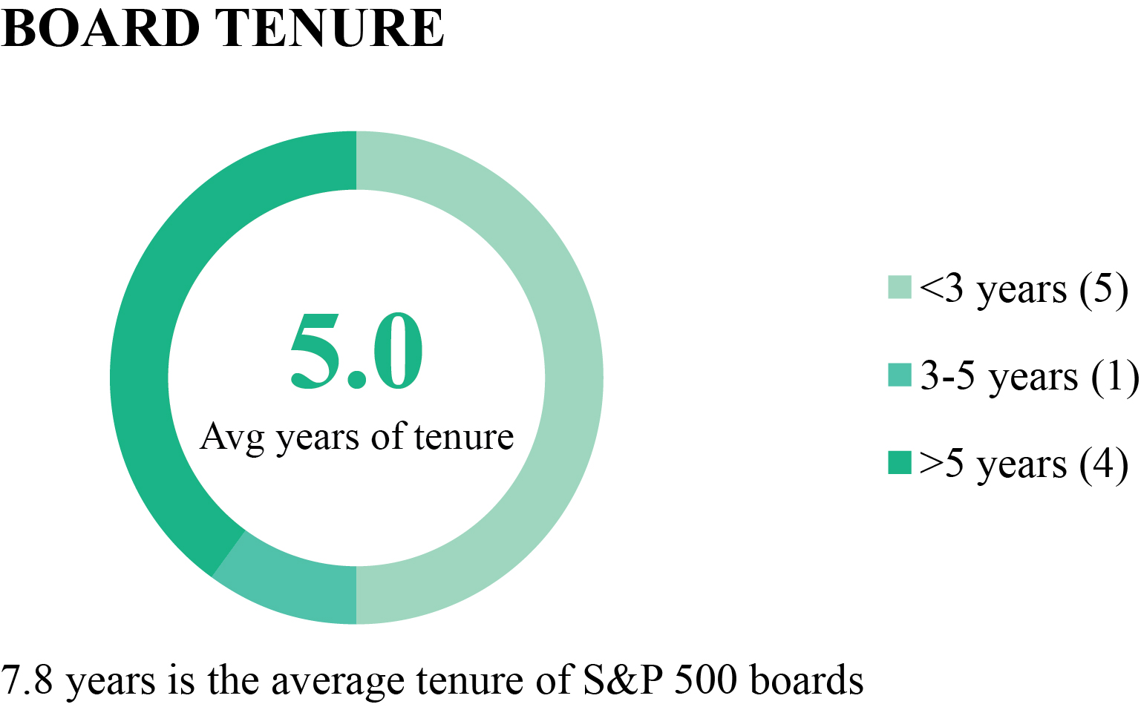 | 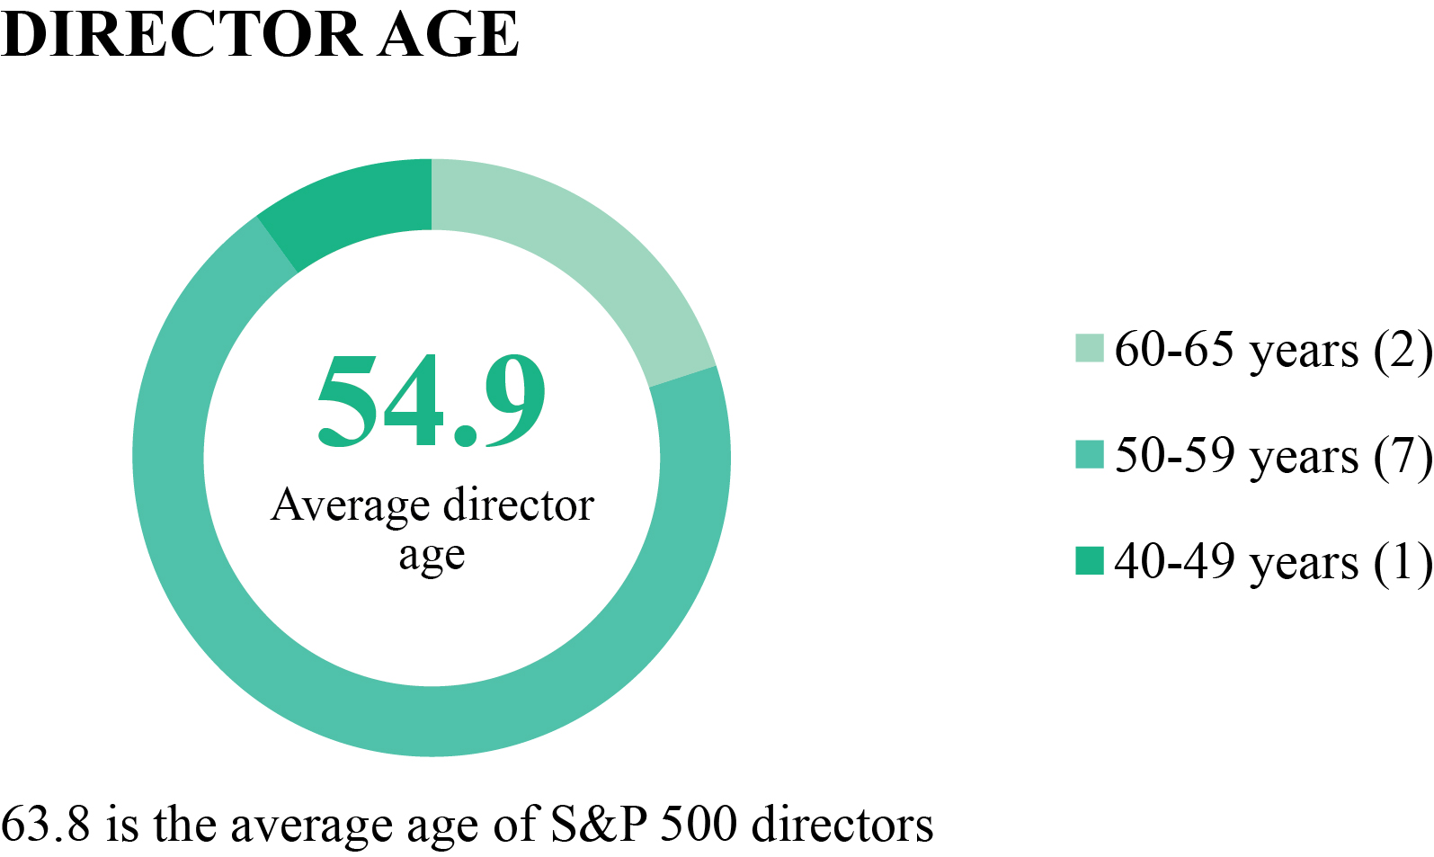

16

Board of Directors
Pro Forma Board Composition: Director Experience, Attributes and Skills
The Board believes that a complementary mix of varied experiences, attributes and skills will best serve our Company and our stockholders. Our Board is comprised of a high-performing group of individuals whose previous experience, financial and business acumen, personal ethics and dedication to our Company benefit the Company and our stockholders. The Board composition is intentionally designed to align with the Company's strategic focus on AI implementation and enhanced independent oversight. The addition of three independent board members since our 2025 Annual Meeting, two additional independent nominees, and the intended appointment of an independent Board Chair ensure a diverse, expert-led body capable of driving stockholder value. The following reflects the anticipated skills and experience profile of the Board of Directors for the 2026-2027 term, assuming the election of all nominees at the 2026 Annual Meeting:
Director Nominee Experience, Attributes and Skills

Qualifications, Expertise, and Attributes |  |  | # of  Directors
 | Senior Executive Experience |  | 9 of 10
Deep experience leading, managing and//or transforming an organization, with accountability for overall performance and
strategic direction
 | Product, Technology, AI or Data Analytics |  | 10 of 10
 | Possesses a strong understanding of technology products, AI technologies, data analysis techniques or cybersecurity risks to drive insights, improve decision-making, and enhance business value
 | Accounting and Finance |  | 7 of 10
Leadership of a financial firm or management of the finance function of an enterprise, resulting in financial sophistication,
proficiency in overseeing financial reporting and disclosure controls and procedures
 | Corporate Governance |  | 8 of 10
Experience serving on public company boards or counseling such boards on governance, risk management and fiduciary
duties
 | Marketplace / eCommerce Experience |  | 6 of 10
Significant experience in operating two-sided online marketplaces, which may include expertise managing online sales
platforms or deploying digital marketing strategies to drive customer and partner acquisition, conversion and engagement
 | Travel and Leisure Industry |  | 8 of 10
 | Knowledge of the travel and leisure industry and the challenges and opportunities facing our business
 | Global / International Business |  | 8 of 10
We operate a global business and believe it is important the Board includes directors with a mix of global business
perspectives representing a variety of markets

Director Independence
Under the Nasdaq Rules, the Board has a responsibility to make an affirmative determination that those members of the Board who serve as independent directors do not have any relationships that would interfere with the exercise of independent judgment in carrying out the responsibilities of a director. The Board makes these determinations annually. In connection with these independence determinations, the Board reviews information regarding transactions, relationships and arrangements relevant to independence, including those required by the Nasdaq Rules. This information is obtained from director responses to questionnaires circulated by management, as well as our records and publicly available information. Following this determination, management monitors those transactions, relationships and arrangements that were relevant to such determination, as well as solicits updated information potentially relevant to independence from internal personnel and directors, to determine whether there have been any developments that could potentially have an adverse impact on the Board’s prior independence determination.
17

Based on the information provided by each director concerning his or her background, employment and affiliations and upon review of this information, our Board has determined that each of Mses. Bisesto, Morgan and Shineman Blake and Messrs. Cates, Dichter, Fonseca, Philips, Sparks and Wiesenthal does not have a relationship that should interfere with the exercise of independent judgment in carrying out the responsibilities of a director and that each of these directors is an “independent director” as defined under the applicable rules and regulations of the SEC and Nasdaq. In making its independence determinations, the Board considered the applicable legal standards and any relevant transactions, relationships or arrangements of which it was aware. In addition to the satisfaction of the director independence requirements set forth in the Nasdaq Rules, members of the Audit Committee also satisfied separate independence requirements under the current standards imposed by the SEC and the Nasdaq Rules for audit committee members. All members of the Nominating and Corporate Governance Committee and Compensation Committee are independent.
Board Leadership Structure

Mr. Maffei serves as the Chair of the Board, and Mr. Goldberg serves as President and Chief Executive Officer of Tripadvisor. The roles of Chief Executive Officer and Chair of the Board are separated in recognition of the differences between the two roles. This leadership structure provides us with the benefit of the Chair's oversight of Tripadvisor’s strategic goals and vision, coupled with the benefit of a full-time Chief Executive Officer dedicated to focusing on the day-to-day management and continued growth of Tripadvisor and its operating businesses. The Board appointed Mr. Philips as the Lead Independent Director to promote Board independence, accountability, and governance best practices.
Independent members of the Board chair our Audit Committee, Compensation Committee (and during its existence, our Section 16 Committee), and Nominating and Corporate Governance Committee. Effective April 28, 2026, Mr. Maffei resigned from the Compensation Committee. Following his resignation, all members of the Compensation Committee satisfied the independence requirements of Section 16 of the Securities Exchange Act and the Section 16 Committee was subsumed into the Compensation Committee. The Compensation Committee now performs all functions formerly attributed to the Section 16 Committee.
Following the directors' election at our 2026 Annual Meeting, the Board intends to appoint an independent director to serve as Chair.
Meeting Attendance
The Board met seven times and acted by written consent two times in 2025. During this period, each member of the Board attended at least 75% of the meetings of the Board and the Board committees during the period in which they served in 2025. The independent directors meet in regularly scheduled sessions, typically before or after each Board meeting, without the presence of management. Directors are encouraged but not required to attend annual meetings of stockholders. Six of the incumbent directors who were directors at the time attended the 2025 Annual Meeting of Stockholders.
Committees of the Board of Directors
The Board has the following standing committees: the Audit Committee, the Nominating and Corporate Governance Committee, and the Compensation Committee. Each of the committees operates under written charters adopted by the Board. At each regularly scheduled Board meeting, the Chair of each committee typically provides the full Board with an update of all significant matters discussed, reviewed, considered and/or approved by the relevant committee since the last regularly scheduled Board meeting. The membership of our Audit and Compensation Committees ensures that directors with no direct ties to Company management are charged with oversight for all financial reporting and executive compensation related decisions made by Company management.
The following table sets forth the current members of the Board and the members of each committee of the Board as of the date of this Proxy Statement. Gregory B. Maffei and Albert E. Rosenthaler are included below as current members of our Board; however, each has notified the Company that he will not stand for re-election at the 2026 Annual Meeting of Shareholders and will retire from the Board at the end of his present term. Further, on April 28, 2026, Mr. Maffei resigned from his position on the Compensation Committee and the Board consolidated the Section 16 Committee into the Compensation Committee. Moving forward, a singular, fully independent Compensation Committee oversees all aspects of executive compensation, including compliance with Section 16 of the Exchange Act. We therefore did not include a separate description of the Section 16 Committee below.
18

 |  | Audit  Committee |  | Compensation  Committee |  | Nominating and Corporate Governance Committee
Gregory B. Maffei |  | — |  | — |  | —
Matt Goldberg |  | — |  | — |  | —
Andrew Cates |  | — |  | — |  | X
Alex Dichter |  | — |  | — |  | —
Dhiren Fonseca |  | — |  | X |  | —
Betsy L. Morgan |  | — |  | Chair |  | X
Jeremy G. Philips |  | X |  | — |  | Chair
Albert E. Rosenthaler |  | — |  | — |  | —
Trynka Shineman Blake |  | X |  | X |  | —
Robert S. Wiesenthal |  | Chair |  | — |  | X

19

 | Audit Committee
Members:  Robert S. Wiesenthal (Chair)  Jeremy G. Philips  Trynka Shineman Blake | The Audit Committee of the Board currently consists of three directors: Ms. Shineman and Messrs. Philips and Wiesenthal. Mr. Wiesenthal is the Chair of the Audit Committee. Each Audit Committee member satisfies the independence requirements under the current standards imposed by the rules of the SEC and Nasdaq. The Board has determined that each of Ms. Shineman and Messrs. Philips and Wiesenthal is an “audit committee financial expert,” as such term is defined in the regulations promulgated under the Securities Exchange Act of 1934, as amended (the “Exchange Act”).  The Audit Committee is appointed by the Board to assist the Board with a variety of matters discussed in detail in the Audit Committee charter, including reviewing and discussing with management standards and/or metrics as recommended by regulators and Nasdaq, and monitoring:  •  the integrity of our accounting, financial reporting and public disclosures process;  •  our relationship with our independent registered public accounting firm, including qualifications, performance and independence;  •  the performance of our internal audit department;  •  our compliance with legal and regulatory requirements and the Company’s compliance policies and programs; and  •  the extent to which various issues (including but not limited to cybersecurity risks and environmental, social and governance ("ESG") matters, etc.) will impact the Company’s financial performance and the Company’s ability to create long-term value.  The Audit Committee met five times in 2025. The formal report of the Audit Committee with respect to the year ended December 31, 2025, is set forth in the section below titled “Audit Committee Report.” A copy of the Audit Committee Charter is available on our website.
 | Compensation Committee
Members:  Betsy L. Morgan (Chair)  Dhiren Fonseca  Trynka Shineman Blake | The Compensation Committee currently consists of three directors: Mr. Fonseca and Mses. Morgan and Shineman, with Ms. Morgan serving as the Chair of the Compensation Committee. Each member is an “independent director” as defined by the Nasdaq Rules. No member of the Compensation Committee is an employee of Tripadvisor.  The Compensation Committee is appointed by the Board to assist the Board with a variety of  matters discussed in detail in its charter, including:  •  designing and overseeing compensation with respect to our executive officers, including salary matters, bonus plans and stock compensation plans;  •  administrating our stock plans, including approving grants of equity awards but excluding matters governed by Rule 16b-3 under the Exchange Act;  •  periodically reviewing and approving compensation of the members of our Board; and  •  overseeing the Company’s strategy and policies, programs, initiatives and actions related to human capital management within the Company’s workforce, that include talent recruitment, development and retention, promoting inclusion, Company culture and employee engagement.  The Compensation Committee met five times in 2025. A description of our policies and practices for the consideration and determination of executive compensation is included in the section below titled “Compensation Discussion and Analysis.” A copy of the Compensation Committee Charter is available on our website.

20

 | Nominating and Corporate Governance Committee
Members:  Jeremy Philips (Chair)  Andrew Cates  Betsy Morgan  Robert S. Wiesenthal | The Nominating and Corporate Governance Committee of the Board currently consists of four directors: Ms. Morgan and Messrs. Cates, Philips, and Wiesenthal. Mr. Philips serves as Chair of the Nominating and Corporate Governance Committee. Each member satisfies the independence requirements under the current standards imposed by the rules of the SEC and Nasdaq.  The Nominating and Corporate Governance Committee is appointed by the Board to assist the Board with a variety of matters discussed in detail in the Nominating and Corporate Governance Committee charter, including:  •  identifying individuals qualified to become Board members and recommending to the Board any director nominees;  •  conducting periodic reviews of the performance of the Board and each of its committees;  •  recommending to the Board director nominees for each committee;  •  assisting the Board in overseeing any applicable corporate policies; and  •  considering, developing and recommending to the Board matters of corporate governance, including consideration of corporate governance guidelines.  The Nominating and Corporate Governance Committee met two times in 2025. A copy of the Nominating and Corporate Governance Committee Charter is available on our website.
Risk Oversight
Assessing and managing the day-to-day risk of our business is the responsibility of Tripadvisor’s management. Our Board as a whole is responsible for oversight of our overall risk landscape and risk management efforts, including through delegation of specific risk oversight responsibilities to its standing committees. Our Board is involved in risk oversight through direct decision-making authority with respect to significant matters and the oversight of management by the Board and its committees. The President and Chief Executive Officer; the Chief Financial Officer; the Chief Legal Officer and the Chief Compliance Officer attend Board meetings and discuss operational risks with the Board, including risks associated with the geographies in which we operate or are considering operating. Management also provides reports and presentations on strategic risks to the Board. Among other areas, the Board is involved, directly or through its committees, in overseeing risks related to our corporate strategy, business continuity, data privacy and cybersecurity, artificial intelligence and other technology risks, crisis preparedness, and competitive and reputational risks.
The Board has delegated primary responsibility for oversight over certain risks to the Audit Committee, the Nominating and Corporate Governance Committee and the Compensation Committee. The committees of the Board primarily execute their oversight responsibility for risk management as follows:
•
The Audit Committee has primary responsibility for discussing with management Tripadvisor’s major financial risks and the steps management has taken to identify, assess, mitigate, monitor and manage such risks. The Audit Committee also has primary responsibility for oversight over the Company’s significant business risks, including operational, data privacy, and cybersecurity risks, and the Company's processes to identify, assess, manage and, to the extent required, disclose material cybersecurity incidents. In fulfilling its responsibilities, the Audit Committee receives regular reports from, among others, the Chief Financial Officer, the Chief Legal Officer, the Chief Accounting Officer and the Chief Compliance Officer as well as from representatives of tax, treasury, information security, internal audit, and the Company’s independent auditors. The Audit Committee makes regular reports to the Board. In addition, the Company has, under the supervision of the Audit Committee, established procedures available to all employees for the anonymous and confidential submission of complaints relating to any matter to encourage employees to report questionable activities directly to our senior management and the Audit Committee.
•
The Compensation Committee considers and evaluates risks related to our cash and equity-based compensation programs, policies and practices and evaluates whether our compensation programs encourage participants to take excessive risks that are reasonably likely to have a material adverse effect on Tripadvisor or our business. Consistent with SEC disclosure requirements, the Compensation Committee, working with management, has assessed the compensation policies and practices for our employees, including our executive officers, and have concluded that such policies and practices do not create risks that are reasonably likely to have a material adverse effect on Tripadvisor.
21

•
The Nominating and Corporate Governance Committee will play a crucial role in risk oversight through its responsibility to assist the Board in overseeing the Company's governance framework. This includes the periodic review and reassessment of the Company's Code of Business Conduct and Ethics (the "Code"), a key mechanism for managing ethical and legal risks. By regularly reviewing and updating the Code, the Committee helps mitigate risks related to compliance, integrity and reputation. The Committee oversees the periodic evaluation of the Board and its committees' performance, working to ensure effective oversight and recommending adjustments to the structure and composition of the Board and its committees where needed. This review process involves assessments of how effectively the Board and its committees address and manage risk.
Ultimately, management is responsible for the day-to-day risk management process, including identification of key risks and implementation of policies and procedures to manage, mitigate and monitor risks. In fulfilling these duties, management conducts annually an enterprise and internal audit risk assessment and uses the results of these assessments in its risk management efforts. In addition, management has designated a Chief Compliance Officer and formed a Compliance Committee in connection with the implementation, management and oversight of our corporate compliance program with the goal of promoting operational excellence throughout the entire organization and adherence with all legal and regulatory requirements and with the highest ethical standards.
Director Nominations
The Board has established a Nominating and Corporate Governance Committee, consisting solely of independent directors. The Nominating and Corporate Governance Committee is responsible for identifying individuals qualified to become Board members and for recommending to the Board any qualified director nominees to become Board members and to recommend any director nominees for each committee. The Board has not adopted specific requirements for eligibility to serve as a director of Tripadvisor or a specific diversity policy; however, the Board does consider, among other things, the background of potential director nominees when considering nominees to serve on our Board. We value an array of opinions, perspectives, and personal and professional experiences and backgrounds. In evaluating candidates, regardless of how recommended, the Board considers a number of factors, including whether the professional and personal ethics and values of the candidate are consistent with those of Tripadvisor; whether the candidate’s experience and expertise would be beneficial to the Board in rendering service to Tripadvisor, including in providing a mix of Board members that represent a range of backgrounds, perspectives and opinions; whether the candidate is willing and able to devote the necessary time and energy to the work of the Board and its committees; and whether the candidate is prepared and qualified to represent the best interests of Tripadvisor’s stockholders.
The Board does not have a formal policy regarding the consideration of director candidates recommended by stockholders, as historically Tripadvisor has not received such recommendations. However, the Board would evaluate such recommendations in the same way it evaluates other potential director nominees if made in the future, taking into account the advance-notice and other procedures set forth in our bylaws. Stockholders who wish to make such a recommendation should send the recommendation to Tripadvisor, Inc., 400 1st Avenue, Needham, Massachusetts 02494, Attention: Secretary. The envelope must contain a clear notation that the enclosed letter is a “Director Nominee Recommendation.” The letter must identify the author as a stockholder, provide a brief summary of the candidate’s qualifications and history and be accompanied by evidence of the sender’s stock ownership, as well as a consent by the potential candidate to serve as a director if nominated and elected. This recommendation process is separate from, and does not replace, the formal procedures for stockholder nominations contained in our bylaws. Any director candidate recommendations will be reviewed by the Secretary and, if deemed appropriate, forwarded to the Nominating and Corporate Governance Committee for further review. If the Nominating and Corporate Governance Committee believes that the candidate fits the profile of a director nominee as described above, it may include that candidate in its pool of potential nominees for consideration by the full Board.
Environmental, Social and Governance
When we travel we are reminded that the world is a friendly place, that people are generous, and that we share more in common with our fellow travelers than not. We strive to use our platform to not only help people around the world plan, book and experience their perfect trip but also to be an ally for social good, including on ESG issues. At Tripadvisor, we consider ESG in how we support our team, how we give back to the community, and how we can reduce our environmental impacts. In addition to the Corporate Governance section above, below are the three areas in which we engage in the most critical initiatives.
People Practices
We believe a critical driver of our Company’s success is our people. The Company’s management oversees various initiatives for talent acquisition, retention, and development and provides regular reports to the Board. Our objectives include hiring, retaining, and advancing a workforce of varied cultures, backgrounds, abilities, and perspectives. We have several initiatives and programs in place to achieve these goals.
22

We are committed to identifying and developing talent to help our employees accelerate their growth and achieve their career goals. Our overall talent acquisition and retention strategy is designed to attract and retain qualified employees who will help us achieve our performance goals and work to ensure the success of the Company.
We believe in recruiting the best people for the job without regard to gender, race, ethnicity, sexual orientation, gender identity, disability, or other protected characteristics. We support and develop our employees through global training and development programs that build and strengthen employees’ leadership and professional skills. Leadership development includes programs for new leaders as well as programs designed to support more experienced leaders. We also partner with external training organizations to help provide our employees with the knowledge and skills they need to succeed.
We advance inclusion in our workplace by offering a variety of learning experiences focused on increasing awareness, reducing bias, upskilling managers, and fostering a work culture of belonging. These learning experiences are available to all levels of the organization, from senior leadership to individual contributors. In addition to our internal development, we are committed to enriching our employees' development through external learning experiences that are relevant to their roles in our organization.
To support our workforce, we have a variety of global, employee-driven Employee Resource Groups ("ERGs") designed to provide support, connection, and business impact, and all employees are welcome to join and participate. ERGs play an important role in supporting our strategy by shaping our organizational culture, offering learning and development experiences, and promoting community. Beyond their internal impact, ERGs also bring unique perspectives and insights that inform our markets, products, content, and employee experience.
Corporate Responsibility
Our corporate responsibility program is currently focused on supporting responsible business practices in our operations as well as strengthening our community impact through philanthropy and civic engagement. We believe in mobilizing our people, expertise, resources and community to tackle some of society’s most pressing humanitarian challenges. We recognize that by putting our purpose into action, we can have a positive impact on the communities we serve and help promote a world of understanding, empathy and care. For our users, we aim to deliver innovative products and services to give them the confidence and freedom to create memorable experiences that will improve their own lives and the lives of those around them. For our employees, we emphasize a working environment where sustainability matters, and a company culture that embraces varied talents and unique perspectives, where colleagues feel valued as both individuals and members of the team. For stockholders, we are focused on increasing the fundamental value of the Company and driving long-term stockholder value. For communities where we live and work, we are dedicated to improving individual well-being and strengthening families and communities.
Internally, our TripGives program aims to inspire and enable our employees to be active global citizens by supporting the causes they care about in communities around the world. Through our Give, Serve, Learn model, we unite employees around pressing local and global issues and encourage them to lead community projects where they live and work. Starting in 2021, Tripadvisor committed to dedicating funding and resources for our ERGs to launch community impact projects with nonprofits.
We are committed to respecting human rights. As a global leader in the travel industry, we believe we have an opportunity to use our platform to effect positive change in people’s lives, including the advancement of human rights through our business activities. In this regard, in 2021, Tripadvisor adopted a Global Human Rights Policy setting forth our commitment to establishing and maintaining best practices in respecting fundamental human rights and the ability to contribute to positive human rights impacts. The policy formalizes our long-standing commitment to uphold and respect human rights for all people. This policy also consolidates our existing commitments and brings increased clarity on processes and procedures designed to assess and mitigate human rights risks, to avoid directly infringing on human rights and to prevent or mitigate adverse human rights impacts that are or potentially may be linked to our business.
Environmental Impact
We recognize that climate change and adverse impacts on the natural world are among the most pressing challenges facing humanity today. Environmental sustainability and how we manage our environmental impacts have implications for the geographies and markets in which we operate, our employees, our business partners, our customers, our investors and other stakeholders. We believe that we all have a responsibility to preserve and protect our planet and communities for generations to come. Internally, over the last few years, we have invested in energy reduction and waste management strategies across the globe.
Communications with the Board
Stockholders who wish to communicate with the Board or a particular director may send such communication to Tripadvisor, Inc., 400 1st Avenue, Needham, Massachusetts 02494, Attention: Secretary. The mailing envelope must contain a clear notation
23

indicating that the enclosed letter is a “Stockholder-Board Communication” or “Stockholder-Director Communication.” All such letters must identify the author as a stockholder, provide evidence of the sender’s stock ownership and clearly state whether the intended recipients are all members of the Board or certain specified directors. The Secretary will then review such correspondence and forward it to the Board, or to the specified director(s), if deemed appropriate. Communications that are primarily commercial in nature, that are not relevant to stockholders or other interested constituents, or that relate to improper or irrelevant topics will generally not be forwarded to the Board or to the specified director(s).
24

PROPOSAL 2:
RATIFICATION OF APPOINTMENT OF
INDEPENDENT REGISTERED PUBLIC ACCOUNTING FIRM
Overview
The Audit Committee is directly responsible for the appointment, compensation, retention and oversight of the external accounting firm retained to audit the Company’s financial statements. The Audit Committee has retained KPMG LLP (“KPMG”) as Tripadvisor’s independent registered public accounting firm for the fiscal year ending December 31, 2026.
KPMG has served as Tripadvisor’s independent registered public accounting firm continuously since the audit of the Company’s financial statements for the fiscal year ended December 31, 2014. In order to assure continuing auditor independence, the Audit Committee periodically considers whether there should be a regular rotation of the independent external audit firm. The members of the Audit Committee and the Board believe that the continued retention of KPMG to serve as the Company’s independent registered public accounting firm is in the best interest of the Company and its investors. A representative of KPMG is expected to be present at the Annual Meeting, and will be given an opportunity to make a statement if he or she so chooses and will be available to respond to appropriate questions.
If the stockholders fail to vote to ratify the appointment of KPMG, the Audit Committee will reconsider whether to retain KPMG and may retain that firm or another firm without resubmitting the matter to our stockholders. Even if stockholders vote on an advisory basis in favor of the appointment, the Audit Committee may, in its discretion, direct the appointment of a different independent registered public accounting firm at any time during the year if it determines that such a change would be in the best interests of Tripadvisor and our stockholders.
Required Vote
We ask our stockholders to ratify the appointment of KPMG as our independent registered public accounting firm for the fiscal year ending December 31, 2026. This proposal requires the affirmative vote of a majority of the voting power of the shares, present in person or represented by proxy at the meeting, and entitled to vote thereon. With respect to the ratification of KPMG, you may vote “FOR”, “AGAINST” or “ABSTAIN”. Abstentions and broker non-votes, if any, will have the same effect as votes "AGAINST" the proposal. Brokers have discretion to vote on the proposal for ratification of the independent registered public accounting firm.

THE BOARD RECOMMENDS THAT STOCKHOLDERS VOTE “FOR” RATIFICATION OF THE APPOINTMENT OF KPMG LLP AS TRIPADVISOR’S INDEPENDENT REGISTERED PUBLIC ACCOUNTING FIRM FOR THE FISCAL YEAR ENDING DECEMBER 31, 2026.

Fees Paid to Our Independent Registered Public Accounting Firm
KPMG was Tripadvisor’s independent registered public accounting firm for the fiscal years ended December 31, 2025 and 2024. The following table sets forth aggregate fees for professional services rendered by KPMG for the years ended December 31, 2025 and 2024.

 |  | 2025 |  | 2024
Audit Fees (1) |  | $2,563,000 |  | $2,645,663
Audit-Related Fees (2) |  | 125,893 |  | 74,459
Tax Fees (3) |  | 73,744 |  | 84,020
Other Fees (4) |  | 2,700 |  | 2,700
Total Fees |  | $2,765,337 |  | $2,806,842

(1)
Audit Fees include fees and expenses associated with the annual audit of our consolidated financial statements, statutory audits, reviews of our quarterly interim financial statements, accounting consultations, review of SEC registration statements, report on the effectiveness of internal control, comfort letters, and consents and other services related to SEC matters.
(2)
Audit-Related Fees consist of fees billed for assurance and related services that are reasonably related to the performance of the audit or review of our consolidated financial statements and not reported under “Audit Fees,” which also includes non-recurring transaction-related services performed separate from the annual audit.
(3)
Tax Fees include fees and expenses for tax compliance, tax planning, and tax advice.
(4)
Other Fees include accounting research software.
25

Audit and Non-Audit Services Pre-Approval Policy
The Audit Committee has responsibility for appointing, setting the compensation of, retaining and overseeing the work of the independent registered public accounting firm. In recognition of this responsibility, the Audit Committee has adopted a policy governing the pre-approval of all audit and permitted non-audit services performed by Tripadvisor’s independent registered public accounting firm to ensure that the provision of such services does not impair the independent registered public accounting firm’s independence from Tripadvisor and our management. Unless a type of service to be provided by our independent registered public accounting firm has received general pre-approval from the Audit Committee, it requires specific pre-approval by the Audit Committee. The payment for any proposed non-audit services in excess of pre-approved cost levels requires specific pre-approval by the Audit Committee.
Pursuant to its pre-approval policy, the Audit Committee may delegate its authority to pre-approve services to one or more of its members, and it has currently delegated this authority to its Chair, subject to a limit of $250,000 per approval. The decisions of the Chair (or any other member(s) to whom such authority may be delegated) to grant pre-approvals must be presented to the full Audit Committee at its next scheduled meeting. The Audit Committee may not delegate its responsibilities to pre-approve services to Company management.
All of the audit-related and all other services provided to us by KPMG in 2025 and 2024 were approved by the Audit Committee by means of specific pre-approvals or pursuant to the procedures contained in the Company’s pre-approval policy.
The Audit Committee has considered the non-audit services provided by KPMG in 2025 and 2024, as described above, and believes that they are compatible with maintaining KPMG’s independence in the conduct of their auditing functions.
26

AUDIT COMMITTEE REPORT
Management has primary responsibility for our financial statements, reporting process and system of internal control over financial reporting. Tripadvisor’s independent registered public accounting firm is engaged to audit and express opinions on the conformity of our financial statements to generally accepted accounting principles, and the effectiveness of Tripadvisor’s internal control over financial reporting.
The Audit Committee serves as a representative of the Board and assists the Board in monitoring (i) the integrity of our accounting, financial reporting and public disclosures process, (ii) our relationship with our independent registered public accounting firm, including qualifications, performance and independence, (iii) the performance of our internal audit department, and (iv) our compliance with legal and regulatory requirements. In this context, the Audit Committee met five times in 2025 and, among other things, took the following actions:
•
appointed KPMG as our auditors and discussed with the auditors the overall scope and plans for the independent audit and pre-approved all audit and non-audit services to be performed by KPMG;
•
reviewed and discussed with management and the auditors the audited consolidated financial statements for the year ended December 31, 2025, as well as our quarterly financial statements and interim financial information contained in each quarterly earnings announcement prior to public release;
•
discussed with the auditors the matters required to be discussed by the Public Company Accounting Oversight Board (“PCAOB”) and the SEC, and received all written disclosures and letters required by the applicable requirements of the PCAOB;
•
discussed with the auditors its independence from Tripadvisor and Tripadvisor’s management as well as considered whether the non-audit services provided by the auditors could impair its independence and concluded that such services would not;
•
reviewed and discussed with management and the auditors our compliance with the requirements of the Sarbanes-Oxley Act of 2002 with respect to internal control over financial reporting, together with management’s assessment of the effectiveness of our internal control over financial reporting and the auditors’ audit of internal control over financial reporting; and
•
regularly met with KPMG, with and without management present, to discuss the results of their examinations, including the integrity, adequacy and effectiveness of the accounting and financial reporting processes and controls.
Relying on the reviews and discussions referred to above, the Audit Committee recommended to the Board that the audited consolidated financial statements be included in our Annual Report on Form 10-K for the year ended December 31, 2025, and the Board approved such inclusion.
No portion of this Audit Committee Report shall be deemed to be incorporated by reference into any filing under the Securities Act of 1933, as amended (the “Securities Act”), or the Exchange Act, through any general statement incorporating by reference in its entirety the Proxy Statement in which this report appears, except to the extent that Tripadvisor specifically incorporates this report or a portion of it by reference. In addition, this report shall not be deemed to be “soliciting material” or “filed” under either the Securities Act or the Exchange Act.
Members of the Audit Committee: Robert S. Wiesenthal (Chair)
Trynka Shineman Blake
Jeremy G. Philips
27

EXECUTIVE OFFICERS
Set forth below is certain background information, as of April 30, 2026, regarding Tripadvisor’s executive officers. There are no family relationships among directors or executive officers of Tripadvisor.

Name |  | Age |  | Position
Matt Goldberg |  | 55 |  | President and Chief Executive Officer
Michael Noonan |  | 57 |  | Chief Financial Officer
Seth J. Kalvert1 |  | 56 |  | Chief Legal Officer and Secretary
Kristen Dalton |  | 53 |  | Chief Strategy and Operations Officer
Almir Ambeskovic |  | 48 |  | President of TheFork
Pepijn Rijvers |  | 49 |  | Chief Business Officer

(1) As previously announced, Mr. Kalvert will step down from his role as Chief Legal Officer and Secretary effective May 1, 2026. Following his departure, he has agreed to remain available to the Company in an advisory capacity to provide transition services.

Refer to “Proposal 1: Election of Directors” above for information about our President and Chief Executive Officer Matt Goldberg.
Michael Noonan has served as Chief Financial Officer of Tripadvisor since October 31, 2022. Prior to Tripadvisor, from October 2020 to October 2022, Mr. Noonan was the Chief Financial Officer of Noom, Inc., a consumer-focused digital health company. Prior to Noom, from January 2016 to October 2020, Mr. Noonan served as Senior Vice President of Finance for Booking Holdings, Inc., where he led numerous corporate finance activities such as financial planning and capital budgeting, as well as investor relations. Mr. Noonan’s experience also includes several capital markets roles at RBC Capital Markets, NYSE Euronex, J.P. Morgan, and Bear Stearns & Co. Mr. Noonan holds an MBA from Duke University and a B.A. from Davidson College.
Seth J. Kalvert has served as Chief Legal Officer and Secretary of Tripadvisor since August 2011. Prior to joining Tripadvisor, from March 2005 to August 2011, Mr. Kalvert held positions at Expedia Group, Inc., a travel technology company that owns and operates travel fare aggregators and travel metasearch engines, most recently as Vice President and Associate General Counsel. Prior to that, Mr. Kalvert worked at IAC, Inc., a holding company with a portfolio of media and internet businesses. Mr. Kalvert began his career as an associate at Debevoise & Plimpton, LLP, a New York law firm. Mr. Kalvert holds a J.D. from Columbia Law School and an A.B. from Brown University.
Kristen Dalton has served as the Chief Strategy and Operations Officer since November 2025. Prior to that, Ms. Dalton held positions of increasing responsibility with Tripadvisor. From January 2024 until November 2025, Ms. Dalton served as President of brand Tripadvisor. From January 2023 until December 2023, Ms. Dalton served as Chief Operating Officer of brand Tripadvisor and, from October 2019 until January 2023, Ms. Dalton served as Vice President of Finance. Before joining Tripadvisor, Ms. Dalton was a Vice President at Vistaprint from 2014 through 2019. Ms. Dalton also held senior positions at ACE Group, AXA, and Zurich Financial Services. Ms. Dalton holds a Bachelor of Science in Accounting from Villanova University.
Almir Ambeskovic has served as President of TheFork since February 2021. Prior to becoming President, Mr. Ambeskovic held the position of Vice President of Sales and Marketing for TheFork from May 2020 through January 2021. Mr. Ambeskovic joined TheFork in 2014 as the Italy Country Manager following TheFork's acquisition of RestOpolis, an online restaurant reservation startup he founded and led in Milan since 2011.
Pepijn Rijvers has served as Chief Business Officer since November 2025. In this role, Mr. Rijvers leads strategy, operations, and innovation to drive long-term growth across the Group’s commercial businesses for both brand Tripadvisor and Viator. He previously served as President of Viator from April 2025 to November 2025. Prior to joining the Company, from September 2022 to March 2025, Mr. Rijvers served as Executive Vice President and later Chief Product & Technology Officer at the World Business Council for Sustainable Development ("WBCSD"). Prior to WBCSD, Mr. Rijvers spent over 12 years at Booking.com in various senior leadership positions, including Senior Vice President and Managing Director of Accommodations, where he oversaw the company's core global business.

28

COMPENSATION DISCUSSION AND ANALYSIS
2025 Business Highlights
We exited 2025 with momentum, delivering meaningful progress against our strategic priorities, strengthening our portfolio positioning, and diversifying our revenue and adjusted EBITDA mix. Experiences, Hotels and Other and TheFork each contributed to profit this year through a disciplined balance of growth and investment. More specifically, the Company was able to achieve the following:
•
In the fiscal year ended December 31, 2025 ("Fiscal 2025"), consolidated revenue was $1.9 billion, as compared to $1.8 billion in the fiscal year ended December 31, 2024 ("Fiscal 2024"); and
•
Consolidated Adjusted EBITDA* for Fiscal 2025 was $319 million, as compared to $339 million in Fiscal 2024.
*Consolidated Adjusted EBITDA is a non-GAAP financial measure. Refer to our 2025 Annual Report for a reconciliation of consolidated adjusted EBITDA to Net Income, the most directly comparable financial measure calculated and presented in accordance with GAAP.
The Fiscal 2025 named executive officers ("NEOs") referred to herein are: (i) Matt Goldberg, our principal executive officer ; (ii) Michael Noonan, our principal financial officer; (iii) Seth J. Kalvert, our chief legal officer; (iv) Kristen Dalton, our chief strategy and operations officer; and (v) Almir Ambeskovic, president of TheFork.
Compensation Program Objectives
Our compensation program is designed to achieve the following objectives:
•
Attract, motivate and retain highly skilled employees with the business experience and acumen that management and the Compensation Committee believes are necessary for the achievement of our long-term business objectives;
•
Reward specific short-term and long-term financial and strategic objectives;
•
Align our employees’ long-term financial interests with those of our stockholders;
•
Ensure that the compensation opportunity provided to these employees remains competitive with the compensation paid to similarly situated employees at comparable companies; and
•
Ensure our program design does not encourage our executive officers to take unreasonable risks relating to our business.
The Compensation Committee believes that the relative weighing of compensation elements for our NEOs and the programmatic design of our annual bonus program and equity program which includes reliance on financial performance metrics, as described in this CD&A, reflects these objectives.
29

The table below sets forth information regarding the primary elements of our executive compensation program in 2025:

Compensation  Element | Compensation  Objective | Performance  Metrics | Characteristics | Time Horizon
Base Salary |  Attract and retain qualified executives |  None |  Market-competitive, fixed level of compensation |  Annual
Annual Bonus |  Attract and retain qualified executives   Motivate employees to achieve specific short and long-term strategic goals and objectives |  Revenue   Adjusted EBITDA |  At target, annual incentive provides market-competitive total cash opportunity   At-risk compensation |  Annual
Equity Awards - Time-Based RSUs |  Align employees' and stockholders’ interests   Attract and retain qualified executives |  N/A |  Generally vest over four years to enhance retention   At-risk compensation |  Four years
Equity Awards - Performance-Based RSUs |  Motivate performance of senior-level employees to achieve specific long-term financial and strategic objectives |  Revenue   Adjusted EBITDA |  At-risk compensation   Two-year performance period, with a three-year vesting period |  Three years

As described in more detail below, for the financial performance components of annual bonus and performance-based equity awards, the Company uses consolidated revenue and Adjusted EBITDA for certain executives and business unit revenue and Adjusted EBITDA for others, or some combination thereof. This is intentionally designed to align executive compensation with their areas of responsibility and the others over which the executives have the most influence.

Roles and Responsibilities
Role of the Compensation Committee
The Compensation Committee is appointed by the Board and consists entirely of directors who are “outside directors” for purposes of Section 162(m) of the Code. The Compensation Committee is responsible for (i) designing and overseeing our compensation with respect to our executive officers, including salary matters, bonus plans and stock compensation plans; and (ii) approving all grants of equity awards. Notwithstanding the foregoing, the Compensation Committee has delegated to the Company's Chief Executive Officer the authority to grant certain types of equity awards, subject to certain limitations, to employees other than executive officers. As described in further detail below, the Compensation Committee works with management and an independent compensation consultant to determine appropriate compensation for our executive officers other than our President and Chief Executive Officer. The compensation of our CEO is determined by the Compensation Committee in consultation with an independent compensation consultant.
Role of Executive Officers
Management participates in reviewing and refining our executive compensation program. Our President and Chief Executive Officer annually reviews the performance of Tripadvisor and each executive officer other than himself with the Compensation Committee and makes recommendations with respect to the appropriate base salary, annual bonus and grants of equity awards for each executive officer, other than himself. Based in part on these recommendations and the other factors discussed below, the Compensation Committee reviews and approves the annual compensation package of each NEO, other than our President and Chief Executive Officer. No officer participates directly in the final deliberations or determinations regarding his or her own compensation package.
30

Role of Compensation Consultant
Pursuant to the Compensation Committee Charter, the Compensation Committee is authorized to, and have direct responsibility for, the appointment, compensation and oversight of the work of any compensation consultant retained by the Compensation Committee. For Fiscal 2025, the Compensation Committee has retained FW Cook, a premier provider of independent executive and non-employee director compensation consulting services to compensation committees and senior management, as their independent compensation consultant to assist with our 2025 compensation program. FW Cook has served as the Compensation Committee's independent compensation consultant since July 2021. FW Cook has provided objective, independent and expert advice to the Compensation Committee and senior management on matters related to executive pay. More specifically, FW Cook provides the following services to the Compensation Committee:
•
Assist in developing and annually evaluating a peer group of publicly-traded companies to help assess executive compensation, equity usage relative to peer companies and “new hire” compensation;
•
Compile and analyze competitive compensation market data and review all elements of Tripadvisor’s executive compensation program and practices to assist the Compensation Committees in developing a competitive compensation framework for our executive officers;
•
Review the value of equity compensation granted to our executives and advise on matters related to our long-term incentive compensation structure generally as well as any potential one-off equity grants;
•
Provide advice on matters related to director compensation; and
•
Provide updates on executive compensation trends and regulatory developments.
While the Compensation Committee meets regularly with the independent compensation consultant and considers input from the compensation consultant in making decisions with respect to compensation matters, the Compensation Committee additionally considers other factors in making decisions on executive pay adjustments, including individual and company performance, information and analysis it receives from management and their own judgment and experience. The Compensation Committee makes all final decisions regarding executive compensation.
Based on consideration of the factors set forth in the rules of the SEC and Nasdaq, the Compensation Committee has determined that its relationship with FW Cook and the work performed by FW Cook on behalf of the Compensation Committee has not raised any conflict of interest that would prevent it from independently advising the Compensation Committee. In addition, in compliance with the Compensation Committee Charter, the Compensation Committee approved the fees paid to FW Cook for work performed in 2025. These fees were paid for services exclusively related to executive and non-employee director compensation. FW Cook did not provide any other services to the Company or its affiliates during the last completed fiscal year.
Role of Stockholders
We have historically held an advisory vote to approve the compensation of our NEOs (the "say-on-pay vote") every three years. At our 2024 Annual Meeting of Shareholders (the "2024 Annual Meeting"), stockholders considered and voted upon the frequency of future say-on-pay votes, and voted in favor of a say-on-pay vote every three years. Following the 2024 Annual Meeting, our Board considered various factors, including the results of the non-binding advisory vote on the frequency of future stockholder advisory votes, in its deliberations, and decided that it was in the best interest of the Company to hold a say-on-pay vote every three years. Accordingly, the next stockholder say-on-pay vote will be held at the 2027 Annual Meeting of Stockholders.
At our 2024 Annual Meeting, we held a say-on-pay vote on the compensation of our NEOs in 2023 (the "2024 say-on-pay vote"). Approximately 98% of the votes cast were in favor of our 2024 say-on-pay vote. The Compensation Committee considers the results of the advisory say-on-pay votes, among other factors described in this CD&A section, in evaluating our executive compensation programs and philosophy. In evaluating our 2025 executive compensation program, the Compensation Committee considered the result of the 2024 say-on-pay vote.
Our Compensation Committee takes into account input from our stockholders, the recommendations of major proxy advisory firms, the practices of companies in our peer group and the views of our compensation consultant in designing our executive compensation program and setting compensation for our NEOs. Specifically, our executive compensation program includes the following features that we believe promote stockholders’ interests and strong corporate governance:
•
Greater portions of compensation that are incentive based, or “variable,” as described in more detail below;
•
Increased focus on structuring annual bonus and equity awards so that payouts are tied to the achievement of established financial targets and strategic objectives;
•
Cash and equity incentive awards are subject to our Clawback Policy;
31

•
Robust executive stock ownership guidelines;
•
A policy that prohibits hedging, or hedging against losses, of Tripadvisor securities; and
•
Provisions in our equity plans that prohibit repricing of stock options without stockholder approval.
We will continue to evaluate ways to ensure that our executive compensation programs compensate our NEOs for performance that furthers our business strategy and initiatives, competitive performance, sound corporate governance principles and stockholder value and return. We will continue to seek to align our NEOs’ incentive compensation opportunities to the achievement of short-term and long-term performance objectives that are directly aligned with the interest of our stockholders.
Compensation Program Elements
General
The primary elements of our direct executive compensation program are base salary, annual bonus and equity awards. The program is designed to closely align executive compensation with performance by tying annual bonuses to performance and allocating a majority of target compensation to performance-based equity awards that directly link the value of executive compensation to our stock price performance.
Our pay-for-performance philosophy is reflected in the charts below showing the key design and structural aspects of our program. With the exception of base salary, all elements of annual compensation are performance-based, variable or “at-risk”.

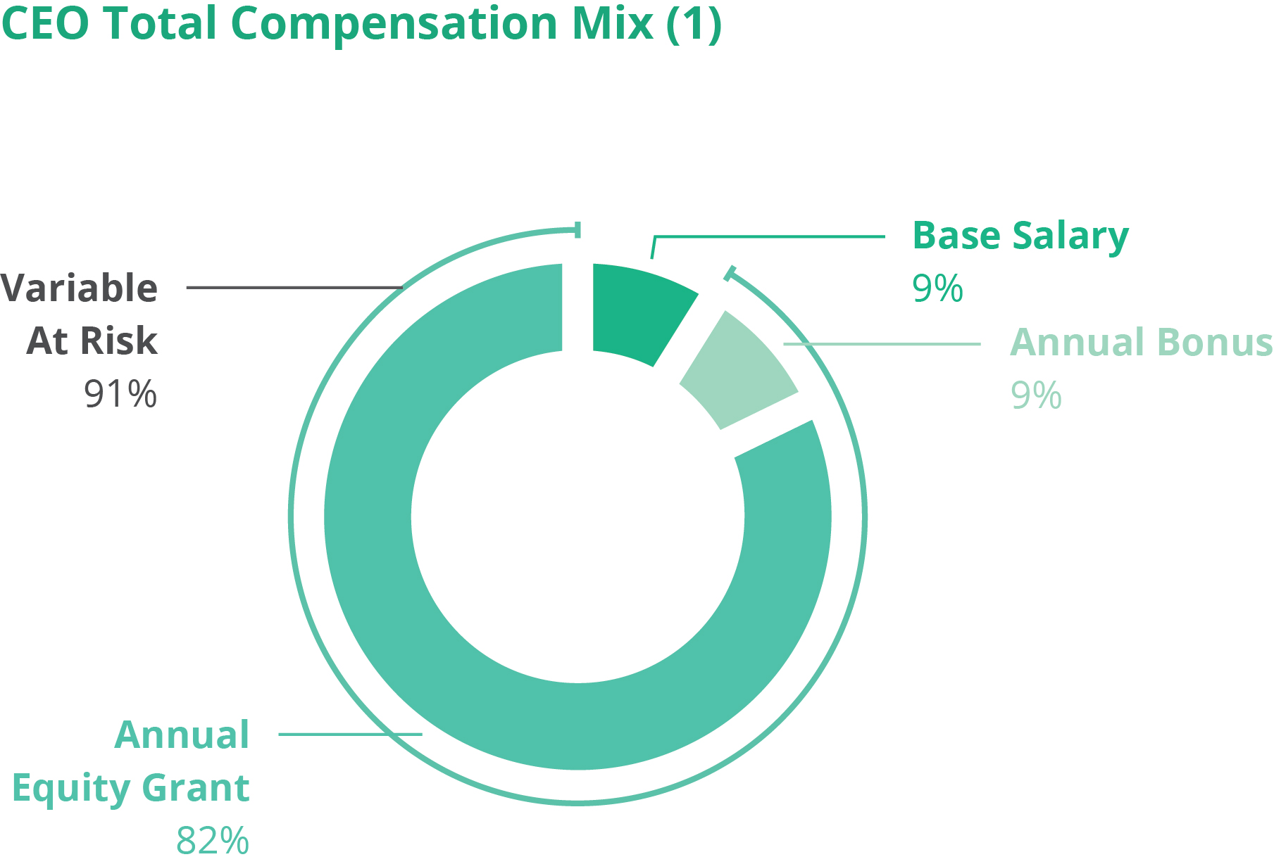 |  | 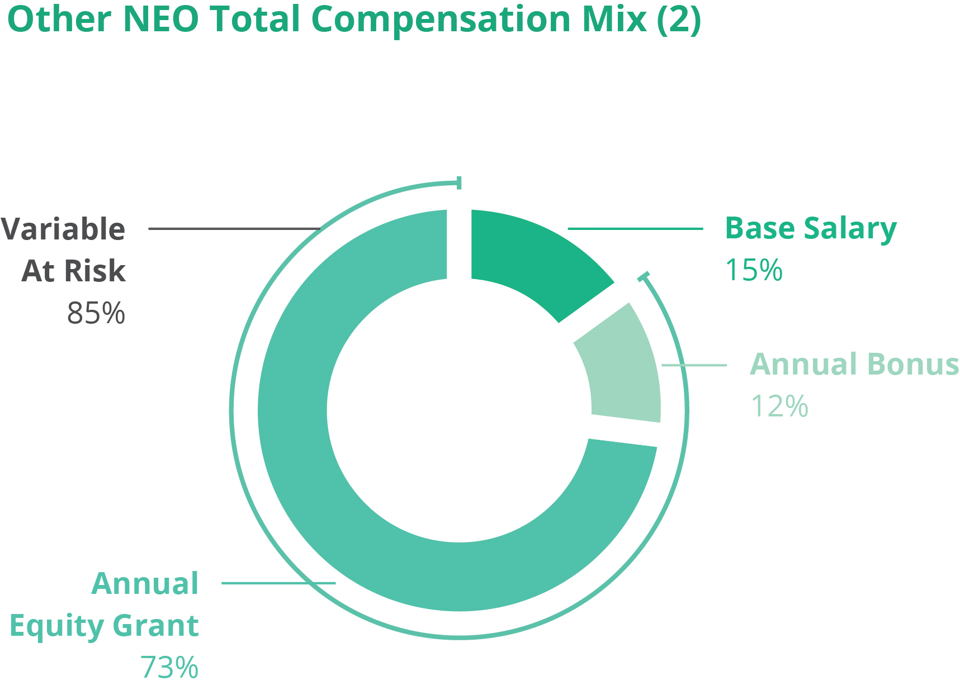

(1)
CEO Total Compensation consists of 2025 base salary, annual bonus paid, and the aggregate grant date fair value of the 2025 equity awards as disclosed in the Summary Compensation Table.
(2)
Other NEO Total Compensation reflects (i) the average of the amounts paid to Messrs. Noonan, Kalvert, Ambeskovic and Ms. Dalton consisting of 2025 base salary, annual bonus paid, and the aggregate grant date fair value of the 2025 annual equity awards, all as disclosed in the Summary Compensation Table.
One of the primary objectives of our compensation philosophy is to design pay opportunities that align with our performance and long-term value creation for our stockholders. The significant weighting of long-term incentive compensation aims to ensure that our NEOs’ primary focus is sustained long-term performance, while our short-term incentive compensation motivates consistent annual performance.
Following recommendations from management or based on other considerations, the Compensation Committee may also adjust compensation for specific individuals at other times during the year when there are significant changes in responsibilities or under other circumstances that the Compensation Committee considers appropriate.
Base Salary
Base salary represents the fixed portion of an NEO’s total compensation and is intended to provide compensation for expected day-to-day performance. An NEO’s base salary is initially determined upon hire or promotion based on a number of factors including, but not limited to, his or her responsibilities, prior experience, and salary levels of other executives within Tripadvisor. Providing a competitive base salary to our executives is essential to achieving our objectives of attracting and retaining talent. Base salary is typically reviewed annually, at which time management makes recommendations to the Compensation Committee based on consideration of a variety of factors including, but not limited to, the following:
•
each NEO’s total compensation relative to other executives in similarly situated positions;
32

•
his or her performance relative to previously established performance goals;
•
competitive compensation market data, when available;
•
his or her responsibilities, prior experience and individual compensation history;
•
general economic conditions; and
•
the recommendations of the President and Chief Executive Officer (other than with respect to his own compensation).
After careful consideration of the factors discussed above with respect to each of the NEOs, the Compensation Committee approved base salary changes for our NEOs for 2025. The table below sets forth, for each NEO, the 2024 base salary, the base salary increase and the 2025 base salary.

Name |  | 2024(1) |  | Base Salary  Increase /Decrease |  | 2025(2) |  | Percentage Change from 2024 to 2025
Matt Goldberg |  | $900,000 |  | $— |  | $900,000 |  | 0.00%
Michael Noonan |  | $545,000 |  | $15,000 |  | $560,000 |  | 2.75%
Seth J. Kalvert |  | $535,000 |  | $15,000 |  | $550,000 |  | 2.80%
Kristen Dalton |  | $500,000 |  | $10,000 |  | $510,000 |  | 2.00%
Almir Ambeskovic(3) |  | $477,060 |  | $14,684 |  | $491,744 |  | 3.07%

(1)
Reflects base salary of the NEOs as of December 31, 2024.
(2)
Reflects base salary of the NEOs as of December 31, 2025.
(3)
Mr. Ambeskovic's compensation is paid in Euros but reflected here in Dollars. To facilitate comparability of base salary across periods, a consistent foreign exchange rate of 1.17330 was applied for both 2024 and 2025.
Annual Bonus
Unless otherwise provided by the provisions of his or her employment agreement, the target annual bonus opportunities for our NEOs are generally established by the Compensation Committee, based on competitive market data and recommendations by the President and Chief Executive Officer, other than in connection with his own compensation. Annual bonuses are awarded to recognize and reward each NEO based on achievement of the Company’s annual operating plan as well as achievement of any strategic or business goals set for such NEO and such NEO’s specific contributions to the Company’s performance. The amount awarded each year is based on (i) with respect to 75%, the extent to which certain pre-established financial performance targets are achieved during the year; and (ii) with respect to the remaining 25%, the extent to which individual performance goals are achieved during the year. The annual bonus is “variable compensation” because the Company must achieve certain performance goals and/or the NEO must achieve individual performance goals aligned with strategic and business goals in order for the NEOs to receive an annual incentive bonus, with the amount of bonus based on the extent to which the targets and goals are achieved. The annual bonus is designed to motivate our NEOs to improve Company and individual performance. The annual bonus program aligns a portion of executive compensation with key financial targets and, as a result, provides a valuable link between compensation and stockholder value creation.
The financial performance goals for Messrs. Goldberg, Noonan and Kalvert consist of Company revenue (50%) and adjusted EBITDA (50%) for the consolidated group of companies. The financial performance goals for Mr. Ambeskovic and Ms. Dalton also consist of revenue (50%) and adjusted EBITDA (50%) financial performance targets but are primarily focused on the financial performance of the business unit each of them led in 2025 (TheFork and brand Tripadvisor, respectively) with a smaller percentage of the financial performance based on performance for the consolidated group of companies. For each financial performance metric and goal, there is a minimum, or threshold, level of performance required for bonus with respect to such metric, a target for 100% payout with respect to such metrics and a maximum level for the maximum payout with respect to such metric. The annual bonus was designed with such threshold, target and maximum goals in order to create more financial incentive for management to achieve a performance range of target or higher.
33

In March 2026, the Compensation Committee approved payouts for bonuses with respect to Fiscal 2025 for each of our NEOs after taking into account a variety of factors including, but not limited to, the following:
•
Performance for the consolidated group and each of the business units relative to targets previously established;
•
Performance against the strategic initiatives described above and the executive officers’ contributions and efforts with respect to such initiatives;
•
Each NEO’s individual performance; and
•
The recommendations of the Chief Executive Officer and President (other than in connection with his own compensation).
The table below sets forth, for each NEO, the target bonus for Fiscal 2025, the actual bonus paid and percentage of bonus paid relative to the annual bonus target for each NEO.

Name |  | Target  Bonus as %  of Base Salary |  | Target  Bonus |  | Bonus  Award |  | Percentage  of Award  to Target
Matt Goldberg |  | 100% |  | $900,000 |  | $840,960 |  | 93.4%
Michael Noonan |  | 80% |  | $448,000 |  | $418,611 |  | 93.4%
Seth J. Kalvert |  | 80% |  | $440,000 |  | $411,136 |  | 93.4%
Kristen Dalton |  | 90% |  | $459,000 |  | $342,666 |  | 74.7%
Almir Ambeskovic |  | 70% |  | $344,221 |  | $411,666 |  | 119.6%

Equity Awards
The Compensation Committee uses equity awards to align executive compensation with our long-term performance. Equity awards link compensation to financial performance because their value depends on Tripadvisor’s performance and/or share price. Equity awards are also an important retention tool because they vest over a multi-year period, subject to continued service by the award recipient. Equity awards are typically granted to our NEOs upon hire or promotion and annually thereafter. Management generally recommends annual equity awards in the first quarter of each year when the Compensation Committee meets to make determinations regarding annual bonuses for the last completed fiscal year and to set compensation and financial targets for the current fiscal year.
The practice of the Compensation Committee is to generally grant equity awards to our NEOs only in open trading windows, although awards may occasionally be granted off-cycle, including awards for new hires. It is the policy of the Board and the Compensation Committee to not take material nonpublic information into account when determining the timing and terms of equity awards or to time the release of material nonpublic information for the purpose of affecting the value of executive compensation. We did not grant any stock options, stock appreciation rights or similar option-like instruments to our NEOs in 2025.
Under the Tripadvisor, Inc. 2023 Stock and Annual Incentive Plan (the "2023 Plan"), the Compensation Committee may grant a variety of long-term incentive vehicles. The following is a general description of the vehicles we used in 2025:
Service-Based Restricted Stock Units ("RSUs"). RSUs are a promise to issue shares of our common stock in the future provided that the NEO remains employed with us through the award’s vesting period. RSUs provide the opportunity for capital accumulation and long-term incentive value and are intended to assist in satisfying our retention objectives. As a result, RSUs typically vest over a four-year requisite service period. For our NEOs, in Fiscal 2025, the grant date fair value of RSUs represented 50% of the grant date fair value of all equity awards, with PSUs representing the remaining 50%.
Performance-Based Restricted Stock Units (“PSUs”). PSUs are also a promise to issue shares of common stock in the future provided that the NEO remains employed with us through the awards vesting period and certain pre-determined financial performance metrics are achieved. The number of shares earned, if any, depends on the extent to which financial performance metrics established by the Compensation Committee are met, relative to the targets established by the Compensation Committee. For our NEOs, in Fiscal 2025, the grant date fair value of these PSUs represented 50% of the grant date fair value of all equity awards, with RSUs representing the remaining 50%.
34

The PSUs are subject to specific financial performance metrics and established threshold, target and maximum performance targets for a two-year performance period. The PSUs are subject to a two-year performance period, following which 50% will vest at the end of the performance period and the remaining 50% will vest one year later. Based on the Company's results for the two-year period ended December 31, 2025, the PSUs awarded in 2024 vested at 38.6% of the original grant.
The Compensation Committee reviews various factors considered by management when they establish Tripadvisor’s equity award grant pool including, but not limited to, the following:
•
Tripadvisor’s business and financial performance, including year-over-year performance;
•
dilution rates, taking into account projected headcount growth and employee turnover;
•
equity compensation utilization by peer companies;
•
general economic conditions; and
•
competitive compensation market data regarding award values.
For specific awards to our NEOs, the Compensation Committee considers a variety of factors including, but not limited to, the following:
•
Tripadvisor’s business and financial performance, including year-over-year performance;
•
individual performance and future potential of the executive;
•
the overall size of the equity award pool;
•
award value relative to other Tripadvisor employees;
•
the value of previous awards and amount of outstanding unvested equity awards;
•
competitive compensation market data, to the degree that the available data is comparable; and
•
the recommendations of the President and Chief Executive Officer, other than in connection with his own compensation.

After review and consideration of the recommendations of management and the President and Chief Executive Officer, other than with respect to awards for himself, the Compensation Committee decides whether to grant equity awards to our NEOs. After consideration of the factors discussed above, in February 2025, the Compensation Committee granted the equity awards set forth in the table below to Messrs. Goldberg, Noonan, Kalvert, and Ambeskovic and Ms. Dalton in connection with our annual equity award program.

Name |  | Grant Date Fair  Value |  | Number of  RSUs |  | Number of  PSUs
Matt Goldberg |  | $8,199,994 |  | 274,983 |  | 274,983
Michael Noonan |  | $3,499,974 |  | 117,370 |  | 117,370
Seth J. Kalvert |  | $2,499,990 |  | 83,836 |  | 83,836
Kristen Dalton |  | $1,999,998 |  | 67,069 |  | 67,069
Almir Ambeskovic |  | $2,249,978 |  | 75,452 |  | 75,452
The RSUs vest over four years, with 25% of such award vesting on the first anniversary of the grant date and 6.25% of the award vesting in equal quarterly installments commencing thereafter and for the remaining three years. The PSUs only vest if and to the extent the Company achieves pre-determined cumulative revenue and adjusted EBITDA financial metrics (each weighted 50%) over a two-year performance period. Based upon actual attainment relative to the financial metrics, employees may receive 0% to 200% of the target number of PSUs originally granted. Upon completion of the two-year performance period, a determination is made as to the actual number of PSUs awarded and such PSUs vest in two equal annual installments on each of December 31, 2026 and December 31, 2027.
35

Employee Benefits
In addition to the primary elements of compensation described above, our NEOs are also eligible to participate in employee benefits programs available to our employees generally, including the Tripadvisor Retirement Savings Plan, a tax-qualified 401(k) plan on the same basis as other employees. Under this plan, Tripadvisor matches 50% of each dollar contributed by a participant, up to the first 6% of eligible compensation, subject to tax limits.
In addition, we provide other benefits to our NEOs generally on the same basis as those provided to other employees in the applicable jurisdictions. These benefits may include health (medical, dental, and vision), disability, and group life insurance and/or supplemental coverage in those jurisdictions that offer such benefits. Tripadvisor also sponsors a Global Lifestyle Benefit program generally available to all employees, including our NEOs, which provides for taxable reimbursement of up to $1,750 per year, depending on years of service, for qualifying services and products.
In situations where an NEO is required to relocate, Tripadvisor provides relocation benefits, including reimbursement of moving expenses, temporary housing and other relocation expenses as well as a tax gross-up payment on the relocation benefits. Mr. Goldberg received a housing benefit in 2025. This Company benefit is described further in the footnote to the Summary Compensation Table.
Compensation-Related Policies
Clawback Policy
In light of the SEC’s adoption of final clawback rules and the Nasdaq's adoption of final listing standards consistent with the SEC rules in June 2023, Tripadvisor adopted a formal Clawback Policy on November 1, 2023. The Clawback Policy applies to current and former executive officers, and other employees of the Company who may from time to time be deemed subject to this policy by a majority of the independent directors (as defined in the policy). The policy requires the recovery of incentive-based compensation, which is broadly defined to cover any form of compensation that is granted, earned or vested based wholly or in part upon the attainment of a financial reporting measure, received in the prior three years and after the effective date of the Clawback Policy in the event Tripadvisor is required to prepare an accounting restatement due to the material noncompliance of the Company with any financial reporting requirement under the securities laws.
Insider Trading and Hedging Policy
Tripadvisor has adopted an Insider Trading Policy covering our directors, officers, employees, contractors and consultants that is designed to ensure compliance with relevant SEC regulations, including insider trading rules. Tripadvisor’s Insider Trading Policy also prohibits directors, officers, employees, contractors and consultants from engaging in various types of transactions in which they may profit from short-term speculative swings in the value of Tripadvisor securities. These transactions include “short sales” (or selling borrowed securities which the sellers hopes can be purchased at a lower price in the future), “put” and “call” options (or publicly available rights to sell or buy securities within a certain period of time at a specified price or the like) and hedging transactions, such as collars and forward sale contracts. The policy also prohibits the pledge or use of Company securities as collateral in a margin account or collateral for a loan. Because our Insider Trading Policy and procedures are designed to address transactions by our directors, officers, employees, contractors and consultants, it does not apply to the Company. To the extent the Company engages in market transactions in our securities, it is the Company's intent to comply with applicable laws and regulations relating to insider trading. A copy of our insider trading policy was filed as Exhibit 19.1 to our Annual Report on Form 10-K for the fiscal year ended December 31, 2025.
Stock Ownership Guidelines
In October 2015, the Board of Directors adopted guidelines which require that our NEOs and members of our Board own shares of our common stock to further align their interests with those of our stockholders. These guidelines were reviewed in April 2022 and again in November 2023, after which revised guidelines were approved. Under the current guidelines our NEOs and directors are generally expected to directly hold securities having market or intrinsic value which is equal to or greater than a specified multiple of his or her base salary or cash retainer, as set forth below:
•
For our President and Chief Executive Officer, six times his annual base salary;
•
For all other NEOs, three times his or her annual base salary; and
•
For each non-employee director, three times his or her annual cash retainer.
36

For the purpose of these calculations, shares of common stock and the after-tax value of time-based restricted stock units are counted but shares underlying performance-based restricted stock units and unexercised stock options, whether vested or unvested, are not counted. Individuals subject to these guidelines are expected to achieve the relevant ownership threshold on or before the later of January 31, 2028 or five years after commencing service. As of March 31, 2026, all of our NEOs and members of our Board either met the applicable ownership threshold or were within the permitted time period to attain the required ownership.
The Board recognizes that exceptions to this policy may be necessary or appropriate in individual cases and may approve such exceptions from time to time as it deems appropriate in the interest of our stockholders.
These stock ownership guidelines were established after consideration of the Compensation Committees' review of market practices of other companies in the Company’s peer group with respect to stock ownership guidelines and in an effort to enhance risk mitigation and to more closely align the interests of the Company’s executive officers and Board members with those of the Company’s stockholders.
Code of Business Conduct and Ethics
In April 2026, our Board adopted an amended and restated Code of Business Conduct and Ethics applicable to all of our directors, officers, employees, consultants and independent contractors. A copy of the Code of Business Conduct and Ethics is posted on our website at http://ir.Tripadvisor.com/corporate-governance.
Role of Competitive Compensation Market Data
The Compensation Committee and management consider multiple data sources when reviewing compensation information to ensure that the data reflects compensation practices of relevant companies in terms of size, industry and business complexity. Among other factors, the Compensation Committee considers the following information regarding compensation for our NEOs:
•
Data from compensation surveys that include companies of a similar size and industry; and
•
Data regarding compensation for certain executive officer positions from recent proxy statements and other SEC filings of peer companies.
The Compensation Committee annually retains our compensation consultant to review the compensation peer group and to recommend possible changes. Our business model is specialized in that we use our innovative technology systems and software to attract users and then facilitate transactions between our business partners and those users. Accordingly, our compensation consultant identified comparable companies focusing on publicly traded companies in the business to consumer and software industries as well as revenue and market capitalization.
The compensation consultant reviewed the peer group in 2024 to evaluate compensation for 2025 and suggested no changes to the existing peer group. At the time the peer group was approved, Tripadvisor was positioned near the median in terms of revenue, market capitalization and profitability. Based on the input from FW Cook, the Compensation Committee approved the peer group set forth below for purposes of informing 2025 target compensation levels for our NEOs.

Company Name
Akamai Technologies
Angi
Box
CarGurus
Cimpress plc
Etsy
Expedia Group
Groupon
HubSpot
IAC Inc. (fka IAC/InterActiveCorp)
Redfin
Sabre
Shutterstock
Stitch Fix
Yelp
Zillow Group

37

When available, management and the Compensation Committee consider competitive market compensation paid by peer group companies but do not attempt to maintain a certain target percentile within the compensation peer group or otherwise rely solely on such data when making recommendations to the Compensation Committees regarding compensation for our NEOs. Management and the Compensation Committee strive to incorporate flexibility into our executive compensation program and the assessment process to respond to and adjust for the evolving business environment and the value delivered by our NEOs.
Post-Employment Compensation
The Company has entered into employment arrangements with each of our NEOs. Pursuant to these agreements, Severance Plan and statutory requirements, each of our NEOs is eligible to receive certain severance payments and benefits in the event of a qualifying termination of employment. The material terms of these employment agreements are described below under the heading “Potential Payments Upon Termination or Change in Control” below. For further information regarding the severance payments and benefits received in connection with an NEO's resignation, please see “Potential Payments Upon Termination or Change in Control.”
We believe that a strong, experienced management team is essential and in the best interests of the Company and our stockholders. In addition, we recognize that the possibility of a change in control could arise and that such an event could result in the departure of our senior leaders to the detriment of the Company and our stockholders. As a result, in 2017 we adopted a severance plan applicable to certain senior leaders (the “Severance Plan”). The Severance Plan formalizes and standardizes our severance practices for certain of our senior leaders. Adoption of the Severance Plan was approved by the Compensation Committees. The Severance Plan applies to all NEOs as well as certain other senior leaders. While the benefits are generally consistent with the severance benefits provided for in individual employment agreements, there are some differences. In 2025, following a review by the Compensation Committee, in consultation with its independent compensation consultant, we amended and restated the Severance Plan to provide greater consistency among the severance provisions applicable to our NEOs and to better align those provisions with market practice for non-change in control terminations. Under the terms of the Severance Plan, in the event of any conflict or inconsistency between the terms of any employment agreement and the Severance Plan, the terms more beneficial to the executive shall prevail. To the extent any non-U.S. law requires the Company to provide benefits of any kind to an employee or imposes terms more favorable than the terms of the Severance Plan in connection with the employee's involuntary termination or similar event, the participant shall be entitled to the better of such mandatory benefits or terms and the benefits provided under the Severance Plan, without duplication. For a description and quantification of change in control payments and benefits for our NEOs, please see the section below entitled “Potential Payments Upon Termination or Change in Control.”
The 2023 Plan provides only for “double trigger” acceleration (i.e., acceleration upon termination by the Company other than for Cause or disability or resignation for Good Reason, in each case within three months prior to and 12 months following a Change in Control). The 2023 Plan also provides for acceleration of all equity awards upon the death of a participant. Please see “Estimated Potential Incremental Payments” below for further information regarding the treatment of equity awards held by our NEOs upon certain circumstances.
Tax Considerations
Section 162(m) of the Code generally precludes a tax deduction by any publicly-held company for compensation paid to the top executive officers in excess of $1 million. With respect to taxable years before January 1, 2018, compensation in excess of $1 million was exempt from this deduction limit if it qualified as “performance-based compensation” within the meaning of Section 162(m). Effective for taxable years beginning after December 31, 2017, the Tax Cuts and Jobs Act of 2017 (i) expanded the scope of Section 162(m) such that all NEOs are “covered employees” and anyone who was an NEO in any year after 2016 will remain a covered employee for as long as such individual (or his or her beneficiaries) receives compensation from us and (ii) eliminated the exception to the deduction limit for commission-based compensation and performance-based compensation except with respect to certain grandfathered arrangements in effect as of November 2, 2017 that are not subsequently materially modified. Accordingly, compensation paid to our NEOs in excess of $1 million is generally not deductible.
The Board and the Compensation Committee believe that stockholder interests are best served if they retain maximum flexibility to design executive compensation programs that meet stated business objectives. For that reason, while our Board and Compensation Committee consider the potential effects of Section 162(m) of the Code on the compensation paid to our NEOs, in light of the constraints imposed by Section 162(m) and our desire to maintain flexibility in compensation decisions, the Board and the Compensation Committee do not necessarily limit compensation to amounts deductible under Section 162(m).
Compensation Committee Interlocks and Insider Participation
From January 1, 2025 and through the Company's 2025 Annual Meeting, the Compensation Committee consisted of Mr. Maffei and Ms. Morgan. Mr. Jay Hoag also served on the Compensation Committee until his retirement from the Board at the 2025 Annual
38

Meeting. Following the 2025 Annual Meeting and through the end of Fiscal 2025, the Compensation Committee consisted of Mr. Maffei and Mses. Morgan and Shineman Blake.
During 2025, the Board also maintained a Section 16 Committee, which consisted of Mr. Hoag and Ms. Morgan until June 18, 2025, and thereafter consisted of Mses. Morgan and Shineman Blake. None of Messrs. Maffei or Hoag or Mses. Morgan or Shineman Blake was an employee of Tripadvisor during the one-year period ended December 31, 2025 and none of them has ever served as an officer of Tripadvisor.
During the 2025 fiscal year, none of our executive officers served as: (i) a member of the compensation committee (or other committee of the board of directors performing equivalent functions or, in the absence of any such committee, the entire board of directors) of another entity, one of whose executive officers served on our Compensation Committee; (ii) a director of another entity, one of whose executive officers served on our Compensation Committee; or (iii) a member of the compensation committee (or other committee of the board of directors performing equivalent functions or, in the absence of any such committee, the entire board of directors) of another entity, one of whose executive officers served on our Board.
Compensation Committee Report
This report is provided by the Compensation Committee of the Board. The Compensation Committee has reviewed the Compensation Discussion and Analysis and discussed that analysis with management. Based on this review and discussions with management, the Compensation Committee recommended to the Board that the Compensation Discussion and Analysis be included in Tripadvisor’s 2026 Proxy Statement.
No portion of this Compensation Committee Report shall be deemed to be incorporated by reference into any filing under the Securities Act or the Exchange Act, through any general statement incorporating by reference in its entirety the Proxy Statement in which this report appears, except to the extent that Tripadvisor specifically incorporates this report or a portion of it by reference. In addition, this report shall not be deemed to be “soliciting material” or “filed” under either the Securities Act or the Exchange Act.

Members of the Compensation Committee: | Betsy L. Morgan (Chair)  Dhiren Fonseca  Greg Maffei  Trynka Shineman Blake
39

CEO PAY RATIO
Overview
SEC rules require annual disclosure of the ratio of the annual total compensation of a company’s principal executive officer to such company’s median employee’s total annual compensation, excluding the principal executive officer for purposes of this calculation. The purpose of this disclosure is to provide a measure of the equitability of pay within the organization.
The 2025 annual total compensation of our median employee, excluding Mr. Goldberg, our President and CEO, calculated in accordance with the Summary Compensation Table requirements was $105,574.
The 2025 annual total compensation of our President and CEO was $10,086,426.
The ratio of the annual total compensation of our President and CEO to that of our median employee was approximately 96 to 1. We believe this pay ratio is a reasonable estimate calculated in a manner consistent with SEC rules. Please note the following information to provide important context related to our employee population and to describe the methodology and the material assumptions, adjustments, and estimates that we used to calculate this ratio.
•
Tripadvisor is a global company, with complex operations worldwide and many of our employees are located outside of the United States. As of December 31, 2025, our workforce consisted of approximately 2,590 full-time and part-time employees, including hourly employees. Approximately 28% of the Company’s employees are located in the United States, with the remaining employees located in Europe and throughout the rest of the world. We selected December 31, 2025 as the date upon which we would identify the “median employee” because it enabled us to make such identification in a reasonably efficient and economical manner.
•
We included all full-time, part-time, and fixed-term contractor employees globally, excluding our President and CEO. We annualized compensation of 438 full-time and part-time employees who were hired in 2025 but did not work for the Company for the entire fiscal year. Earnings of our employees outside the U.S. were converted to U.S. dollars using the currency exchange rates used for organizational planning purposes, which consider historic and forecasted rates as well as other factors. We did not make any cost of living adjustments.
•
Our compensation measure, which is consistently applied and used to identify our median employee, was annualized base salary, short-term bonus at target and annual long-term equity incentive at target.
•
We identified employees within $650 of the median 2025 annual total compensation and excluded those employees who had anomalous compensation characteristics.
Because the SEC rules for identifying the median employee and calculating the pay ratio based on that employee’s annual total compensation allow companies to adopt a variety of methodologies, to apply certain exclusions, and to make reasonable estimates and assumptions that reflect their employee populations and compensation practices, the pay ratio reported by other companies may not be comparable to our pay ratio, as other companies have offices in different countries, employee populations and compensation practices and may utilize different methodologies, exclusions, estimates and assumptions in calculating their pay ratios.
40

PAY VERSUS PERFORMANCE
As required by Section 953(a) of the Dodd-Frank Wall Street Reform and Consumer Protection Act (“Dodd-Frank”) and Item 402(v) of Regulation S-K, the table below sets forth information about the relationship between compensation actually paid (“CAP”) to the our principal executive officer ("PEO") and non-PEO NEOs and certain financial performance measures of the Company and how the Company aligns executive compensation with the Company's performance. Included in our historical analysis is the compensation for former NEOs Mr. Teunissen and Mss. Soni and Nelson, who are no longer with the Company. For further information concerning the Company’s variable pay-for-performance philosophy and how the Company aligns executive compensation with Company performance, refer to the “Compensation Discussion and Analysis” section of this proxy statement.

Value of Initial Fixed $100
Investment Based On:
Year (1) |  | Summary  Compensation  Table Total  for Mr. Goldberg  PEO ($) (2) |  | Compensation  Actually Paid  to Mr. Goldberg  PEO ($) (3) |  | Summary  Compensation  Table Total  for Mr. Kaufer  PEO ($) (2) |  | Compensation  Actually Paid  to Mr. Kaufer  PEO ($) (3) |  | Average  Summary  Compensation  Table Total  for Non-PEO  NEOs ($) (2) |  | Average  Compensation  Actually Paid  to Non-PEO  NEOs ($) (3) |  | Total  Shareholder  Return ($) (4) |  | Peer Group  Total  Shareholder  Return ($) (5) |  | Net  Income (Loss) ($) (in millions) |  | Adjusted EBITDA ($) (in millions) (6)
(a) |  | (b) |  | (c) |  | (b) |  | (c) |  | (d) |  | (e) |  | (f) |  | (g) |  | (h) |  | (i)
2025 |  | 10,086,426 |  | 8,827,341 |  | — |  | — |  | 3,522,684 |  | 3,253,272 |  | 50.59 |  | 138.27 |  | 40 |  | 319
2024 |  | 10,034,887 |  | 1,627,911 |  | — |  | — |  | 3,804,067 |  | 968,040 |  | 51.32 |  | 115.41 |  | 5 |  | 339
2023 |  | 1,942,733 |  | 1,405,194 |  | — |  | — |  | 2,222,758 |  | 1,936,385 |  | 74.81 |  | 86.60 |  | 10 |  | 334
2022 |  | 14,496,745 |  | 13,353,650 |  | 497,535 |  | (5,949,665) |  | 3,009,827 |  | 749,754 |  | 62.47 |  | 59.35 |  | 20 |  | 295
2021 |  | — |  | — |  | 7,676,612 |  | 8,686,111 |  | 3,161,228 |  | 2,326,196 |  | 94.72 |  | 97.88 |  | (148) |  | 100
(1)
Mr. Goldberg became the PEO on July 1, 2022. Mr. Kaufer served as PEO for a portion of Fiscal 2022 and the entirety of Fiscal 2021 and 2020. Our Non-PEO NEOs for the applicable years were as follows: (i) for Fiscal 2025: Messrs. Noonan, Kalvert, Ambeskovic and Ms. Dalton; (ii) for Fiscal 2024: Messrs. Noonan and Kalvert; (iii) for Fiscal 2023: Messrs. Noonan, Kalvert and Teunissen and Ms. Soni; (iv) for Fiscal 2022: Messrs. Noonan, Kalvert and Teunissen and Mss. Soni and Nelson; (v) for Fiscal 2021: Messrs. Kalvert and Teunissen and Mss. Soni and Nelson.
(2)
Amounts reported in these columns represent: (i) the total compensation reported in the Summary Compensation Table for the applicable fiscal year in the case of our PEOs; and (ii) the average of the total compensation reported in the Summary Compensation Table for the applicable fiscal year for our Non-PEO NEOs.
(3)
Amounts reported in these columns represent CAP; adjustments were made to the amounts reported in the Summary Compensation Table for the applicable fiscal year. A reconciliation of the adjustments for our PEOs and the average of the Non-PEO NEOs is set forth in the tables below, which describe the adjustments, each of which is prescribed by the SEC rules, to calculate the CAP amounts from the amounts described in the Summary Compensation Table.
(4)
Total Shareholder Return ("TSR") is cumulative for the measurement periods ending December 31, 2025, 2024, 2023, 2022 and 2021.
(5)
The Company's Peer Group represents the Research Data Group ("RDG") Internet Composite Index, which is a published industry index used by the Company for purposes of compliance with Item 201(e) of Regulation S-K.
(6)
Adjusted EBITDA, a non-GAAP financial measure, is the Company's selected measure. Refer to our 2025 Annual Report for a reconciliation of adjusted EBITDA to Net Income, the most directly comparable financial measure calculated and presented in accordance with US GAAP.

 |  | Mr. Goldberg |  |  |  |  | Mr. Kaufer
Compensation Actually Paid to PEO |  | 2025 ($) | 2024 ($) | 2023 ($) | 2022 ($) |  | 2022 ($) |  | 2021 ($)
Summary Compensation Table Total |  | 10,086,426 | 10,034,887 | 1,942,733 | 14,496,745 |  | 497,535 |  | 7,676,612
Deductions for Grant Date Fair Value of Stock Awards and Option Awards reported in Summary Compensation Table |  | (8,199,994) | (8,085,804) | — | (13,025,860) |  | — |  | (6,402,979)
Addition of Year-End Fair Value Awards Granted in the Applicable Fiscal Year that are Outstanding and Unvested |  | 7,118,672 | 3,375,095 | — | 11,882,765 |  | — |  | 6,080,847
Additions (Deductions) for Change in Fair Value of Awards Granted in Prior Fiscal Years' That Vested in the Applicable Fiscal Year |  | 73,899 | (138,605) | (410,526) | — |  | (3,760,236) |  | 4,048,455
Deduction of Fair Value of Prior Fiscal Years' Awards Forfeited During the Fiscal Year |  | (8,164) | — | — | — |  | (871,802) |  | (1,720,411)
Additions (Deductions) for Change in Fair Value of Prior Fiscal Years' Awards Unvested at Fiscal Year End |  | (243,498) | (3,557,662) | (127,013) | — |  | (1,815,162) |  | (996,413)
Compensation Actually Paid to PEO |  | 8,827,341 | 1,627,911 | 1,405,194 | 13,353,650 |  | (5,949,665) |  | 8,686,111

41

Average Compensation Actually Paid to Non-PEO NEOs |  | 2025 ($) | 2024 ($) | 2023 ($) | 2022 ($) |  | 2021 ($)
Summary Compensation Table Total |  | 3,522,684 | 3,804,067 | 2,222,758 | 3,009,827 |  | 3,161,228
Deductions for Grant Date Fair Value of Stock Awards and Option Awards reported in Summary Compensation Table |  | (2,562,485) | (2,801,865) | (1,504,585) | (2,049,980) |  | (2,299,953)
Addition of Year-End Fair Value Awards Granted in the Applicable Fiscal Year that are Outstanding and Unvested |  | 2,224,574 | 1,070,653 | 1,265,320 | 966,987 |  | 1,182,594
Additions (Deductions) for Change in Fair Value of Awards Granted in Prior Fiscal Years' That Vested in the Applicable Fiscal Year |  | 121,595 | (67,560) | 49,618 | 103,337 |  | 749,321
Deduction of Fair Value of Prior Fiscal Years' Awards Forfeited During the Fiscal Year |  | (7,390) | — | (140,175) | (106,930) |  | (14,848)
Additions (Deductions) for Change in Fair Value of Prior Fiscal Years' Awards Unvested at Fiscal Year End |  | (45,706) | (1,037,255) | 43,449 | (1,173,486) |  | (452,146)
Average Compensation Actually Paid to Non-PEO NEOs |  | 3,253,272 | 968,040 | 1,936,385 | 749,754 |  | 2,326,196

Performance Measures Used to Link Company Performance and Compensation Actually Paid
The following is a list of our most important performance measures used by us to link CAP to our NEOs to Company performance for Fiscal 2025. Each metric below is used for purposes of determining payouts under either our annual incentive program or vesting of our PSUs. The performance measures included in this table are not ranked by relative importance.
Adjusted EBITDA
Revenue
Stock Price
Please see the section "Compensation Discussion and Analysis" for a further description of these metrics and how they are used in the Company's executive compensation program.
Relationship Between Compensation Actually Paid and Financial Performance
As described in more detail in the section "Compensation Discussion and Analysis," the Company's executive compensation programs reflect a variable pay-for-performance philosophy. The Company generally seeks to incentivize long-term performance, and therefore does not specifically align the Company's performance measures with CAP (as computed in accordance with SEC rules) for a particular fiscal year. In accordance with the SEC rules, the Company is providing the following descriptions of the relationships between information presented in the pay versus performance table.
42

The chart below reflects the relationship between the PEO and average non-PEOs CAP and our Net Income for the fiscal years ended December 31, 2021, 2022, 2023, 2024 and 2025.
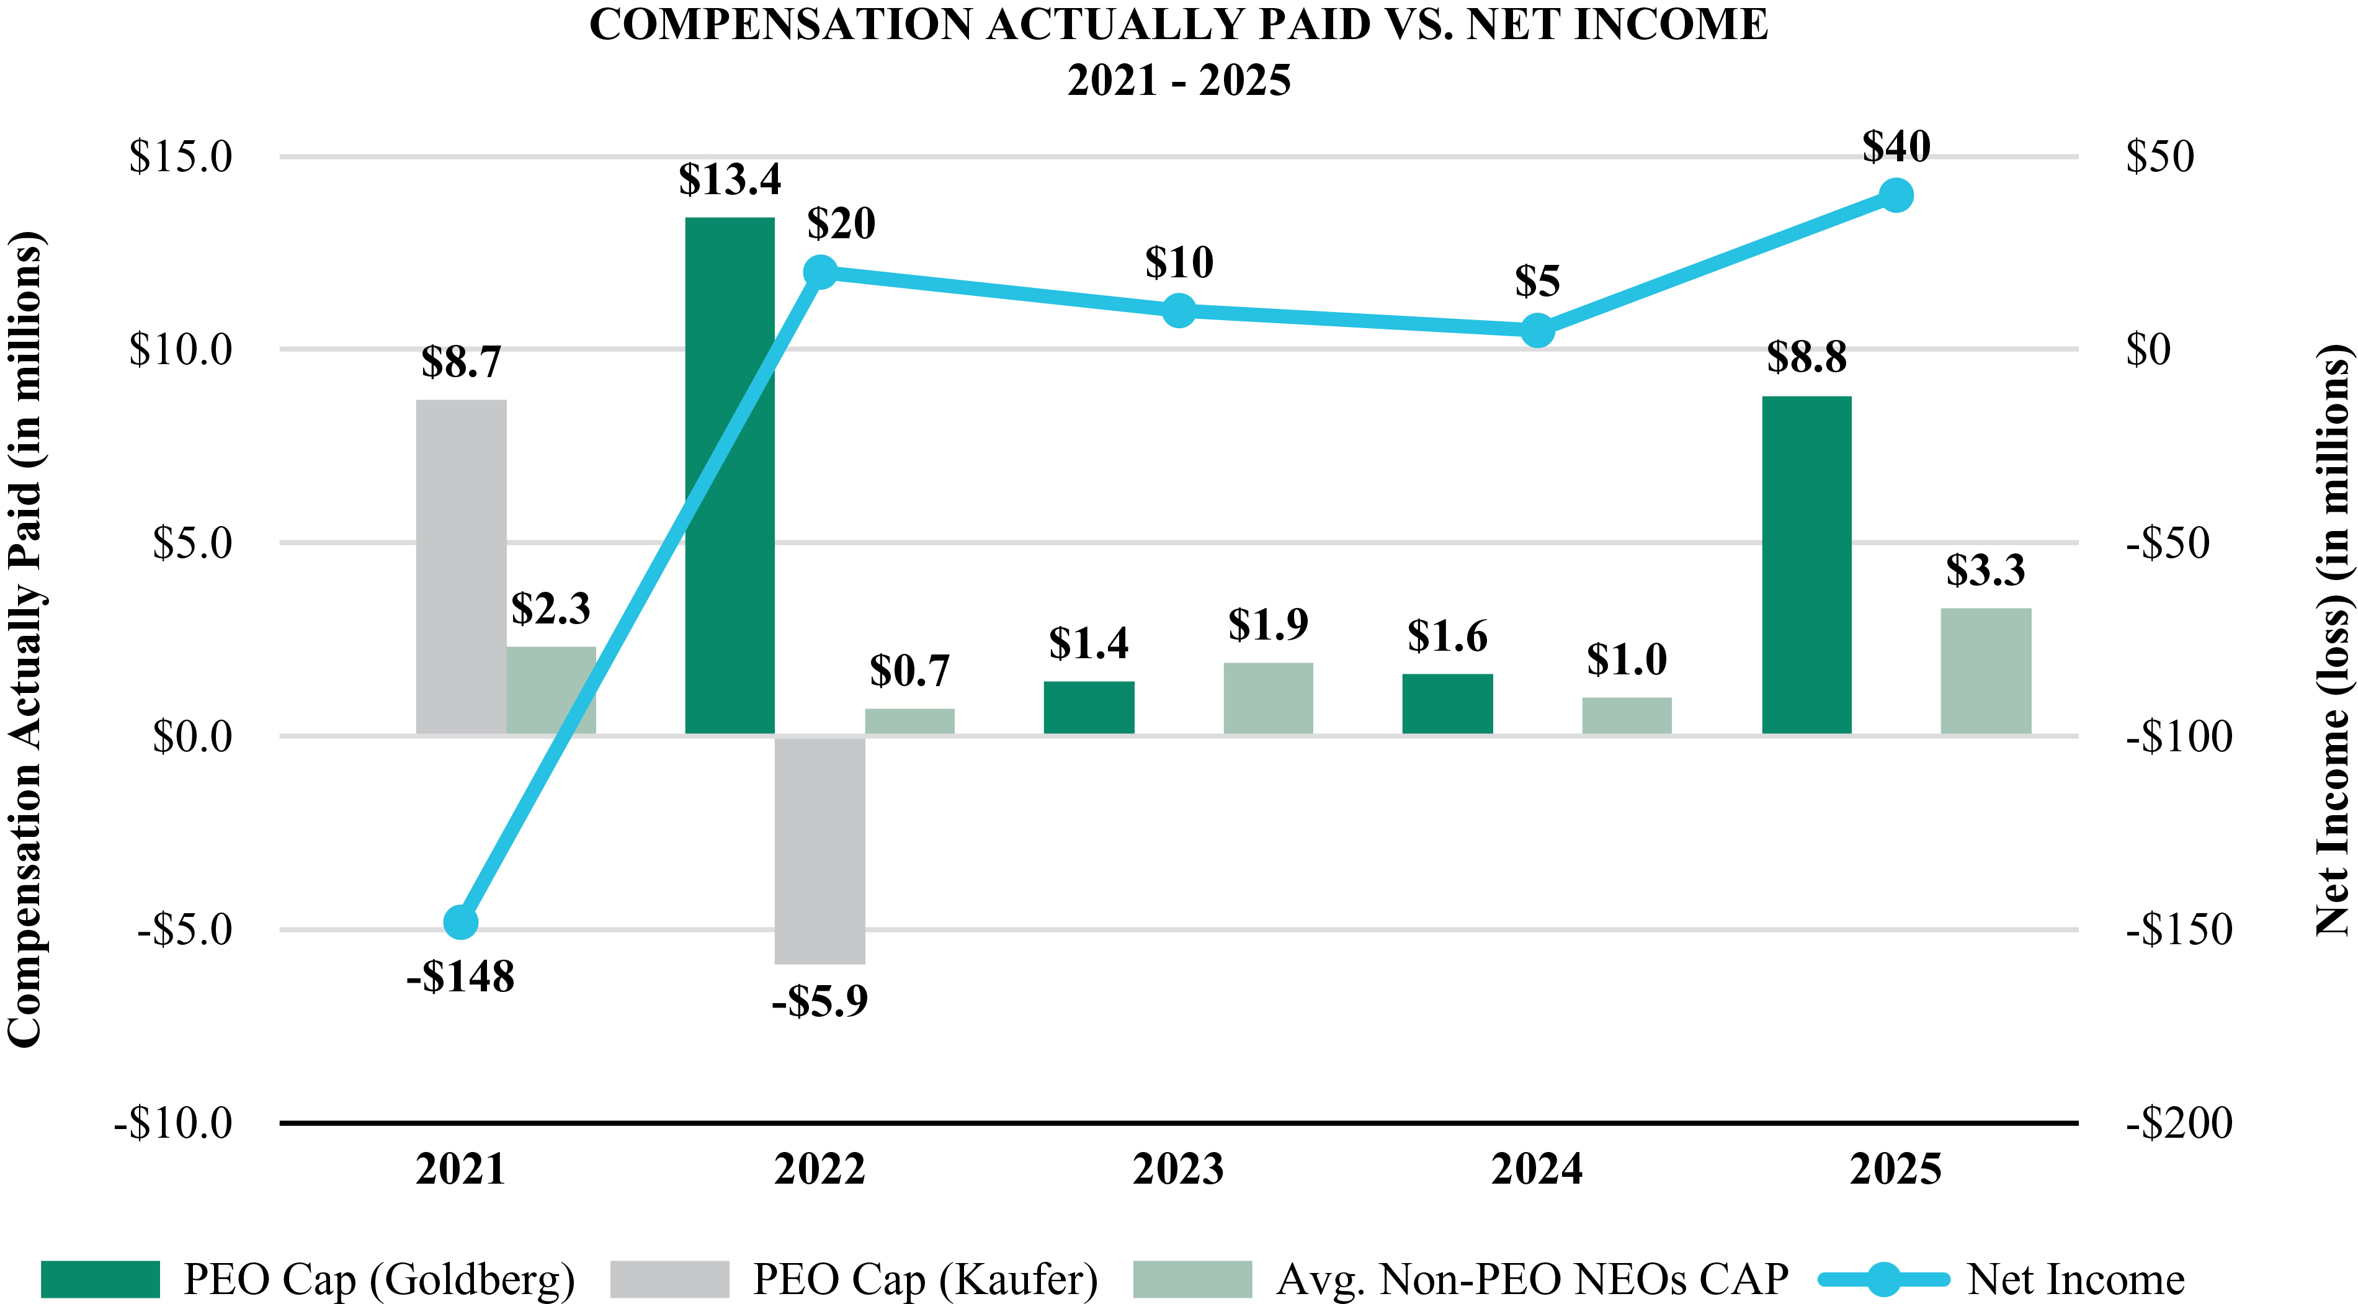

The chart below reflects the relationship between our TSR and our Peer Group TSR, as well as the relationship between CAP and our TSR for the PEO and non-PEOs for the fiscal years ended December 31, 2021, 2022, 2023, 2024 and 2025. TSR amounts reported in graphs assume an initial fixed investment of $100.00 on January 1, 2021, and that all dividends, if any, were reinvested.

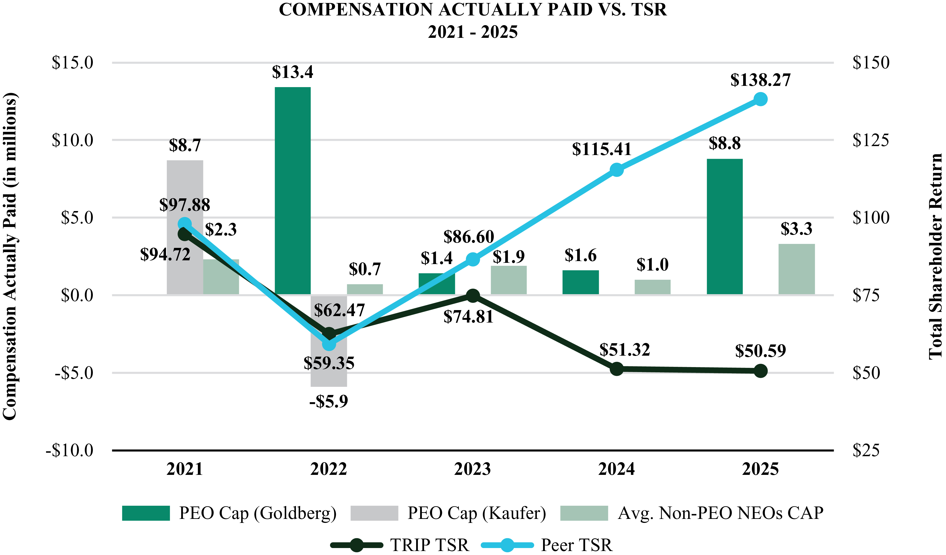

43

The chart below reflects the relationship between the PEO and average non-PEO NEOs and the Company's Adjusted EBITDA for the years ended December 31, 2021, 2022, 2023, 2024 and 2025.
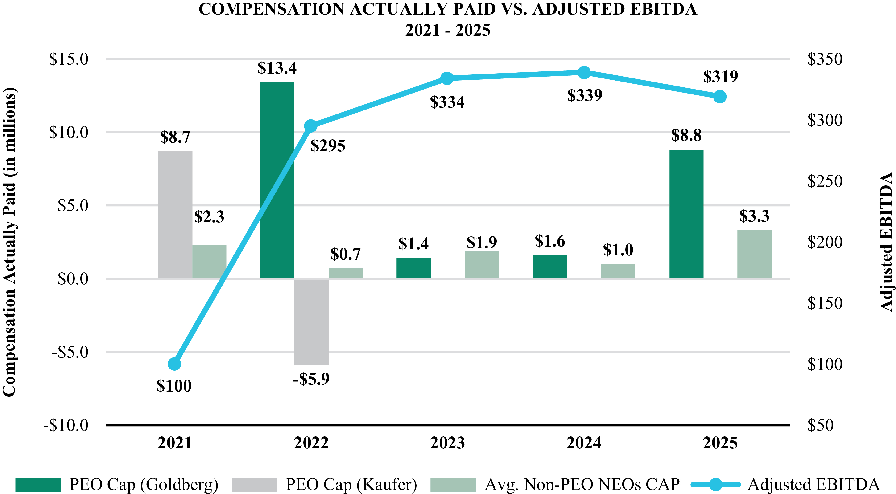
44

EXECUTIVE COMPENSATION
Summary Compensation
The NEOs referred to herein encompasses: (i) our principal executive officer, Mr. Goldberg; (ii) our principal financial officer, Mr. Noonan; and (iii) the only other executive officer (other than any individual who served as our principal executive officer or principal financial officer) who was serving in such capacity as of the last day of Fiscal 2025. Ms. Dalton and Mr. Ambeskovic were designated executive officers by the Board of Directors on April 29, 2025. The following table sets forth certain information regarding the compensation earned by, or paid to, each of our NEOs for services rendered in the fiscal years indicated.

Name and  Principal Position |  | Year |  | Salary  ($) |  | Bonus  ($)(1) |  | Stock  Awards  ($)(2) |  | Option  Awards  ($)(2) |  | Non-Equity  Incentive Plan  Compensation  ($)(3) |  | All Other  Compensation  ($)(4) |  | Total  ($)
Matt Goldberg |  | 2025 |  | 900,000 |  | — |  | 8,199,994 |  | — |  | 840,960 |  | 145,472 |  | 10,086,426
President and Chief Executive Officer |  | 2024 |  | 900,000 |  | — |  | 8,085,804 |  | — |  | 900,000 |  | 149,083 |  | 10,034,887
 |  | 2023 |  | 900,000 |  | — |  | — |  | — |  | 891,000 |  | 151,733 |  | 1,942,733
Michael Noonan |  | 2025 |  | 557,693 |  | — |  | 3,499,974 |  | — |  | 418,611 |  | 27,589 |  | 4,503,867
Chief Financial Officer |  | 2024 |  | 541,924 |  | — |  | 3,311,300 |  | — |  | 450,000 |  | 22,165 |  | 4,325,389
 |  | 2023 |  | 525,000 |  | 400,000 |  | 2,744,377 |  | — |  | 415,000 |  | 42,127 |  | 4,126,504
Seth J. Kalvert |  | 2025 |  | 547,692 |  | — |  | 2,499,990 |  | — |  | 411,136 |  | 18,750 |  | 3,477,568
Chief Legal Officer and Secretary |  | 2024 |  | 533,462 |  | — |  | 2,292,430 |  | — |  | 440,000 |  | 16,853 |  | 3,282,745
 |  | 2023 |  | 523,462 |  | — |  | 2,058,262 |  | — |  | 400,000 |  | 6,783 |  | 2,988,507
Kristen Dalton |  | 2025 |  | 508,462 |  | — |  | 1,999,998 |  | — |  | 342,666 |  | 10,500 |  | 2,861,626
Chief Strategy and Operations Officer |  | 2024 |  | — |  | — |  | — |  | — |  | — |  | — |  | —
 |  | 2023 |  | — |  | — |  | — |  | — |  | — |  | — |  | —
Almir Ambeskovic |  | 2025 |  | 489,646 |  | — |  | 2,249,978 |  | — |  | 411,666 |  | 96,384 |  | 3,247,674
President, TheFork |  | 2024 |  | — |  | — |  | — |  | — |  | — |  | — |  | —
 |  | 2023 |  | — |  | — |  | — |  | — |  | — |  | — |  | —

(1)
The amounts for annual bonus awards paid to the NEOs pursuant to the Company’s incentive plan are reflected in the “Non-Equity Incentive Plan Compensation” column. The amount reported for Mr. Noonan represents a one-time signing bonus paid pursuant to the terms of Mr. Noonan's employment agreement.
(2)
The amounts reported represent the aggregate grant date fair value of awards granted in the year indicated, calculated in accordance with Financial Accounting Standards Board (“FASB”) Accounting Standards Codification (“ASC”) Topic 718, disregarding estimated forfeitures related to service-based vesting. For PSUs, the amounts reported include the probable outcome of the performance conditions. The values of the performance-based awards granted to Messrs. Goldberg, Noonan, Kalvert, Ms. Dalton and Mr. Ambeskovic in 2025 assuming maximum achievement of the performance conditions is $8,199,994, $3,499,974, $2,499,990, $1,999,998 and 2,249,978, respectively. See “Grants of Plan-Based Awards” below for information regarding the individual awards and the determination of the grant date fair value of these awards.
(3)
For a description of the annual cash bonus program, please see “Annual Bonus” in the Compensation, Discussion and Analysis.
(4)
Refer to the “2025 All Other Compensation” table below for information regarding the 2025 amounts reported.
2025 All Other Compensation

Name | Housing  ($)(a) | Global  Lifestyle  Benefits  ($) | Matching  Charitable  Donation  ($) | Employer  Retirement  Contributions  ($)(b) | Other  ($)(c) | Total ($)
Matt Goldberg | 120,000 | 1,500 | 5,000 | 10,500 | 8,472 | 145,472
Michael Noonan | — | 970 | 2,500 | 10,500 | 13,619 | 27,589
Seth J. Kalvert | — | 3,250 | 5,000 | 10,500 | — | 18,750
Kristen Dalton | — | — | — | 10,500 | — | 10,500
Almir Ambeskovic | — | 473 | — | N/A | 95,911 | 96,384

(a)
Represents a housing allowance of $10,000 per month, payable pursuant to approval by the Compensation Committee.
(b)
Represents matching contributions under the Tripadvisor Retirement Savings Plan as in effect through December 31, 2025, pursuant to which Tripadvisor matches $0.50 for each dollar a participant contributes, up to the first 6% of eligible compensation, subject to certain limits.
(c)
Represents taxable commuting expenses for Messrs. Goldberg and Noonan and welfare reimbursement, and payout of unused Italian statutory leave (ROL) and festivities, a work from home stipend, and entitlement pursuant to Italian law for Mr. Ambeskovic.
45

Grants of Plan-Based Awards
The table below provides information regarding the plan-based awards granted in 2025 to our NEOs.

 |  |  | Estimated Future Payouts  Under Non-Equity Incentive  Plan Awards($)(1) |  |  |  |  |  | Estimated Future Payouts  Under Equity Incentive  Plan Awards(#) |  |  |  |  |  | All Other  Stock  Awards:  Number of  Shares of  Stock or |  | Grant Date  Fair Value of  Stock and  Option  Awards
Name | Grant Date |  | Threshold |  | Target |  | Maximum |  | Threshold |  | Target |  | Maximum |  | Units (#) |  | ($)(2)
Matt Goldberg
RSUs(3) | 2/26/2025 |  | — |  | — |  | — |  | — |  | — |  | — |  | 274,983 |  | 4,099,997
PSUs(3) | 2/26/2025 |  | — |  | — |  | — |  | 137,492 |  | 274,983 |  | 549,966 |  | — |  | 4,099,997
Annual Bonus | — |  | 450,000 |  | 900,000 |  | 1,800,000 |  | — |  | — |  | — |  | — |  | —
Michael Noonan
RSUs(3) | 2/26/2025 |  | — |  | — |  | — |  | — |  | — |  | — |  | 117,370 |  | 1,749,987
PSUs(3) | 2/26/2025 |  | — |  | — |  | — |  | 58,685 |  | 117,370 |  | 234,740 |  | — |  | 1,749,987
Annual Bonus | — |  | 224,000 |  | 448,000 |  | 896,000 |  | — |  | — |  | — |  | — |  | —
Seth J. Kalvert
RSUs(3) | 2/26/2025 |  | — |  | — |  | — |  | — |  | — |  | — |  | 83,836 |  | 1,249,995
PSUs(3) | 2/26/2025 |  | — |  | — |  | — |  | 41,918 |  | 83,836 |  | 167,672 |  | — |  | 1,249,995
Annual Bonus | — |  | 220,000 |  | 440,000 |  | 880,000 |  | — |  | — |  | — |  | — |  | —
Kristen Dalton
RSUs(3) | 2/26/2025 |  | — |  | — |  | — |  | — |  | — |  | — |  | 67,069 |  | 999,999
PSUs(3) | 2/26/2025 |  | — |  | — |  | — |  | 33,535 |  | 67,069 |  | 134,138 |  | — |  | 999,999
Annual Bonus | — |  | 229,500 |  | 459,000 |  | 918,000 |  | — |  | — |  | — |  | — |  | —
Almir Ambeskovic
RSUs(3) | 2/26/2025 |  | — |  | — |  | — |  | — |  | — |  | — |  | 75,452 |  | 1,124,989
PSUs(3) | 2/26/2025 |  | — |  | — |  | — |  | 37,726 |  | 75,452 |  | 150,904 |  | — |  | 1,124,989
Annual Bonus | — |  | 172,111 |  | 344,221 |  | 688,442 |  | — |  | — |  | — |  | — |  | —

(1)
The amounts reflect the potential range of payments under the Annual Bonus. The actual payments earned for 2025 are reflected in the Non-Equity Incentive Plan Compensation column of the Summary Compensation Table.
(2)
The amounts reported represent the aggregate grant date fair value computed in accordance with FASB ASC Topic 718, disregarding estimated forfeitures related to service-based vesting, and may not correspond to the actual value that will be realized by the executive. We have disclosed the assumptions made in the valuation of the awards in “Note 13—Stock Based Awards and Other Equity Instruments” in the notes to our consolidated financial statements in our 2025 Annual Report. For PSUs granted in 2025, the value reported reflects the grant-date fair value of the awards based on the probable outcome of the performance conditions.
(3)
For a description of the vesting terms of these awards, please see “Outstanding Equity Awards at Fiscal Year-End” below.
46

Outstanding Equity Awards at Fiscal Year-End
The following table provides information regarding the holdings of all equity awards held by our NEOs as of December 31, 2025.

 |  |  |  |  | Option Awards |  |  |  |  |  |  |  | Stock Awards
Name |  | Grant  Date |  |  | Number of  Securities  Underlying  Unexercised  Options  Exercisable (#) |  | Number of  Securities  Underlying  Unexercised  Options  Unexercisable (#) |  | Option  Exercise  Price  ($) |  | Option  Expiration  Date |  | Number of  Shares or  Units of  Stock That  Have Not  Vested (#) |  | Market  Value of  Shares or  Units of  Stock That  Have Not  Vested  ($)(8) |  | Equity  Incentive  Plan  Awards:  Number of  Unearned  Shares,  Units  or Other  Rights  That Have  Not  Vested (#) |  | Equity  Incentive Plan  Awards:  Market or  Payout  Value of  Unearned  Shares,  Units or  Other Rights  That Have  Not Vested  ($)(8)
Matt Goldberg |  | 7/1/2022 | (1) |  | 419,094 |  | 96,714 |  | 18.47 |  | 7/1/2032 |  | — |  | — |  | — |  | —
 |  | 7/1/2022 | (1) |  | — |  | — |  | — |  | — |  | 48,348 |  | 703,947 |  | — |  | —
 |  | 3/4/2024 | (2) |  | — |  | — |  | — |  | — |  | 74,917 |  | 1,090,792 |  | — |  | —
 |  | 3/4/2024 | (3) |  | — |  | — |  | — |  | — |  | — |  | — |  | 133,185 |  | 1,939,174
 |  | 8/16/2024 | (4) |  | — |  | — |  | — |  | — |  | 18,682 |  | 272,010 |  | — |  | —
 |  | 8/16/2024 | (3) |  | — |  | — |  | — |  | — |  | — |  | — |  | 27,173 |  | 395,639
 |  | 2/26/2025 | (2) |  | — |  | — |  | — |  | — |  | 274,983 |  | 4,003,752 |  | — |  | —
 |  | 2/26/2025 | (5) |  | — |  | — |  | — |  | — |  | — |  | — |  | 274,983 |  | 4,003,752
Michael Noonan |  | 10/31/2022 | (6) |  | 57,739 |  | 19,247 |  | 23.62 |  | 10/31/2032 |  | — |  | — |  | — |  | —
 |  | 10/31/2022 | (6) |  | — |  | — |  | — |  | — |  | 9,702 |  | 141,261 |  | — |  | —
 |  | 2/22/2023 | (2) |  | — |  | — |  | — |  | — |  | 21,078 |  | 306,896 |  | — |  | —
 |  | 3/4/2024 | (2) |  | — |  | — |  | — |  | — |  | 33,817 |  | 492,376 |  | — |  | —
 |  | 3/4/2024 | (3) |  | — |  | — |  | — |  | — |  | — |  | — |  | 60,118 |  | 875,318
 |  | 2/26/2025 | (2) |  | — |  | — |  | — |  | — |  | 117,370 |  | 1,708,907 |  | — |  | —
 |  | 2/26/2025 | (5) |  | — |  | — |  | — |  | — |  | — |  | — |  | 117,370 |  | 1,708,907
Seth J. Kalvert |  | 2/22/2016 |  |  | 34,950 |  | — |  | 59.61 |  | 2/22/2026 |  | — |  | — |  | — |  | —
 |  | 2/27/2017 |  |  | 43,776 |  | — |  | 39.31 |  | 2/27/2027 |  | — |  | — |  | — |  | —
 |  | 2/27/2017 |  |  | 79,324 |  | — |  | 39.31 |  | 2/27/2027 |  | — |  | — |  | — |  | —
 |  | 2/22/2018 |  |  | 26,910 |  | — |  | 38.15 |  | 2/22/2028 |  | — |  | — |  | — |  | —
 |  | 2/27/2019 |  |  | 21,281 |  | — |  | 50.63 |  | 2/27/2029 |  | — |  | — |  | — |  | —
 |  | 2/25/2020 |  |  | 44,378 |  | — |  | 25.62 |  | 2/25/2030 |  | — |  | — |  | — |  | —
 |  | 2/23/2021 |  |  | 23,674 |  | — |  | 46.05 |  | 2/23/2031 |  | — |  | — |  | — |  | —
 |  | 2/23/2021 |  |  | 24,838 |  | — |  | 46.05 |  | 2/23/2031 |  | — |  | — |  | — |  | —
 |  | 2/22/2023 | (2) |  | — |  | — |  | — |  | — |  | 15,808 |  | 230,164 |  | — |  | —
 |  | 3/4/2024 | (2) |  | — |  | — |  | — |  | — |  | 23,412 |  | 340,879 |  | — |  | —
 |  | 3/4/2024 | (3) |  | — |  | — |  | — |  | — |  | — |  | — |  | 41,620 |  | 605,987
 |  | 2/26/2025 | (2) |  | — |  | — |  | — |  | — |  | 83,836 |  | 1,220,652 |  | — |  | —
 |  | 2/26/2025 | (5) |  | — |  | — |  | — |  | — |  | — |  | — |  | 83,836 |  | 1,220,652
Kristen Dalton |  | 12/2/2019 |  |  | 6,618 |  | — |  | 28.48 |  | 12/2/2029 |  | — |  | — |  | — |  | —
 |  | 2/25/2020 |  |  | 3,328 |  | — |  | 25.62 |  | 2/25/2030 |  | — |  | — |  | — |  | —
 |  | 7/1/2020 |  |  | 3,216 |  | — |  | 19.22 |  | 7/1/2030 |  | — |  | — |  | — |  | —
 |  | 2/23/2021 |  |  | 5,961 |  | — |  | 46.05 |  | 2/23/2031 |  | — |  | — |  | — |  | —
 |  | 2/22/2022 | (2) |  | — |  | — |  | — |  | — |  | 923 |  | 13,439 |  | — |  | —
 |  | 11/1/2022 | (7) |  | 15,543 |  | 5,181 |  | 23.93 |  | 11/1/2032 |  | — |  | — |  | — |  | —
 |  | 11/1/2022 | (7) |  | — |  | — |  | — |  | — |  | 5,224 |  | 76,061 |  | — |  | —
 |  | 2/22/2023 | (2) |  | — |  | — |  | — |  | — |  | 14,052 |  | 204,597 |  | — |  | —
 |  | 3/4/2024 | (2) |  | — |  | — |  | — |  | — |  | 26,013 |  | 378,749 |  | — |  | —
 |  | 3/4/2024 | (3) |  | — |  | — |  | — |  | — |  | — |  | — |  | 46,244 |  | 673,313
 |  | 2/26/2025 | (2) |  | — |  | — |  | — |  | — |  | 67,069 |  | 976,525 |  | — |  | —
 |  | 2/26/2025 | (5) |  | — |  | — |  | — |  | — |  | — |  | — |  | 67,069 |  | 976,525
47

Almir Ambeskovic |  | 2/22/2016 |  |  | 370 |  | — |  | 59.61 |  | 2/22/2026 |  | — |  | — |  | — |  | —
 |  | 2/27/2017 |  |  | 187 |  | — |  | 39.31 |  | 2/27/2027 |  | — |  | — |  | — |  | —
 |  | 2/22/2018 |  |  | 212 |  | — |  | 38.15 |  | 2/22/2028 |  | — |  | — |  | — |  | —
 |  | 2/27/2019 |  |  | 4,032 |  | — |  | 50.63 |  | 2/27/2029 |  | — |  | — |  | — |  | —
 |  | 2/25/2020 |  |  | 6,398 |  | — |  | 25.62 |  | 2/25/2030 |  | — |  | — |  | — |  | —
 |  | 2/23/2021 |  |  | 36,383 |  | — |  | 46.05 |  | 2/23/2031 |  | — |  | — |  | — |  | —
 |  | 2/22/2023 | (2) |  | — |  | — |  | — |  | — |  | 14,052 |  | 204,597 |  | — |  | —
 |  | 3/4/2024 | (2) |  | — |  | — |  | — |  | — |  | 15,608 |  | 227,252 |  | — |  | —
 |  | 3/4/2024 | (3) |  | — |  | — |  | — |  | — |  | — |  | — |  | 27,746 |  | 403,982
 |  | 2/26/2025 | (2) |  | — |  | — |  | — |  | — |  | 75,452 |  | 1,098,581 |  | — |  | —
 |  | 2/26/2025 | (5) |  | — |  | — |  | — |  | — |  | — |  | — |  | 75,452 |  | 1,098,581

(1)
Vests 25% on July 1st of the first year following the date of grant and as to 6.25% of the remaining shares in equal quarterly installments over the remaining three years of the vesting period, subject to continuous employment with, or performance of services for, the Company through the applicable vesting date.
(2)
Vests 25% on February 15th of the first year following the date of grant and as to 6.25% of the remaining shares in equal quarterly installments over the remaining three years of the vesting period, subject to continuous employment with, or performance of services for, the Company through the applicable vesting date.
(3)
Represents the target number of shares to be issued assuming target achievement of revenue and adjusted EBITDA metrics relative to performance targets established by the Compensation Committee. The PSU awards, to the extent earned, vest in two equal annual installments on each of December 31, 2025 (as soon thereafter the Company determines the extent to which the performance targets have been achieved and the actual number of PSUs to be awarded) and December 31, 2026, subject to continuous employment with, or performance of services for, the Company through the applicable vesting date.
(4)
Vests 25% on August 15th of the first year following the date of grant and as to 6.25% of the remaining shares in equal quarterly installments over the remaining three years of the vesting period, subject to continuous employment with, or performance of services for, the Company through the applicable vesting date.
(5)
Represents the target number of shares to be issued assuming target achievement of revenue and adjusted EBITDA metrics relative to performance targets established by the Compensation Committee. The PSU awards, to the extent earned, vest in two equal annual installments on each of December 31, 2026 (as soon thereafter the Company determines the extent to which the performance targets have been achieved and the actual number of PSUs to be awarded) and December 31, 2027, subject to continuous employment with, or performance of services for, the Company through the applicable vesting date.
(6)
Vests 25% on October 31st of the first year following the date of grant and as to 6.25% of the remaining shares in equal quarterly installments over the remaining three years of the vesting period, subject to continuous employment with, or performance of services for, the Company.
(7)
Vests 25% on November 1st of the first year following the date of grant and as to 6.25% of the remaining shares in equal quarterly installments over the remaining three years of the vesting period, subject to continuous employment with, or performance of services for, the Company.
(8)
The amounts reported in this column represent the market value of shares or units of stock that have not vested calculated by multiplying the number of stock awards that have not vested by $14.56, the closing price of the Company’s common stock on The Nasdaq Stock Market as of December 31, 2025, the last trading day in 2025.
48

Option Exercises and Stock Vested
The following table sets forth information regarding the vesting of stock awards held by the NEOs during 2025. None of our NEOs exercised stock options during 2025.

 |  |  |  | Stock Awards
Name |  | Exercise or  Vest Date |  | Number of Shares  Acquired on Vesting(1) |  | Value Realized  on Vesting  ($)(2)
Matt Goldberg |  | 1/2/2025 |  | 16,115 |  | 240,114
 |  | 2/14/2025 |  | 33,296 |  | 591,004
 |  | 4/1/2025 |  | 16,116 |  | 228,364
 |  | 5/15/2025 |  | 8,324 |  | 130,770
 |  | 7/1/2025 |  | 16,116 |  | 210,314
 |  | 8/15/2025 |  | 15,117 |  | 272,560
 |  | 10/1/2025 |  | 16,115 |  | 262,030
 |  | 11/14/2025 |  | 10,022 |  | 148,125
Michael Noonan |  | 1/31/2025 |  | 2,425 |  | 42,389
 |  | 2/14/2025 |  | 19,244 |  | 341,581
 |  | 2/20/2025 |  | 29,786 |  | 491,469
 |  | 4/30/2025 |  | 2,426 |  | 30,834
 |  | 5/15/2025 |  | 7,972 |  | 125,240
 |  | 7/31/2025 |  | 2,425 |  | 42,583
 |  | 8/15/2025 |  | 7,973 |  | 143,753
 |  | 10/31/2025 |  | 2,426 |  | 39,277
 |  | 11/14/2025 |  | 7,973 |  | 117,841
 |  | 12/31/2025 |  | 29,788 |  | 436,096
Seth J. Kalvert |  | 2/14/2025 |  | 22,613 |  | 401,381
 |  | 2/20/2025 |  | 22,340 |  | 368,610
 |  | 5/15/2025 |  | 5,762 |  | 90,521
 |  | 8/15/2025 |  | 5,763 |  | 103,907
 |  | 11/14/2025 |  | 5,762 |  | 85,162
 |  | 12/31/2025 |  | 22,340 |  | 327,058
Kristen Dalton |  | 1/31/2025 |  | 1,306 |  | 22,829
 |  | 2/14/2025 |  | 15,674 |  | 278,214
 |  | 2/20/2025 |  | 19,858 |  | 327,657
 |  | 2/28/2025 |  | 904 |  | 13,063
 |  | 5/1/2025 |  | 1,306 |  | 16,260
 |  | 5/15/2025 |  | 6,622 |  | 104,032
 |  | 5/30/2025 |  | 904 |  | 13,162
 |  | 8/1/2025 |  | 1,306 |  | 22,842
 |  | 8/15/2025 |  | 6,622 |  | 119,395
 |  | 8/29/2025 |  | 8,135 |  | 138,620
 |  | 10/31/2025 |  | 1,306 |  | 21,144
 |  | 11/14/2025 |  | 6,621 |  | 97,858
 |  | 12/31/2025 |  | 19,858 |  | 290,721
Almir Ambeskovic |  | 2/14/2025 |  | 16,917 |  | 279,638
 |  | 2/20/2025 |  | 19,858 |  | 334,607
 |  | 5/15/2025 |  | 4,544 |  | 58,254
 |  | 8/15/2025 |  | 4,544 |  | 79,656
 |  | 11/14/2025 |  | 4,544 |  | 71,568
 |  | 12/31/2025 |  | 19,858 |  | 291,515

(1)
The amounts reported in this column represent the gross number of shares acquired upon the vesting of RSUs without taking into account any shares that may have been withheld to satisfy applicable tax obligations.
49

(2)
The amounts reported in this column represent the aggregate dollar value realized upon the vesting of RSUs calculated by multiplying the gross number of RSUs vested by the closing price of Tripadvisor common stock on The Nasdaq Stock Market on the vesting date or, if the vesting occurred on a day on which The Nasdaq Stock Market was closed for trading, the next trading day.
Non-Qualified Deferred Compensation
We do not currently have any other defined contribution or other plan that provides for deferred compensation on a basis that is not tax-qualified for our employees.
Potential Payments Upon Termination or Change in Control
We entered into employment arrangements with each of our NEOs. Pursuant to these agreements, each of our NEOs is eligible to receive certain severance payments and benefits in the event of a qualifying termination of employment. The material terms of these employment agreements are described below.
We believe that a strong and experienced management team is essential and in the best interests of our Company and our stockholders. In addition, we recognize that the possibility of a change in control could arise and that such an event could result in the departure of our senior leaders to the detriment of the Company and our stockholders. As a result, we adopted the Severance Plan applicable to certain senior leaders. The plan formalizes and standardizes our severance practices for our most senior leaders. Adoption of the Severance Plan was approved by the Compensation Committees. The Severance Plan applies to all of our current serving NEOs. While the benefits are generally consistent with the severance benefits provided for in individual employment agreements, there are some differences. In addition, under the terms of the Severance Plan, in the event of any conflict or inconsistency between the terms of any employment agreement and the Severance Plan, the terms more beneficial to the officer will prevail. To the extent any non-US law requires the Company to provide benefits of any kind to an employee or imposes terms more favorable than the terms of the Severance Plan in connection with the employee's involuntary termination or similar event, the participant shall be entitled to the better of such mandatory benefits or terms and the benefits provided under the Severance Plan, without duplication.
Change of Control Provisions
In the first and second quarters of 2025, the Compensation Committee, in consultation with its independent compensation consultant, undertook a review of the severance provisions applicable to the Company's NEOs upon a qualifying termination of employment not in connection with a change in control in order to provide consistency among the severance provisions applicable to the NEOs and to align the provisions with market practice.
In connection therewith, effective August 5, 2025, the Company approved an Amended and Restated Executive Severance Plan (the "Severance Plan") applicable to certain senior leaders of the Company, including the NEOs, to standardize and update severance benefits. Pursuant to the Severance Plan, the Company standardized Change of Control protections for NEOs. If an NEO's employment is terminated by the Company without Cause or by the participant for Good Reason within the period beginning three months prior to and ending 12 months following a Change in Control ("Change in Control Period"):
•
stock options and stock appreciation rights held by such participant will automatically become fully exercisable and will remain exercisable until the later of (i) the last day on which such option or stock appreciation right is exercisable as specified in the applicable award agreement or (ii) the earlier of the first anniversary of the Change in Control and the expiration of the term of the option or stock appreciation right; and
•
all other awards will become fully vested (with any performance-based awards being deemed met at target) and the restrictions and conditions on all other awards will automatically be deemed waived.
Matt Goldberg Employment Arrangement
On May 2, 2022, Tripadvisor LLC entered into an employment agreement with Mr. Goldberg. Pursuant to the employment agreement:
•
Mr. Goldberg's initial annual base salary was $800,000, which increased to $900,000 effective January 1, 2023.
•
Mr. Goldberg received a signing bonus of $500,000, but he was required to repay such amount to the Company in full if Mr. Goldberg resigned without Good Reason or if the Company terminated his employment for Cause (as such terms are defined in the employment agreement) prior to Mr. Goldberg completing 12 months of employment.
•
For a period of no less than 12 months commencing on his start date, the Company pays Mr. Goldberg $10,000 per month to maintain a residence within 20 miles of the Company’s Needham office.
50

•
Pursuant to the 2018 Plan, Mr. Goldberg received a one-time equity award of market-based restricted stock units ("MSUs”) with a grant date value of $3,500,000.
•
Mr. Goldberg received an award of RSUs and stock options pursuant to the 2018 Stock Plan, such awards representing annual awards for 2022 and 2023. The RSUs had an award value of $4,762,500 and the stock options had an award value of $4,762,500.
•
Mr. Goldberg is eligible for an annual bonus, subject to achievement of individual and corporate objectives to be established and to approval of the Compensation Committee, with a target of 100% of base salary.
•
Beginning in 2024, Mr. Goldberg is eligible for annual equity grants pursuant to the 2023 Plan, with an annual target award value of $6,350,000 in a combination of RSUs, stock options and/or other forms of equity award, subject to achievement of individual and corporate objectives and other terms and conditions, including with respect to vesting, approval by the Compensation Committee.
Mr. Goldberg participates in the Severance Plan and, as such, is eligible to receive severance benefits pursuant to the Severance Plan under certain circumstances, including a termination of employment by the Company without Cause more than three months prior to and more than 12 months following a Change in Control or a termination of his employment by the Company without Cause or by Mr. Goldberg for Good Reason within three months prior to or 12 months following a Change in Control, as each of those terms is defined in the Severance Plan. In addition to the benefits that he would otherwise be entitled to under the Severance Plan, Mr. Goldberg is entitled to the following rights and benefits:
•
in the case of the termination of his employment due to his death, full acceleration of any outstanding and unvested equity awards;
•
in the case of the termination of his employment without Cause or for Good Reason not in connection with a Change in Control (as such term is defined in the Severance Plan), (A) the Company will consider in good faith the payment of an annual bonus on a pro rata basis for the year in which the termination of employment occurs based on actual performance during the year, and (B) all equity awards that are outstanding and unvested at the time of such termination but which would but for termination of employment have vested during the 18 months following such termination shall vest as of the date of such termination (provided that equity awards that vest less frequently than annually shall be treated as though such awards vested annually), subject to the achievement of any performance conditions applicable to such equity awards (including the PSUs); and
•
in the case of a termination of employment due to his death or a termination of his employment by the Company without Cause or by Mr. Goldberg for Good Reason not in connection with a Change in Control, any the vested stock options and stock appreciation rights (including pursuant to any acceleration provisions) shall remain exercisable through the earlier of the date that is 18 months following the date of termination of his employment and the original expiration date of the award.
Receipt of the severance payments and benefits set forth above is contingent upon Mr. Goldberg executing and not revoking a separation and release in favor of the Company. Mr. Goldberg has agreed to be restricted from competing with the Company or any of its subsidiaries or affiliates, or soliciting their employees, consultants, independent contractors, customers, suppliers or business partners, among others, from his start date through a 12-month period after termination of his service with the Company.
Michael Noonan Employment Arrangement
On October 10, 2022, Tripadvisor LLC entered into an employment agreement with Mr. Noonan. The employment agreement, provides that:
•
Mr. Noonan’s initial annual base salary was $525,000 and he was not eligible for a merit increase until 2024.
•
Mr. Noonan received a signing bonus of $400,000 in January 2023 but was required to repay such amount to the Company in full if Mr. Noonan resigned without Good Reason (as defined in the employment agreement) or if the Company terminated his employment for Cause (as defined in the Severance Plan) prior to completing 12 months of employment from his start date.
•
Mr. Noonan received a one-time equity award pursuant to the 2018 Plan with an aggregate grant date value of $2,750,000. Of such award, $916,667 was issued in the form of RSUs, $916,667 was issued in the form of MSUs and $916,667 was issued in the form of stock options.
•
In the first quarter of 2023, at the same time that the Company awarded its annual equity grants to employees pursuant to the 2018 Plan and as part of the Company’s long-term equity incentive program, Mr. Noonan received another equity award with a target aggregate grant date value of approximately $2,750,000.
51

•
During his employment, Mr. Noonan is eligible for an annual bonus, subject to achievement of individual and corporate objectives to be established by the Compensation Committee, with a target amount of 80% of base salary.
•
Beginning in 2024, Mr. Noonan is eligible for annual equity grants pursuant to the 2023 Plan, with an annual target award value of $2,750,000 in a combination of RSUs, stock options and/or other forms of equity award, subject to achievement of individual and corporate objectives and other terms and conditions, including with respect to vesting, approval by the Compensation Committee.
Mr. Noonan participates in the Severance Plan and, as such, is eligible to receive severance benefits pursuant to the Severance Plan under certain circumstances, including termination of employment by the Company without Cause other than within three months prior to or 12 months following a Change in Control (as such term is defined in the Severance Plan), and the termination of his employment by the Company without Cause or his resignation for Good Reason (as each such term is defined in the Severance Plan). In addition, pursuant to his employment agreement, Mr. Noonan is eligible to receive the same severance benefits he is eligible for in the event of a termination of his employment without Cause other than within three months prior to or 12 months following a Change in Control in the event he resigns for Good Reason (as defined in the employment agreement) not in connection with a Change in Control.
Receipt of the severance payments and benefits set forth above is contingent upon Mr. Noonan executing and not revoking a separation and release in favor of the Company. Mr. Noonan has agreed to be restricted from competing with the Company or any of its subsidiaries or affiliates, or soliciting their employees, consultants, independent contractors, customers, suppliers or business partners, among others, from his start date through the 12-month period after a termination of his service with the Company. The non-compete will not apply if Mr. Noonan’s employment is terminated by the Company without cause or in connection with a position elimination or layoff. All post-employment restrictions will be extended to 24 months if Mr. Noonan breaches his fiduciary duty to the Company or unlawfully takes, physically or electronically, property belonging to the Company or any of its parents, subsidiaries, divisions or units.
Seth J. Kalvert Employment Arrangement
Effective March 29, 2021, Tripadvisor LLC entered into an employment agreement with Mr. Kalvert. Pursuant to the employment arrangement with Mr. Kalvert, in the event that he terminates his employment for Good Reason or is terminated by the Company without Cause (in each case as such terms are defined in the employment agreement), then:
•
The Company will continue to pay his base salary for 12 months following the termination date, provided that such payments will be offset by any amount earned from another employer during such time period;
•
The Company will consider in good faith the payment of an annual bonus on a pro rata basis for the year in which the termination of employment occurs based on actual performance for the year in which termination of employment occurs;
•
If Mr. Kalvert is participating in the Company’s group health plan and subject to his timely election and eligibility for COBRA benefits, the Company will pay the monthly premium for health insurance coverage for Mr. Kalvert and his eligible dependents until the earlier of 12 months following termination or the date Mr. Kalvert becomes re-employed or otherwise ineligible for COBRA coverage;
•
All equity awards held by Mr. Kalvert that otherwise would have vested during the 12-month period following termination of his employment will accelerate and become fully vested and exercisable (provided that equity awards that vest less frequently than annually shall be treated as though such awards vested annually), subject to the achievement of any performance conditions applicable to such equity awards; and
•
Mr. Kalvert will have 18 months following such date of termination of employment to exercise any vested stock options (including stock options accelerated pursuant to the terms of his employment agreement) or, if earlier, through the scheduled expiration date of the options.
In the event that his employment terminates by reason of his death or disability, Mr. Kalvert will be entitled to continued payment of base salary through the end of the month in which such termination of employment occurs, offset by any amounts payable during such period to Mr. Kalvert under any disability insurance plan or policy provided by the Company. In the event Mr. Kalvert is absent from full-time performance of his duties due to disability, the Company will continue to pay, through the termination of employment, Mr. Kalvert’s base salary offset by any amounts payable during such period under any disability insurance plan or policy provided by the Company. In addition, any outstanding equity awards will continue to vest during such period and until his termination of employment.
52

Receipt of the severance payments and benefits set forth above is contingent upon Mr. Kalvert executing and not revoking a separation and release in favor of the Company. In addition, Mr. Kalvert agreed to be restricted from competing with the Company or any of its subsidiaries or affiliates or soliciting their employees, consultants, independent contractors, customers, suppliers or business partners, among others, through one year after the effective date of the termination of his employment.
Kristen Dalton Employment Arrangement

Effective December 10, 2025, Tripadvisor LLC entered into an employment arrangement with Ms. Dalton in connection with her appointment as Chief Strategy and Operations Officer. The arrangement provides that:
•
Ms. Dalton's annual base salary increased to $510,000, effective December 10, 2025.
•
Ms. Dalton is eligible for an annual cash incentive opportunity with a target of 90% of base salary, subject to the achievement of individual and business unit performance objectives and continued employment through the payment date, in accordance with the applicable bonus program.
•
Ms. Dalton is eligible for annual equity awards under the Company's 2023 Stock and Annual Incentive Plan, with a target aggregate grant date value of $2,000,000, with the actual value, form and terms of such awards determined by the Compensation Committee in its discretion.
•
For 2026, Ms. Dalton received an annual equity award with an aggregate grant date value of $1,000,000, consisting of 50% restricted stock units and 50% performance stock units, and no stock options.
•
Ms. Dalton's employment remains "at will," and, other than participation in the Severance Plan on the same basis as our other NEOs.

Ms. Dalton participates in the Severance Plan and, as such, is eligible to receive severance benefits pursuant to the Severance Plan under certain circumstances, including termination of employment by the Company without Cause or resignation for Good Reason, as such terms are defined in the Severance Plan.
Almir Ambeskovic Employment Arrangement

Effective March 1, 2021, La Fourchette Italy S.r.l., a subsidiary of the Company, entered into an indefinite-term employment arrangement with Mr. Ambeskovic as President of TheFork. The arrangement provides that:
•
Mr. Ambeskovic is employed as an executive under the Italian National Collective Agreement for Executives in the commercial sector and receives a gross annual base salary of €300,000, payable in 14 installments, consisting of the mandatory minimum salary and an "ad personam" superminimum component that may absorb certain collectively bargained increases.
•
Mr. Ambeskovic is eligible for an annual cash bonus opportunity with a target equal to 70% of base salary, with any bonus determined at the Company's discretion based on individual and business unit performance, and payment requires that he be employed and not under notice of termination on the bonus pay date.
•
For the duration of his employment and for 12 months following termination, Mr. Ambeskovic is subject to non-competition and non-solicitation obligations; in consideration of the post-termination non-competition covenant, and unless the Company waives such covenant, he is entitled upon termination to a gross non-competition payment of €210,000, payable in 12 equal monthly installments.
•
His employment may be terminated by either party subject to Italian law and the applicable collective agreement notice requirements, and, in addition to rights under Italian law, he participates in the Company's Severance Plan on the same basis as our other NEOs.
The summary of the employment arrangements for Messrs. Goldberg, Noonan and Kalvert is qualified in its entirety by reference to their employment arrangements, which were previously filed with the Securities and Exchange Commission as follows: (i) for Mr. Goldberg, Exhibit 10.1 to the Company’s Form 8-K as filed with the SEC on May, 4, 2022, (ii) for Mr. Noonan, Exhibit 10.1 to the Company’s Form 8-K as filed with the SEC on October 11, 2022, and (iii) for Mr. Kalvert, Exhibit 10.7 to the Company’s Quarterly Report on Form 10-Q as filed with the SEC on May 6, 2021.
53

Equity Compensation Plan Information
The following table provides information as of December 31, 2025 regarding shares of common stock that may be issued under Tripadvisor’s equity compensation plans consisting of the 2023 Plan, and the Tripadvisor 2018 Stock and Annual Incentive Plan, as amended (the “2018 Plan”), the Tripadvisor, Inc. Amended & Restated 2011 Stock and Annual Incentive Plan (the “2011 Plan”), and the Deferred Compensation Plan for Non-Employee Directors

 |  | Equity Compensation Plan Information
Plan category |  | Number of  securities to be  issued upon  exercise of  outstanding  options, warrants  and rights |  |  | Weighted Average  exercise price of  outstanding  options, warrants  and rights |  | Number of securities  remaining available  for future issuance  under equity  compensation plan  (excluding securities  reflected in column  (a))
 |  | (a) |  |  | (b) |  | (c)
Equity compensation plans approved by security holders |  | 13,841,029 | (1) |  | $30.30 | (2) | 12,733,349
Equity compensation plans not approved by security holders |  | N/A |  |  | N/A |  | N/A
Total |  | 13,841,029 |  |  | — |  | 12,733,349

(1)
Includes (i) 2,000,276 shares of common stock issuable upon the exercise of outstanding options, (ii) 10,348,437 shares of common stock issuable upon the vesting of RSUs, (iii) 1,458,533 shares of common stock issuable upon the vesting of PSUs (assuming target performance is achieved), and (iv) 33,783 shares of common stock issuable upon the vesting of MSUs (assuming target performance is achieved).
(2)
Since RSUs, PSUs and MSUs do not have an exercise price, such units are not included in the weighted average exercise price calculation.
Severance Plan
The Severance Plan was originally adopted in August 2017 and was amended and restated in 2025 following a review by the Compensation Committee, in consultation with its independent compensation consultant, to provide consistency among the severance provisions applicable to the NEOs and to align the provisions with market practice. The Severance Plan formalizes and standardizes the Company’s severance practices for certain designated employees. Employees covered by the Severance Plan generally will be eligible to receive severance benefits in the event of a termination of employment by the Company without Cause or, under certain circumstances, resignation by the employee for Good Reason. If a termination of employment occurs in connection with a Change in Control, the participants would generally be eligible to receive enhanced severance benefits. The severance benefits provided pursuant to the Severance Plan are determined based on the job classification of the employees and, in certain cases, his or her years of service with the Company. To the extent any non-U.S. law requires the Company to provide benefits of any kind to an employee or imposes terms more favorable than the terms of the Severance Plan in connection with the employee's involuntary termination or similar event, the participant shall be entitled to the better of such mandatory benefits or terms and the benefits provided under the Severance Plan, without duplication.
Under the Severance Plan, in the event of a termination of employment by the Company without Cause or by the executive for Good Reason (each, a "Qualifying Termination") that does not occur within a Change in Control Period, eligible participants are generally eligible for the following severance benefits:

•
continued payment of base salary for a period determined based on the employee's classification within the organization and, in certain cases, years of service;
•
payment of an amount based on the participant's target annual bonus;
•
continuation of coverage under the Company's health insurance plan through payment of COBRA premiums for a period determined based on the employee's classification within the organization and, in certain cases, years of service; and
54

•
with respect to the NEOs, limited accelerated vesting of outside equity awards that would otherwise vest during a specified post-termination period, subject to applicable performance conditions, and continued exercisability of vested stock options and stock appreciation rights through the original expiration date of the award.
For the Company's CEO, the amendments also provide that a Qualifying Termination not in connection with a Change in Control includes a resignation for Good Reason. Messrs. Noonan and Kalvert retain their eligibility for severance benefits in the event of a resignation for Good Reason not in connection with a Change in Control pursuant to the terms of their offer letters with the Company.
Under the Severance Plan, in the event of a termination by the Company without Cause or by the employee for Good Reason, in each case within the Change in Control Period, eligible participants are generally eligible for the following severance benefits:
•
payment of a lump sum amount equal to (i) a minimum of 12 and up to 24 months of the participant’s base salary, plus (ii) the participant’s target bonus multiplied by 1, 1.5 or 2 (in each case, based on employee’s classification within the organization); and
•
payment of a lump sum amount equal to the premiums required to continue the participant’s medical coverage under the Company’s health insurance plan for a period ranging from 12 to 24 months (in such case, based on employee’s classification within the organization).
No changes were made to the severance benefits payable upon a Qualifying Termination of employment in connection with a Change in Control.
The foregoing summary is qualified in its entirety by reference to the Severance Plan, which was filed as Exhibit 10.10 to the Company's Quarterly Report on Form 10-Q for the quarter ended June 30, 2025, as filed with the SEC on August 7, 2025.
Estimated Potential Incremental Payments
The table below reflects the estimated amount of incremental compensation payable to each of our NEOs in the following circumstances: (i) termination of employment as a result of death of the NEO; (ii) a termination of employment by the Company without Cause not in connection with a Change in Control, (iii) resignation by NEO for Good Reason not in connection with a Change in Control, (iv) a Change in Control or (v) a termination of employment by the Company without Cause or by NEO for Good Reason in connection with a Change in Control. No benefits are payable upon a resignation by the NEO without Good Reason, or termination of employment by the Company for Cause. Upon a termination of employment due to the NEO's disability or retirement, no benefits are provided, other than an extension of time for the exercise of any outstanding options and, in the case of Mr. Kalvert, continued payment of his base salary through the end of the month in which his employment due to disability occurs.
The amounts shown in the table (i) assume that the triggering event was effective December 31, 2025; (ii) are based on the terms of the employment arrangements in effect as of December 31, 2025 and do not reflect any subsequent amendments; and (iii) are based on the “better of” the terms set forth in the respective employment arrangements or the terms of the Severance Plan. The price of the Company's common stock on which certain calculations are based was $14.56 per share, the closing price of the Company's common stock on Nasdaq on December 31, 2025, the last trading day of the year. These amounts are estimates of the
55

incremental amounts that would be paid out to each NEO upon such triggering event. The actual amounts to be paid out can only be determined at the time of the triggering event, if any.

Name and Benefit |  | Death ($) |  | Termination  Without  Cause ($) |  | Resignation  for Good  Reason ($) |  | Change in  Control ($) |  | Termination  w/o Cause  or for Good  Reason in  connection with  Change in  Control ($)
Matt Goldberg
Salary |  | — |  | 1,350,000 |  | 1,350,000 |  | — |  | 1,800,000
Bonus (1) |  | — |  | 1,350,000 |  | 1,350,000 |  | — |  | 1,800,000
Equity Awards (2) |  | 10,975,474 |  | 7,093,575 |  | 7,093,575 |  | — |  | 10,422,124
Health & Benefits (3) |  | — |  | 55,137 |  | 55,137 |  | — |  | 73,516
Total estimated value |  | 10,975,474 |  | 9,848,711 |  | 9,848,711 |  | — |  | 14,095,640
Michael Noonan
Salary |  | — |  | 560,000 |  | 560,000 |  | — |  | 840,000
Bonus (1) |  | — |  | 448,000 |  | 448,000 |  | — |  | 672,000
Equity Awards (2) |  | 4,696,212 |  | 2,338,090 |  | 2,338,090 |  | — |  | 4,488,763
Health & Benefits (3) |  | — |  | 35,700 |  | 35,700 |  | — |  | 53,549
Total estimated value |  | 4,696,212 |  | 3,381,790 |  | 3,381,790 |  | — |  | 6,054,312
Seth J. Kalvert
Salary |  | — |  | 550,000 |  | 550,000 |  | — |  | 825,000
Bonus (1) |  | — |  | 440,000 |  | 440,000 |  | — |  | 660,000
Equity Awards (2) |  | 3,246,254 |  | 1,570,268 |  | 1,570,268 |  | — |  | 3,102,635
Health & Benefits (3) |  | — |  | 36,032 |  | 36,032 |  | — |  | 54,047
Total estimated value |  | 3,246,254 |  | 2,596,300 |  | 2,596,300 |  | — |  | 4,641,683
Kristen Dalton
Salary |  | — |  | 510,000 |  | — |  | — |  | 765,000
Bonus (1) |  | — |  | — |  | — |  | — |  | 688,500
Equity Awards (2) |  | 2,885,792 |  | 588,582 |  | — |  | — |  | 2,726,216
Health & Benefits (3) |  | — |  | 36,369 |  | — |  | — |  | 54,553
Total estimated value |  | 2,885,792 |  | 1,134,951 |  | — |  | — |  | 4,234,269
Almir Ambeskovic
Salary |  | — |  | 491,744 |  | — |  | — |  | 737,616
Bonus (1) |  | — |  | — |  | — |  | — |  | 516,331
Equity Awards (2) |  | 2,784,935 |  | 609,477 |  | — |  | — |  | 2,689,198
Health & Benefits (3) |  | — |  | — |  | — |  | — |  | —
Total estimated value |  | 2,784,935 |  | 1,101,221 |  | — |  | — |  | 3,943,146

(1)
In the event of a termination of employment without Cause or for Good Reason not in connection with a Change in Control, the amounts reported represent 1.5 times Mr. Goldberg's target bonus and the full target bonus for Messrs. Noonan and Kalvert for 2025, determined pursuant to the terms of their employment agreements and the Severance Plan. In the event of a termination of employment without Cause or for Good Reason in connection with a Change in Control, the amounts reported represent two times Mr. Goldberg's target bonus and 1.5 times Messrs. Noonan, Kalvert, Ambeskovic and Ms. Dalton’s target bonus. Mr. Ambeskovic is an executive located in Italy, therefore, he is also eligible for statutory severance amounts in accordance with local law. Any amounts due to Mr. Ambeskovic as required by local law will be reduced by any severance paid under the Executive Severance Policy. To the extent that any non-U.S. law requires the Company to provide benefits of any kind to an executive or imposes terms more favorable than the terms of the ESP in connection with the employee’s Qualifying Termination or similar event, the Participant shall be entitled to the better of such mandatory benefits or terms and the Benefits provided under this Plan, without duplication. To the extent the Company pays any benefits to a non-U.S. Participant outside the Plan in connection with the Participant’s Qualifying Termination or similar event, such payments shall be reduced by any Benefits available to such Participant under the Plan.
56

(2)
Pursuant to the 2023 Plan, the equity award agreement, and/or the employment agreements the entered into with the NEOs, (i) upon a termination of employment by death, all unvested awards automatically vest and options remain exercisable until the earlier of (A) the first anniversary of the date of death, and (B) the expiration of the term of the option; (ii) upon a termination of employment without Cause or a resignation by the employee for Good Reason, not in connection with a Change in Control, all equity awards held by Mr. Goldberg that otherwise would have vested during the 18-month period following termination will accelerate and become vested and exercisable or nonforfeitable and all equity awards held by Messrs. Noonan and Kalvert that otherwise would have vested during the 12-month period following termination, accelerate and become vested and exercisable or nonforfeitable (provided that equity awards that vest less frequently than annually shall be treated as though such awards vested annually), all performance awards shall vest pursuant to the terms of the equity award agreement held by all NEOs; (iii) upon a termination of employment without Cause or a resignation by the employee for Good Reason in connection with a Change in Control, all equity awards held by such executive officers accelerate and become fully vested and exercisable and performance awards shall be considered earned at target and all restrictions shall lapse.
(3)
Assumes extension of benefits or payment of the cost of benefits for a period of time following termination, pursuant to the terms of the employment agreement or the Severance Plan.
57

DIRECTOR COMPENSATION
Overview
The Board sets non-employee director compensation which is designed to provide competitive compensation necessary to attract and retain high quality non-employee directors and to encourage ownership of Tripadvisor common stock to further align their interests with those of our stockholders. Each non-employee director of Tripadvisor is eligible to receive the following compensation:
•
An annual cash retainer of $50,000, paid in equal quarterly installments;
•
An RSU award with a value of $250,000 (based on the closing price of Tripadvisor’s common stock on Nasdaq on the date of grant), upon such director’s election to office, which vest in full on the first anniversary of the grant date and accelerates upon a Change in Control (as defined in the 2023 Plan);
•
An annual cash retainer of $20,000 for each member of the Audit Committee (including the Chair), $15,000 for each member of the Compensation Committee (including the Chair), and $5,000 for each member of the Nominating and Corporate Governance Committee (including the Chair);
•
An additional annual cash retainer of $75,000 for the Chair of the Board;
•
An additional annual cash retainer of $25,000 for the Lead Independent Director; and
•
An additional annual cash retainer of $10,000 for each of the Chair of the Audit Committee, the Chair of the Compensation Committee, and the Chair of the Nominating and Corporate Governance Committee.
We also pay reasonable travel and accommodation expenses of the non-employee directors in connection with their participation in meetings of the Board.
Tripadvisor employees do not receive compensation for serving as directors. Accordingly, Mr. Goldberg did not receive any compensation for his service as a director.
Non-Employee Director Deferred Compensation Plan
Under Tripadvisor’s Non-Employee Director Deferred Compensation Plan, the non-employee directors may defer all or a portion of their directors’ fees. Eligible directors who defer their directors’ fees may elect to have such deferred fees (i) applied to the purchase of share units representing the number of shares of Tripadvisor common stock that could have been purchased on the date such fees would otherwise be payable or (ii) credited to a cash fund. If any dividends are paid on Tripadvisor common stock, dividend equivalents will be credited on the share units. The cash fund will be credited with deemed interest at an annual rate equal to the average “bank prime loan” rate for such year identified in the U.S. Federal Reserve Statistical Release. Upon termination of service as a director of Tripadvisor, a director will receive (i) with respect to share units, such number of shares of Tripadvisor common stock as the share units represent and (ii) with respect to the cash fund, a cash payment. Payments upon termination will be made in either one lump sum or up to five installments, as elected by the eligible director at the time of the deferral election.
58

2025 Non-Employee Director Compensation Table
The following table shows the compensation information for the non-employee directors of Tripadvisor for the year ended December 31, 2025:

Name |  | Fees Earned or  Paid in Cash  ($)(1) |  | Stock  Awards  ($)(2)(3) |  | Total  ($)
Gregory B. Maffei |  | 140,000 |  | 249,990 |  | 389,990
Jay C. Hoag |  | 29,918 |  | — |  | 29,918
Betsy L. Morgan |  | 75,000 |  | 249,990 |  | 324,990
M. Greg O’Hara |  | 41,918 |  | — |  | 41,918
Jeremy G. Philips |  | 70,000 |  | 249,990 |  | 319,990
Albert Rosenthaler |  | 50,000 |  | 249,990 |  | 299,990
Trynka Shineman Blake |  | 70,000 |  | 249,990 |  | 319,990
Alex Dichter |  | 7,671 |  | 150,679 |  | 158,350
Robert S. Wiesenthal |  | 80,000 |  | 249,990 |  | 329,990

(1)
The amounts reported in this column represent the annual cash retainer amounts for services in 2025, including fees with respect to which directors elected to defer and credit towards the purchase of share units representing shares of the Company common stock pursuant to the Company’s Non-Employee Director Deferred Compensation Plan.
(2)
The amounts reported in this column represent the aggregate grant date fair value of RSU awards computed in accordance with FASB ASC Topic 718, disregarding estimated forfeitures related to service-based vesting and therefore may not correspond to the actual value that will be recognized by the non-employee directors from their awards. We have disclosed the assumptions made in the valuation of the awards in "Note 13 - Stock Based Awards and Other Equity Instruments" in the notes to our consolidated financial statements in our 2025 Annual Report.
(3)
As of December 31, 2025, Messrs. Maffei, Philips, Rosenthaler, Wiesenthal, and Mses. Shineman and Morgan each held 19,717 RSUs. Mr. Dichter held 9,829 RSUs. Mr. Hoag resigned from the Board on June 18, 2025. In connection with Mr. O'Hara’s resignation from the Board on November 3, 2025, any unvested RSUs held by him were forfeited in accordance with the terms of the applicable award agreement; no accelerated or prorated vesting or other special equity treatment was provided.
59

SECURITY OWNERSHIP OF CERTAIN BENEFICIAL OWNERS AND MANAGEMENT
Beneficial Ownership Table
The following table presents information as of April 30, 2026, relating to the beneficial ownership of Tripadvisor’s capital stock by (i) each person or entity known to Tripadvisor to own beneficially more than 5% of the outstanding shares of Tripadvisor’s common stock, (ii) each director and director nominee of Tripadvisor, (iii) the NEOs and (iv) our executive officers and directors, as a group. In each case, except as otherwise indicated in the footnotes to the table, the shares are owned directly by the named owners, with sole voting and dispositive power. Unless otherwise indicated, beneficial owners listed in the table may be contacted at Tripadvisor’s corporate headquarters at 400 1st Avenue, Needham, Massachusetts 02494.
For each listed person, entity or group, the number of shares of Tripadvisor common stock also include shares of common stock that may be acquired by such person, entity or group on the conversion or exercise of equity securities, such as stock options, which can be converted or exercised, and RSUs that have or will have vested, within 60 days of April 30, 2026, but do not assume the conversion or exercise of any equity securities owned by any other person, entity or group.
The percentage of votes is based on one vote for each share of common stock. There were 116,359,654 shares of common stock outstanding on April 30, 2026.

 |  | Common Stock
Beneficial Owner |  | Shares |  |  | %
5% Beneficial Owners
BlackRock, Inc. |  | 16,989,501 | (1) |  | 14.6%
50 Hudson Yards, New York, NY 10001
Ameriprise Financial, Inc. |  | 7,416,019 | (2) |  | 6.4%
145 Ameriprise Financial Center, Minneapolis, MN 55474
Vanguard Portfolio Management |  | 6,645,828 | (3) |  | 5.7%
100 Vanguard Blvd,, Malvern, PA, 19355
Vanguard Capital Management |  | 6,037,356 | (4) |  | 5.2%
100 Vanguard Blvd,, Malvern, PA, 19355
Named Executive Officers, Executive Officers and Directors
Gregory B. Maffei |  | 155,078 | (5) |  | *
Trynka Shineman Blake |  | 82,042 | (6) |  | *
Betsy Morgan |  | 82,042 | (6) |  | *
Jeremy G. Philips |  | 92,654 | (6) |  | *
Albert Rosenthaler |  | 98,232 | (6) |  | *
Robert S. Wiesenthal |  | 92,654 | (6) |  | *
Alex Dichter |  | 9,829 | (7) |  | *
Dhiren Fonseca |  | 21,612 | (8) |  | *
Andrew Cates |  | 15,886 | (8) |  | *
Matt Goldberg |  | 750,777 | (9) |  | *
Michael Noonan |  | 213,734 | (10) |  | *
Seth J. Kalvert |  | 485,672 | (11) |  | *
Kristen Dalton |  | 166,073 | (12) |  | *
Almir Ambeskovic |  | 94,449 | (13) |  | *
All executive officers, directors, and director nominees as a group (14 persons) |  | 2,360,734 | (14) |  | 2.0%

* The percentage of shares beneficially owned does not exceed 1% of the class.

(1)
Based solely on information contained in a Schedule 13G/A filed with the SEC on July 17, 2025, by BlackRock, Inc. ("BlackRock"). According to the Schedule 13G/A, BlackRock beneficially owns and has sole dispositive power with respect to 16,989,501 shares of common stock and has sole voting power with respect to 16,752,113 shares.
(2)
Based solely on information contained in a Schedule 13G filed with the SEC on September 30, 2025, by Ameriprise Financial, Inc. ("Ameriprise"). According to the Schedule 13G, Ameriprise beneficially owns and has sole dispositive power with respect to 7,416,019 shares of common stock and has sole voting power with respect to 6,743,410 shares.
60

(3)
Based solely on information contained in a Schedule 13G filed with the SEC on April 29, 2026, by Vanguard Portfolio Management ("Vanguard PM"). According to the Schedule 13G, Vanguard PM beneficially owns and has sole dispositive power with respect to 6,645,828 shares of common stock and has sole voting power with respect to 70,619 shares.
(4)
Based solely on information contained in a Schedule 13G filed with the SEC on April 30, 2026, by Vanguard Capital Management ("Vanguard CM"). According to the Schedule 13G, Vanguard CM beneficially owns and has sole dispositive power with respect to 6,037,356 shares of common stock and has sole voting power with respect to 861,096 shares.
(5)
Includes 1,938 shares of common stock that are held by the Maffei Foundation. Mr. Maffei and his wife, as the two directors of the Maffei Foundation, have shared voting and investment power with respect to any shares held by the Maffei Foundation. Also includes 19,171 RSUs that will vest within 60 days of April 30, 2026.
(6)
Includes 19,171 RSUs that will vest within 60 days of April 30, 2026.
(7)
Includes 9,829 RSUs that will vest within 60 days of April 30, 2026.
(8)
Includes 5,935 RSUs that will vest within 60 days of April 30, 2026.
(9)
Includes options to purchase 483,750 shares of common stock that are currently exercisable and 27,209 RSUs that will vest within 60 days of April 30, 2026.
(10)
Includes options to purchase 67,362 shares of common stock that are currently exercisable and 17,734 RSUs that will vest within 60 days of April 30, 2026.
(11)
Includes options to purchase 299,131 shares of common stock that are currently exercisable and 11,002 RSUs that will vest within 60 days of April 30, 2026.
(12)
Includes options to purchase 35,962 shares of common stock that are currently exercisable, options to purchase 1,295 shares of common stock that will be exercisable within 60 days of April 30, 2026 and 11,197 RSUs that will vest within 60 days of April 30, 2026.
(13)
Includes options to purchase 47,582 shares of common stock that are currently exercisable and 9,259 RSUs that will vest within 60 days of April 30, 2026.
(14)
Includes options to purchase 933,607 shares of common stock that are currently exercisable, options to purchase 1,295 shares of common stock that will be exercisable within 60 days of April 30, 2026 and 213,126 RSUs that will vest within 60 days of April 30, 2026.
Delinquent Section 16(a) Reports
Pursuant to Section 16(a) of the Exchange Act, Tripadvisor officers and directors and persons who beneficially own more than 10% of the registered class of a registered class of Tripadvisor’s equity securities are required to file initial statements of beneficial ownership (Form 3) and statements of changes in beneficial ownership (Forms 4 and 5) with the SEC. Such persons are required by the rules of the SEC to furnish Tripadvisor with copies of all such forms they file. Based solely on a review of the copies of such forms furnished to the Company and/or written representations that no additional forms were required, Tripadvisor believes that all of the Company’s directors, officers and 10% beneficial holders complied with all of the reporting requirements applicable to them with respect to transactions during 2025, except that:
•
Kristen Dalton, Chief Strategy and Operations Officer, filed one late Form 4 on May 8, 2025 to report two transactions that occurred on May 1, 2025. This delay was due to administrative processing delays associated with the SEC's transition to the EDGAR Next system.
•
Alex Dichter, a Director, filed one late Form 4 on November 20, 2025, to report one transaction that occurred on November 10, 2025. This delay was due to technical difficulties and administrative delays within the EDGAR filing system.
61

CERTAIN RELATIONSHIPS AND RELATED PERSON TRANSACTIONS
Review and Approval or Ratification of Related Person Transactions
Pursuant to the Company’s Related Party Transactions Policy, we will enter into or ratify a “related person transaction” only when it has been approved by the Audit Committee of the Board, in accordance with its written charter, or another independent body of the Board. Related persons include our executive officers, directors, director nominees, known 5% or more beneficial owners of our common stock or immediate family members of these persons and entities in which one of these persons has a direct or indirect material interest. Related person transactions are transactions that meet the minimum threshold for disclosure in the proxy statement under the relevant SEC rules (generally, transactions involving amounts exceeding $120,000 in which a related person or entity has a direct or indirect material interest), subject to exceptions specified in the charter. When a potential related person transaction is identified, management presents it to the Audit Committee to determine whether to approve or ratify such a transaction. When determining whether to approve, ratify, amend, disapprove or reject any related person transaction, the Audit Committee considers all relevant factors, including the extent of the related person’s interest in the transaction, whether the terms are commercially reasonable and whether the related person transaction is consistent with the best interests of Tripadvisor and our stockholders.
The legal and accounting departments work with business units throughout Tripadvisor to identify potential related person transactions prior to execution. In addition, we take the following steps with regard to related person transactions:
•
On an annual basis, each director, director nominee and executive officer of Tripadvisor completes a Director and Officer Questionnaire and certification that requires disclosure of any current, past, or proposed related party transactions with us during the last fiscal year in which the director, director nominee or executive officer, or any member of his or her immediate family, had a direct or indirect material interest.
•
Each director, director nominee and executive officer is expected to promptly notify our legal department in writing of any direct or indirect interest that such person or an immediate family member of such person had, has or may have in a transaction in which we participate, in accordance with its charter.
•
Tripadvisor monitors its accounts payable, accounts receivable and other databases with the goal of identifying any other potential related person transactions that may require disclosure.
•
Any reported transaction that our legal department determines may qualify as a related person transaction is referred to the Audit Committee.
Related Person Transactions
On August 27, 2014, the entire beneficial ownership of our common stock and Class B common stock previously held by Liberty Interactive Corporation (“Liberty”) was transferred to LTRIP. Simultaneously, Liberty, LTRIP’s former parent company, distributed, by means of a dividend, to the holders of its Liberty Ventures common stock, Liberty’s entire equity interest in LTRIP. We refer to this transaction as the Liberty Spin-Off. As a result of the Liberty Spin-Off, effective August 27, 2014, LTRIP became a separate, publicly traded company holding 100% of Liberty’s interest in Tripadvisor. Liberty also assigned to LTRIP its rights and obligations under the Governance Agreement. Under the Governance Agreement, LTRIP had the right to nominate up to a number of directors equal to 20% of the total number of the directors for election to the Board and had certain other rights regarding committee participation, so long as certain stock ownership requirements applicable to LTRIP were satisfied.
On December 18, 2024, Tripadvisor, LTRIP and the Merger Sub entered into the Merger Agreement, as previously described. Simultaneously with the Company’s entry into the Merger Agreement, certain additional related-party agreements were entered into, including:
•
A Voting Agreement by and among our director, Gregory B. Maffei, the Company, and LTRIP (the “Maffei Voting Agreement”), pursuant to which, subject to certain conditions, Mr. Maffei committed to vote his LTRIP common stock representing approximately 39% of the total voting power of the LTRIP common stock, in the aggregate, in favor of, among other things, the adoption of the Merger Agreement and the approval of the transactions contemplated thereby, including the Merger.
•
A Voting Agreement by and among Certares LTRIP, LLC (“Certares LTRIP”), the Company, and LTRIP (the “Certares Voting Agreement”), pursuant to which, among other things, Certares LTRIP agreed to vote or cause to be voted all of its LTRIP Series A Preferred Shares in favor of the adoption of an amendment to LTRIP's charter permitting the Merger. Mr. O'Hara, a member of our Board, is the Founder and a Senior Managing Director of Certares Management.
62

On April 29, 2025, the Merger was consummated. In connection with such Merger, (i) all shares of Tripadvisor common stock and Class B common stock held by LTRIP were repurchased and subsequently retired by Tripadvisor, (ii) the Governance Agreement was terminated, and (iii) the Maffei Voting Agreement and Certares Voting Agreement terminated in accordance with their terms.
As described under the heading "Recent Changes," on March 22, 2026, the Company entered into a Cooperation Agreement with Starboard, which at the time of the agreement was the beneficial owner of more than 5% of the Company's outstanding common stock. As a result of this beneficial ownership, Starboard was a related party under the Company's Related Party Transaction Policy and applicable SEC regulations. Pursuant to the terms of the Agreement, the Company has agreed to reimburse Starboard for its reasonable, documented out-of-pocket fees and expenses (including legal fees and expenses) incurred in connection with its investment in the Company, the negotiation and execution of the Agreement, and other matters related thereto, in an aggregate amount not to exceed $650,000. This reimbursement was paid by the Company during the first quarter of 2026.

WHERE YOU CAN FIND MORE INFORMATION AND INCORPORATION BY REFERENCE
Tripadvisor files annual, quarterly and current reports, proxy statements and other information with the SEC. Tripadvisor’s filings are available to the public over the Internet at the SEC’s website at http://www.sec.gov. Tripadvisor’s SEC filings are also available to the public from commercial retrieval services.
The SEC allows Tripadvisor to “incorporate by reference” the information that Tripadvisor’s files with the SEC, which means that Tripadvisor can disclose important information to you by referring you to those documents. The information incorporated by reference is an important part of this proxy statement.
ANNUAL REPORTS
Tripadvisor’s Annual Report to Stockholders for 2026, which includes our 2025 Annual Report (not including exhibits), is available at https://ir.tripadvisor.com/financial-information/annual-reports. Upon written request to Tripadvisor, Inc., 400 1st Avenue, Needham, Massachusetts 02494, Attention: Secretary, Tripadvisor will provide, without charge, an additional copy of Tripadvisor’s 2025 Annual Report on Form 10-K. Tripadvisor will furnish any exhibit contained in the 2025 Annual Report upon payment of a reasonable fee. Stockholders may also review a copy of the 2025 Annual Report (including exhibits) by accessing Tripadvisor’s corporate website at www.Tripadvisor.com or the SEC’s website at www.sec.gov.
PROPOSALS BY STOCKHOLDERS FOR PRESENTATION AT THE 2026 ANNUAL MEETING
You may present proposals for action at a future meeting or submit nominations for election of directors only if you comply with the requirements of the rules established by the SEC and our bylaws, as applicable.
Stockholders who wish to have a proposal considered for inclusion in Tripadvisor’s proxy materials for presentation at the 2027 Annual Meeting of Stockholders, pursuant to Rule 14a-8 under the Exchange Act, must ensure that their proposal is received by Tripadvisor no later than January 11, 2027, at its principal executive offices at 400 1st Avenue, Needham, Massachusetts 02494, Attention: Secretary. The proposal must be made in accordance with the provisions of Rule 14a-8 of the Exchange Act.
Stockholders who wish to bring a proposal or nominate a director at the 2027 Annual Meeting of Stockholders under our bylaws must provide notice and comply with the other requirements included in our bylaws. Such notice must be delivered to or mailed and received at the principal executive offices of the Company not less than 90 days nor more than 120 days prior to the anniversary date of the immediately preceding annual meeting of stockholders or no earlier than March 1, 2027 and no later than March 31, 2027; provided, however, that if the annual meeting is not held within 30 days before or after such anniversary date, then for the notice by the stockholder to be timely it must be so received not later than the close of business on the 10th day following the date on which the notice of the meeting was mailed or public disclosure of the date of such meeting was made, whichever occurs first.
Stockholders who intend to solicit proxies in support of director nominees other than the Board's nominees must also provide written notice to the Secretary that sets forth all the information required by Rule 14a-19 of the Exchange Act, no later than April 30, 2027. Tripadvisor reserves the right to reject, rule out of order or take other appropriate action with respect to any proposal that does not comply with these and other applicable requirements.
63

DELIVERY OF DOCUMENTS TO STOCKHOLDERS SHARING AN ADDRESS
If you share an address with any of our other stockholders, your household might receive only one copy of the Proxy Statement, 2025 Annual Report and Notice, as applicable. If, at any time, you would prefer to receive a separate set of proxy materials, or if you are receiving multiple sets of proxy materials and would like to receive only one, please notify your broker, bank or other nominee if you are a beneficial stockholder or notify us if you are a registered stockholder. To request individual copies of any of these materials for each stockholder in your household if you are a registered stockholder, please contact Tripadvisor, Inc., 400 1st Avenue, Needham, Massachusetts 02494, Attention: Secretary, or call us at (781) 800-5000. We will deliver copies of the Proxy Statement, 2025 Annual Report and/or Notice promptly following your request. If you are a beneficial stockholder, to ask that only one copy of any of these materials be mailed to your household, please contact your broker, bank or other nominee.
Needham, Massachusetts
April 30, 2026

64



Your Vote Counts! TRIPADVISOR, INC. 2026 Annual Meeting Vote by June 28, 2026 11:59 PM ET TRIPADVISOR, INC. 400 1ST AVENUE NEEDHAM, MA 02494 V97026-P52294 You invested in TRIPADVISOR, INC. and it’s time to vote! You have the right to vote on proposals being presented at the Annual Meeting. This is an important notice regarding the availability of proxy materials for the stockholder meeting to be held on June 29, 2026. Get informed before you vote View the Combined Document online OR you can receive a free paper or email copy of the material(s) by requesting prior to June 15, 2026. If you would like to request a copy of the material(s) for this and/or future stockholder meetings, you may (1) visit www.ProxyVote.com, (2) call 1-800-579-1639 or (3) send an email to sendmaterial@proxyvote.com. If sending an email, please include your control number (indicated below) in the subject line. Unless requested, you will not otherwise receive a paper or email copy. For complete information and to vote, visit www.ProxyVote.com Control # Vote Virtually at the Meeting* June 29, 2026 10:00 AM EDT Virtually at: www.virtualshareholdermeeting.com/TRIP2026 *Please check the meeting materials for any special requirements for meeting attendance.

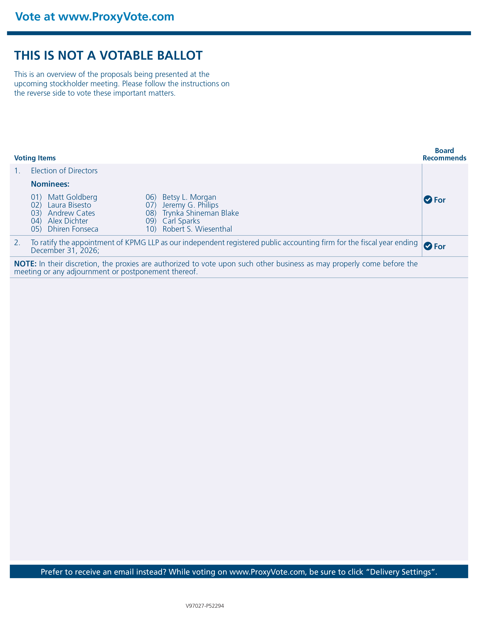

Vote at www.ProxyVote.com THIS IS NOT A VOTABLE BALLOT This is an overview of the proposals being presented at the upcoming stockholder meeting. Please follow the instructions on the reverse side to vote these important matters. Board Recommends Voting Items 1. Election of Directors For Nominees: 01) Matt Goldberg 02) Laura Bisesto 03) Andrew Cates 04) Alex Dichter 05) Dhiren Fonseca 06) Betsy L. Morgan 07) Jeremy G. Philips 08) Trynka Shineman Blake 09) Carl Sparks 10) Robert S. Wiesenthal 2. To ratify the appointment of KPMG LLP as our independent registered public accounting firm for the fiscal year ending December 31, 2026; For NOTE: In their discretion, the proxies are authorized to vote upon such other business as may properly come before the meeting or any adjournment or postponement thereof. Prefer to receive an email instead? While voting on www.ProxyVote.com, be sure to click “Delivery Settings”. V97027-P52294

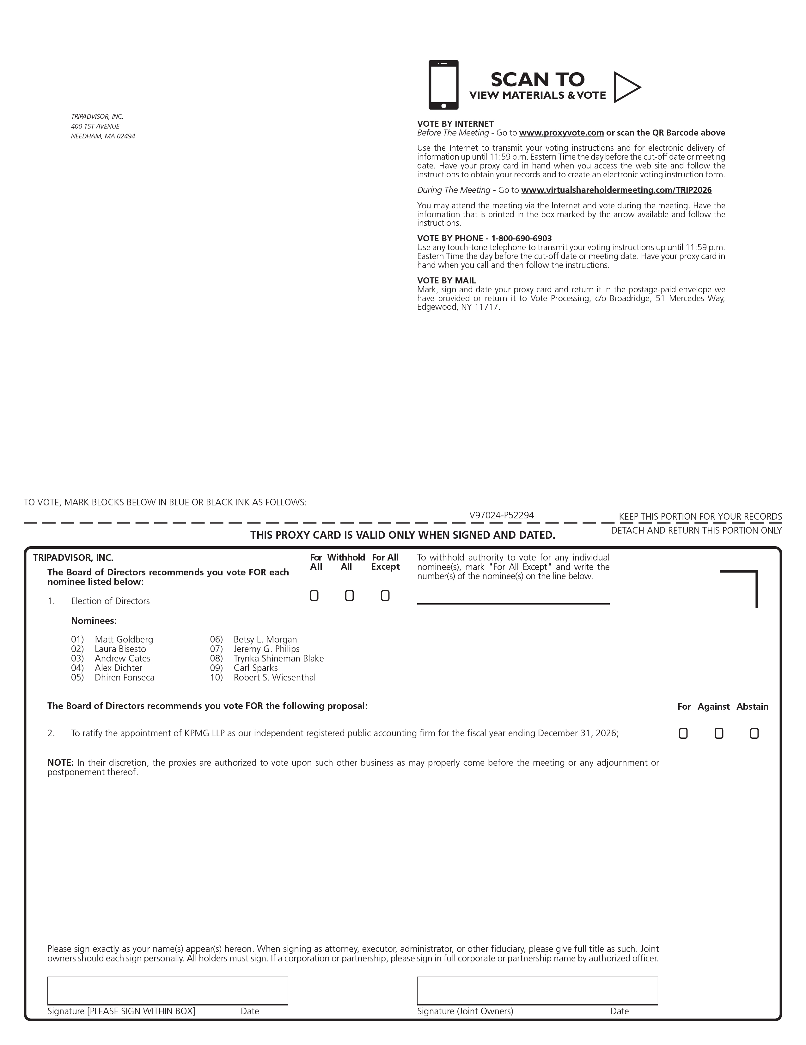

SCAN TO VIEW MATERIALS & VOTE TRIPADVISOR, INC. 400 1ST AVENUE NEEDHAM, MA 02494 VOTE BY INTERNET Before The Meeting - Go to www.proxyvote.com or scan the QR Barcode above Use the Internet to transmit your voting instructions and for electronic delivery of information up until 11:59 p.m. Eastern Time the day before the cut-off date or meeting date. Have your proxy card in hand when you access the web site and follow the instructions to obtain your records and to create an electronic voting instruction form. During The Meeting - Go to www.virtualshareholdermeeting.com/TRIP2026 You may attend the meeting via the Internet and vote during the meeting. Have the information that is printed in the box marked by the arrow available and follow the instructions. VOTE BY PHONE - 1-800-690-6903 Use any touch-tone telephone to transmit your voting instructions up until 11:59 p.m. Eastern Time the day before the cut-off date or meeting date. Have your proxy card in hand when you call and then follow the instructions. VOTE BY MAIL Mark, sign and date your proxy card and return it in the postage-paid envelope we have provided or return it to Vote Processing, c/o Broadridge, 51 Mercedes Way, Edgewood, NY 11717. V97024-P52294 For All Withhold All For All Except TRIPADVISOR, INC. To withhold authority to vote for any individual nominee(s), mark "For All Except" and write the number(s) of the nominee(s) on the line below. The Board of Directors recommends you vote FOR each nominee listed below: ! ! ! 1. Election of Directors Nominees: 01) Matt Goldberg 02) Laura Bisesto 03) Andrew Cates 04) Alex Dichter 05) Dhiren Fonseca 06) Betsy L. Morgan 07) Jeremy G. Philips 08) Trynka Shineman Blake 09) Carl Sparks 10) Robert S. Wiesenthal The Board of Directors recommends you vote FOR the following proposal: 2. To ratify the appointment of KPMG LLP as our independent registered public accounting firm for the fiscal year ending December 31, 2026; NOTE: In their discretion, the proxies are authorized to vote upon such other business as may properly come before the meeting or any adjournment or postponement thereof. Please sign exactly as your name(s) appear(s) hereon. When signing as attorney, executor, administrator, or other fiduciary, please give full title as such. Joint owners should each sign personally. All holders must sign. If a corporation or partnership, please sign in full corporate or partnership name by authorized officer.

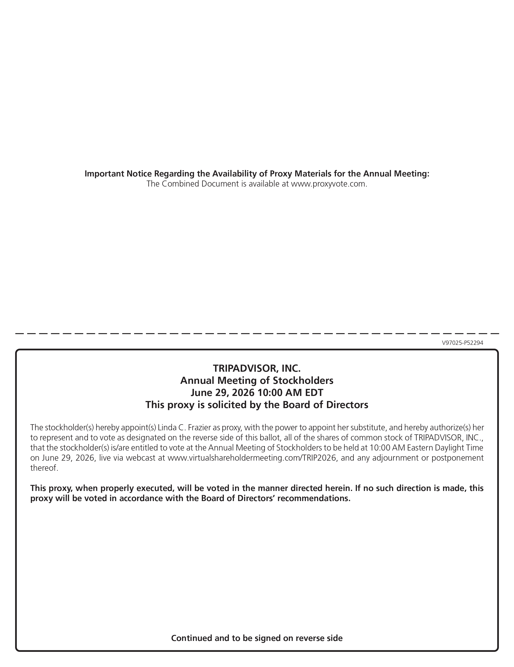

Important Notice Regarding the Availability of Proxy Materials for the Annual Meeting: The Combined Document is available at www.proxyvote.com. V97025-P52294 TRIPADVISOR, INC. Annual Meeting of Stockholders June 29, 2026 10:00 AM EDT This proxy is solicited by the Board of Directors The stockholder(s) hereby appoint(s) Linda C. Frazier as proxy, with the power to appoint her substitute, and hereby authorize(s) her to represent and to vote as designated on the reverse side of this ballot, all of the shares of common stock of TRIPADVISOR, INC., that the stockholder(s) is/are entitled to vote at the Annual Meeting of Stockholders to be held at 10:00 AM Eastern Daylight Time on June 29, 2026, live via webcast at www.virtualshareholdermeeting.com/TRIP2026, and any adjournment or postponement thereof. This proxy, when properly executed, will be voted in the manner directed herein. If no such direction is made, this proxy will be voted in accordance with the Board of Directors recommendations. Continued and to be signed on reverse side

